# Entities VehicleType, DBContext

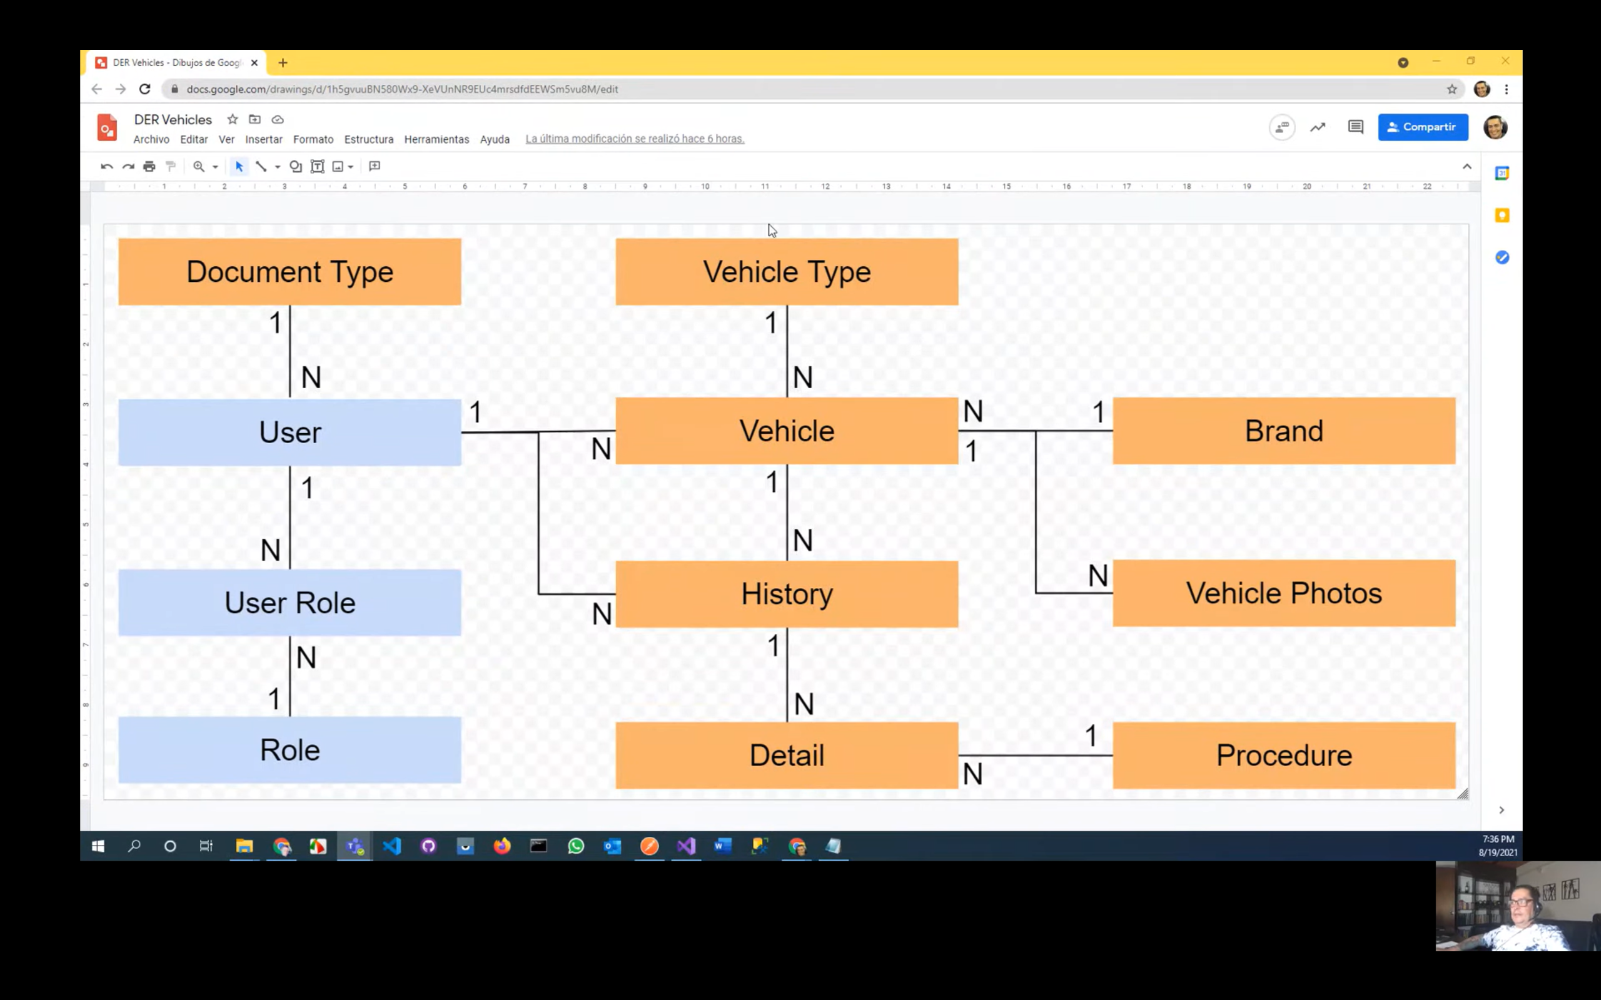

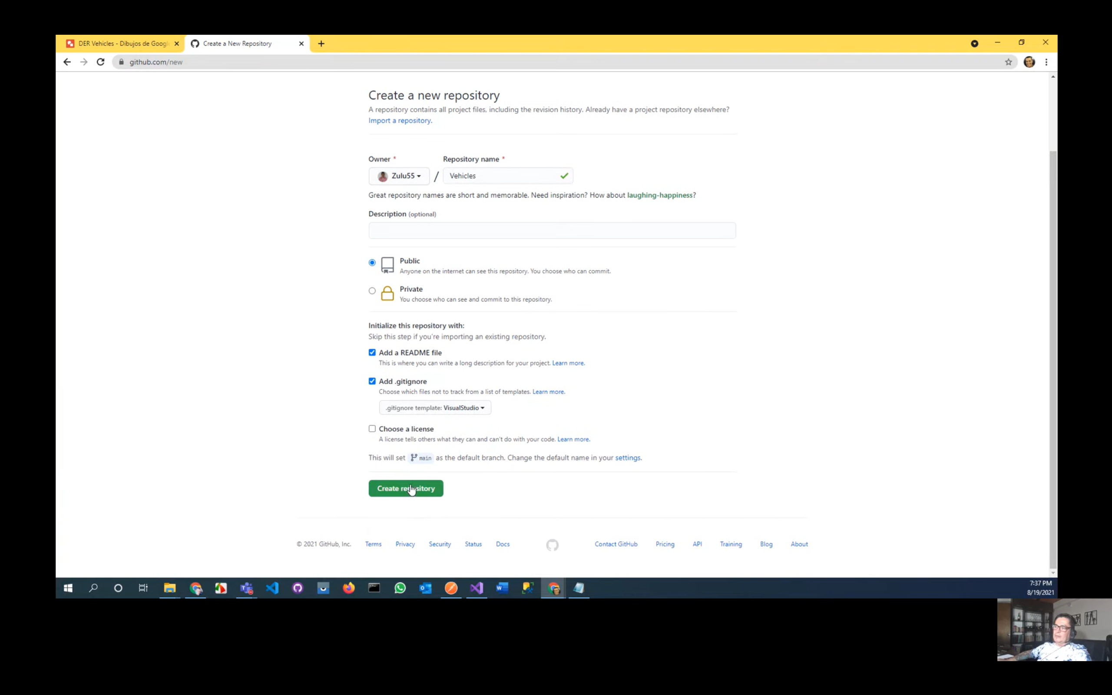

Ingresar a visual studio y clonar lo copiado del repositorio

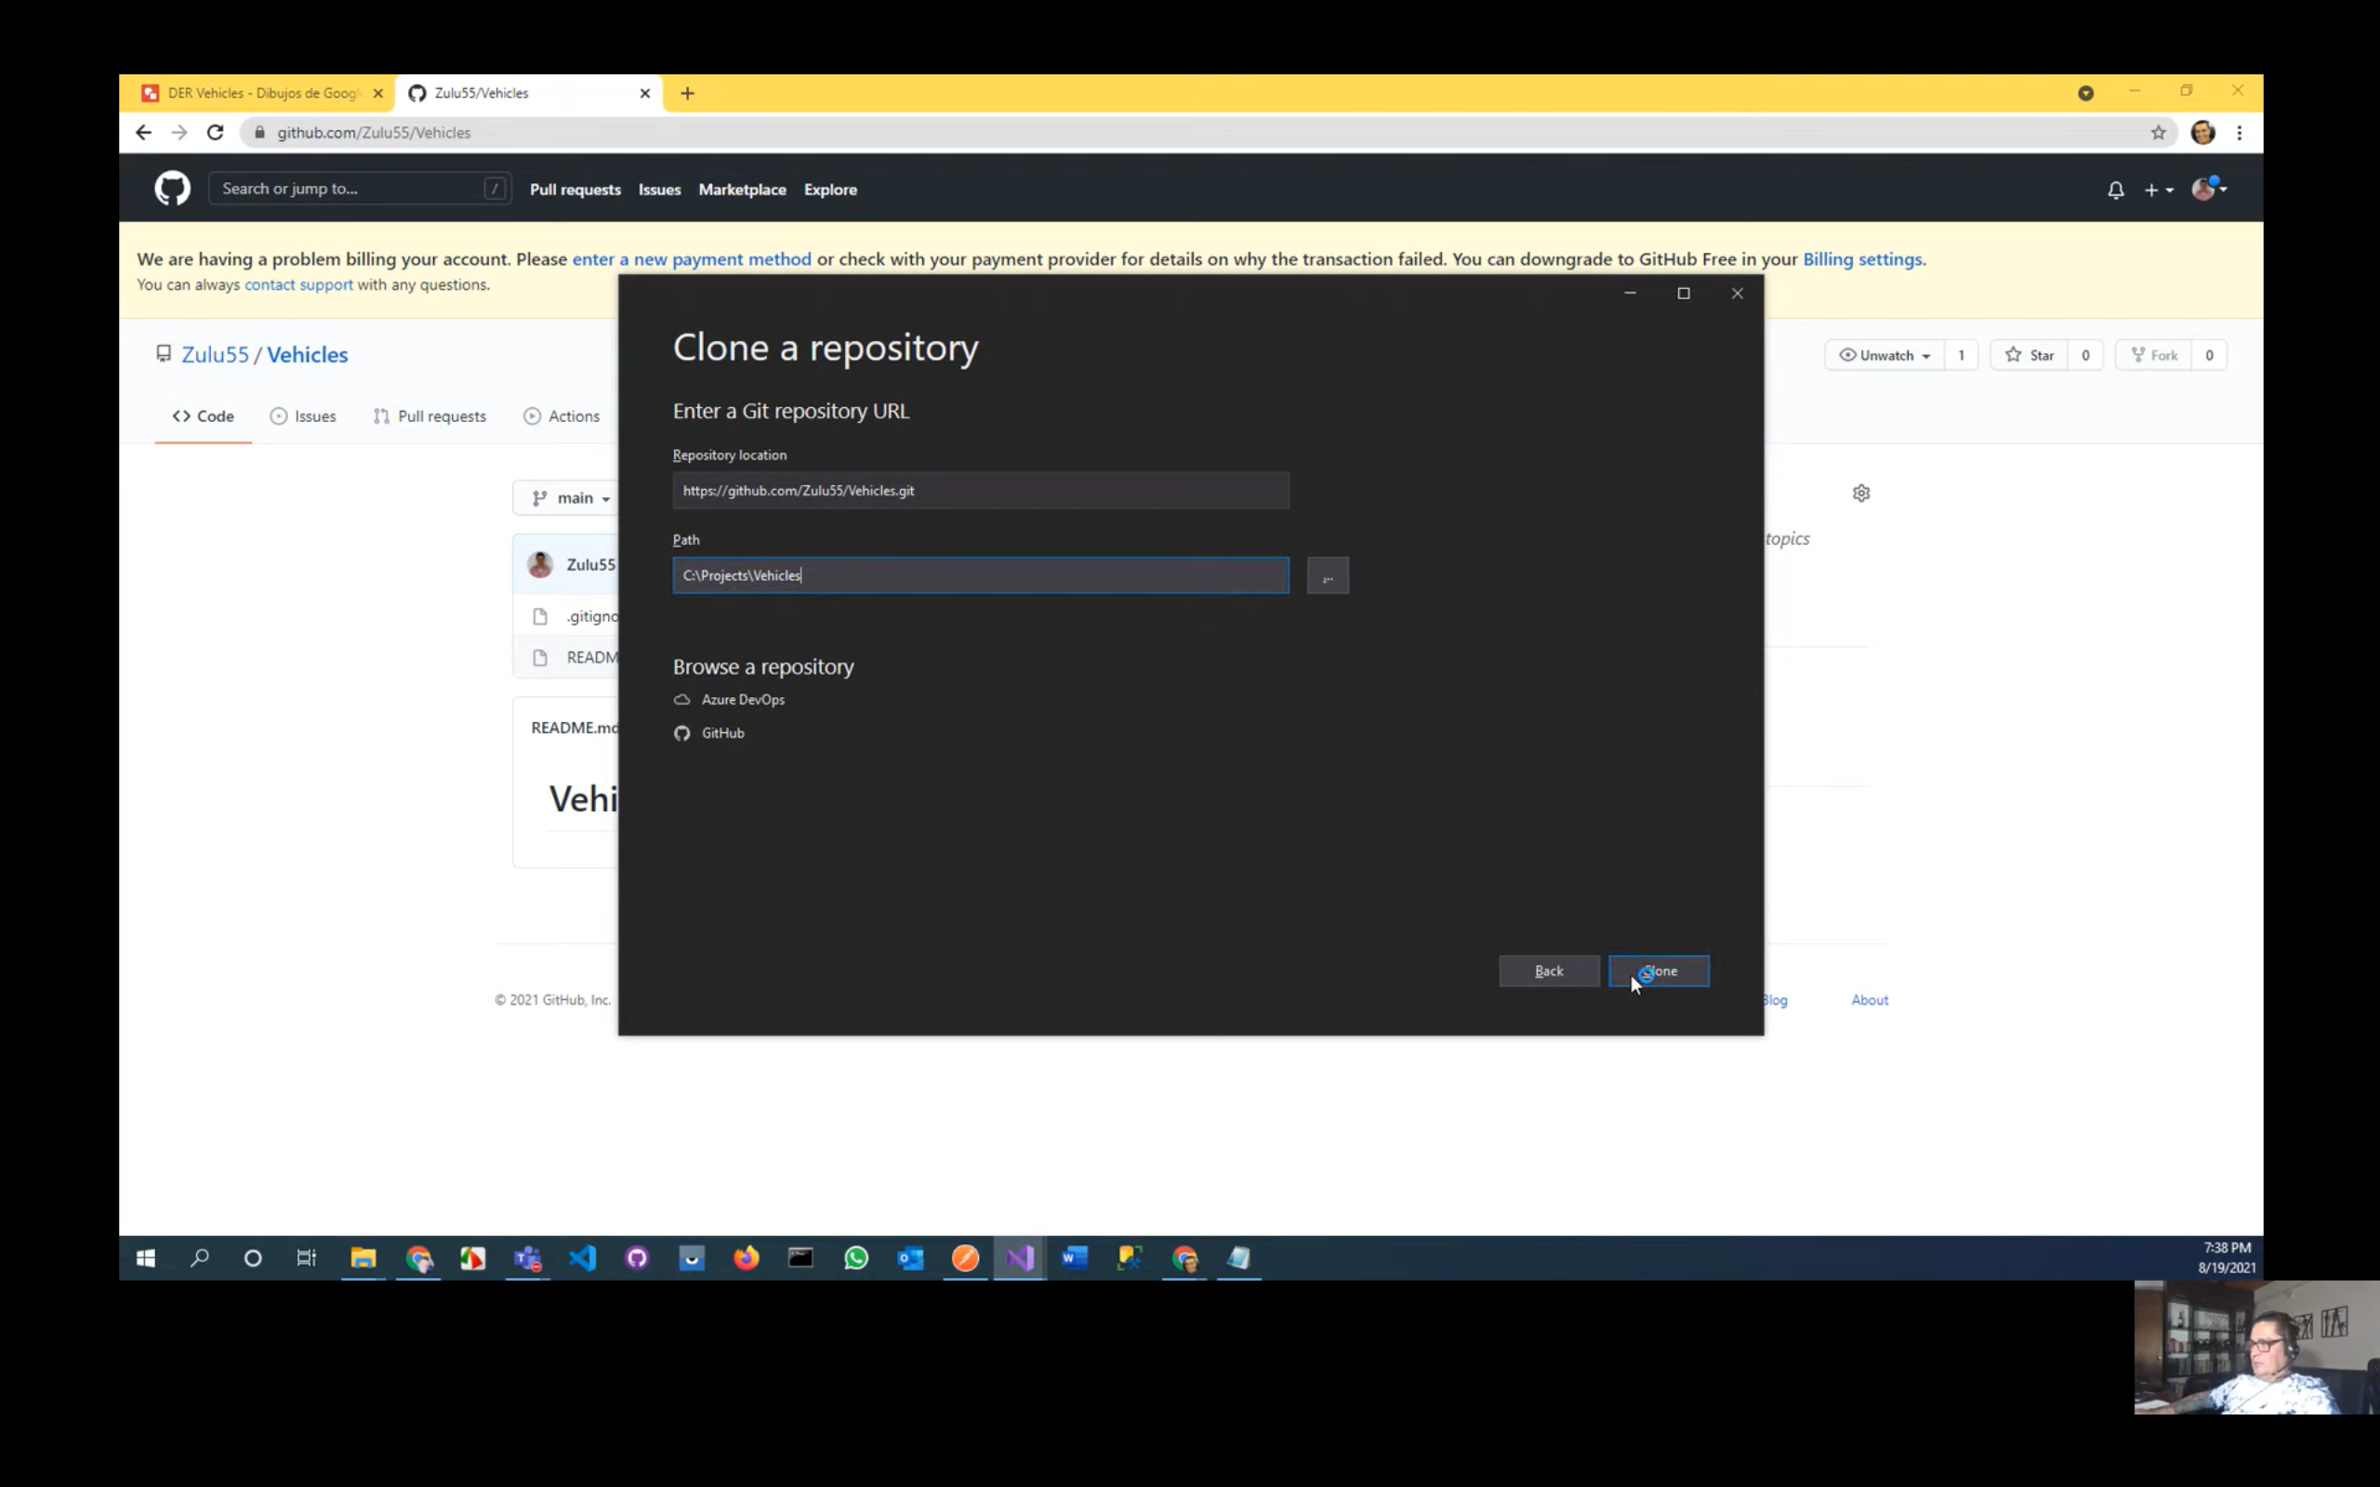

Crear una Back Solution

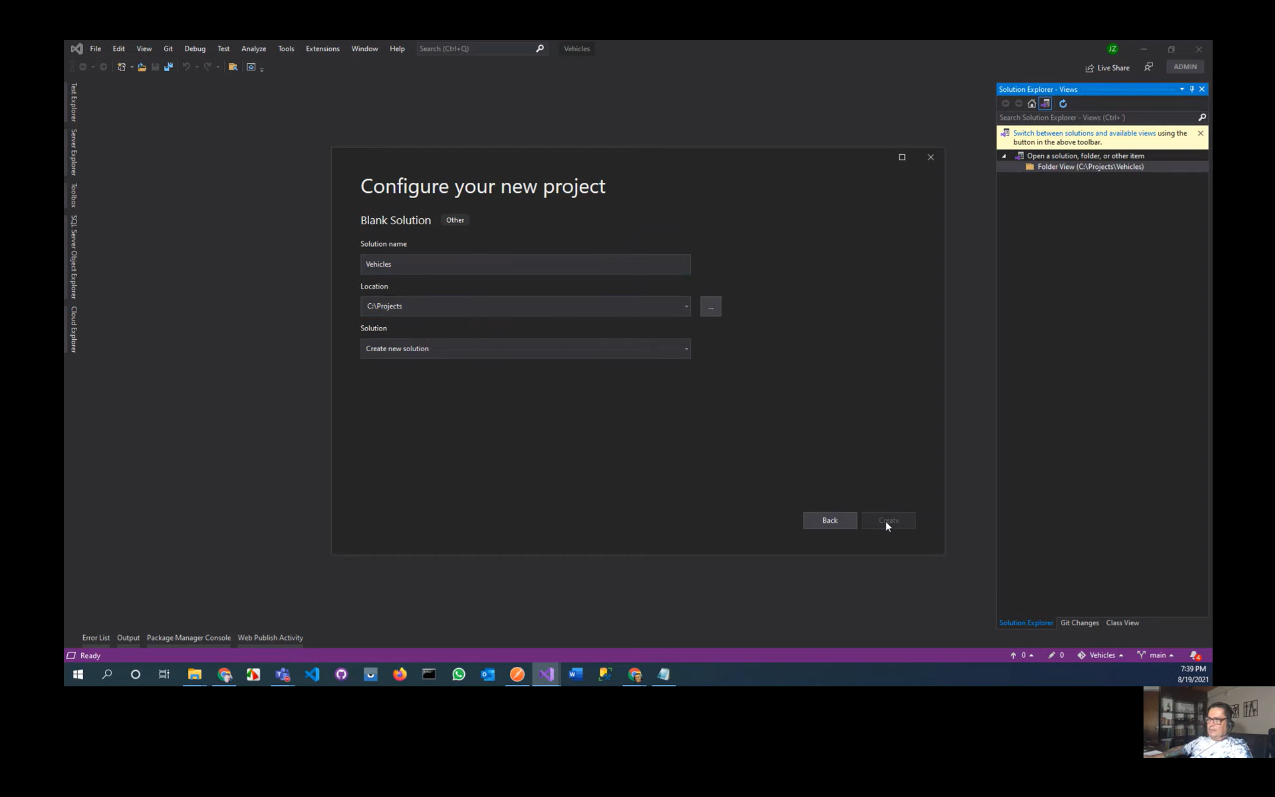

Crear un Class Library en .Net5, eliminar la clase creada por defecto

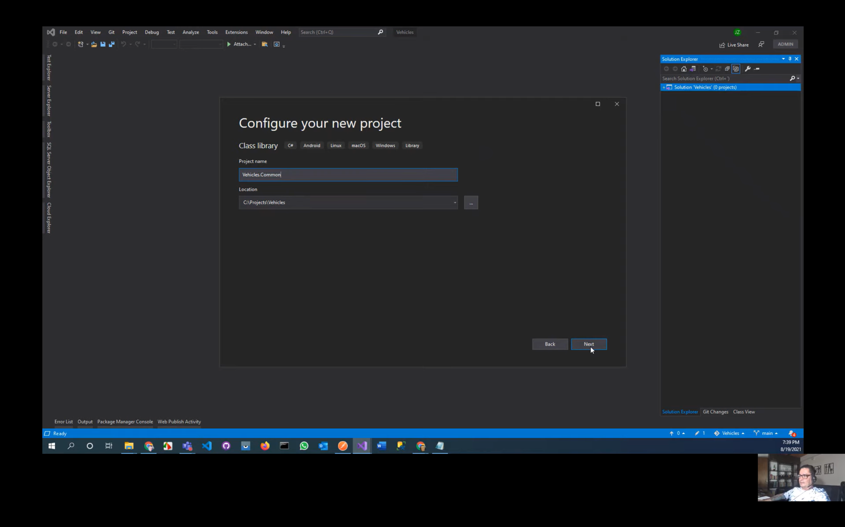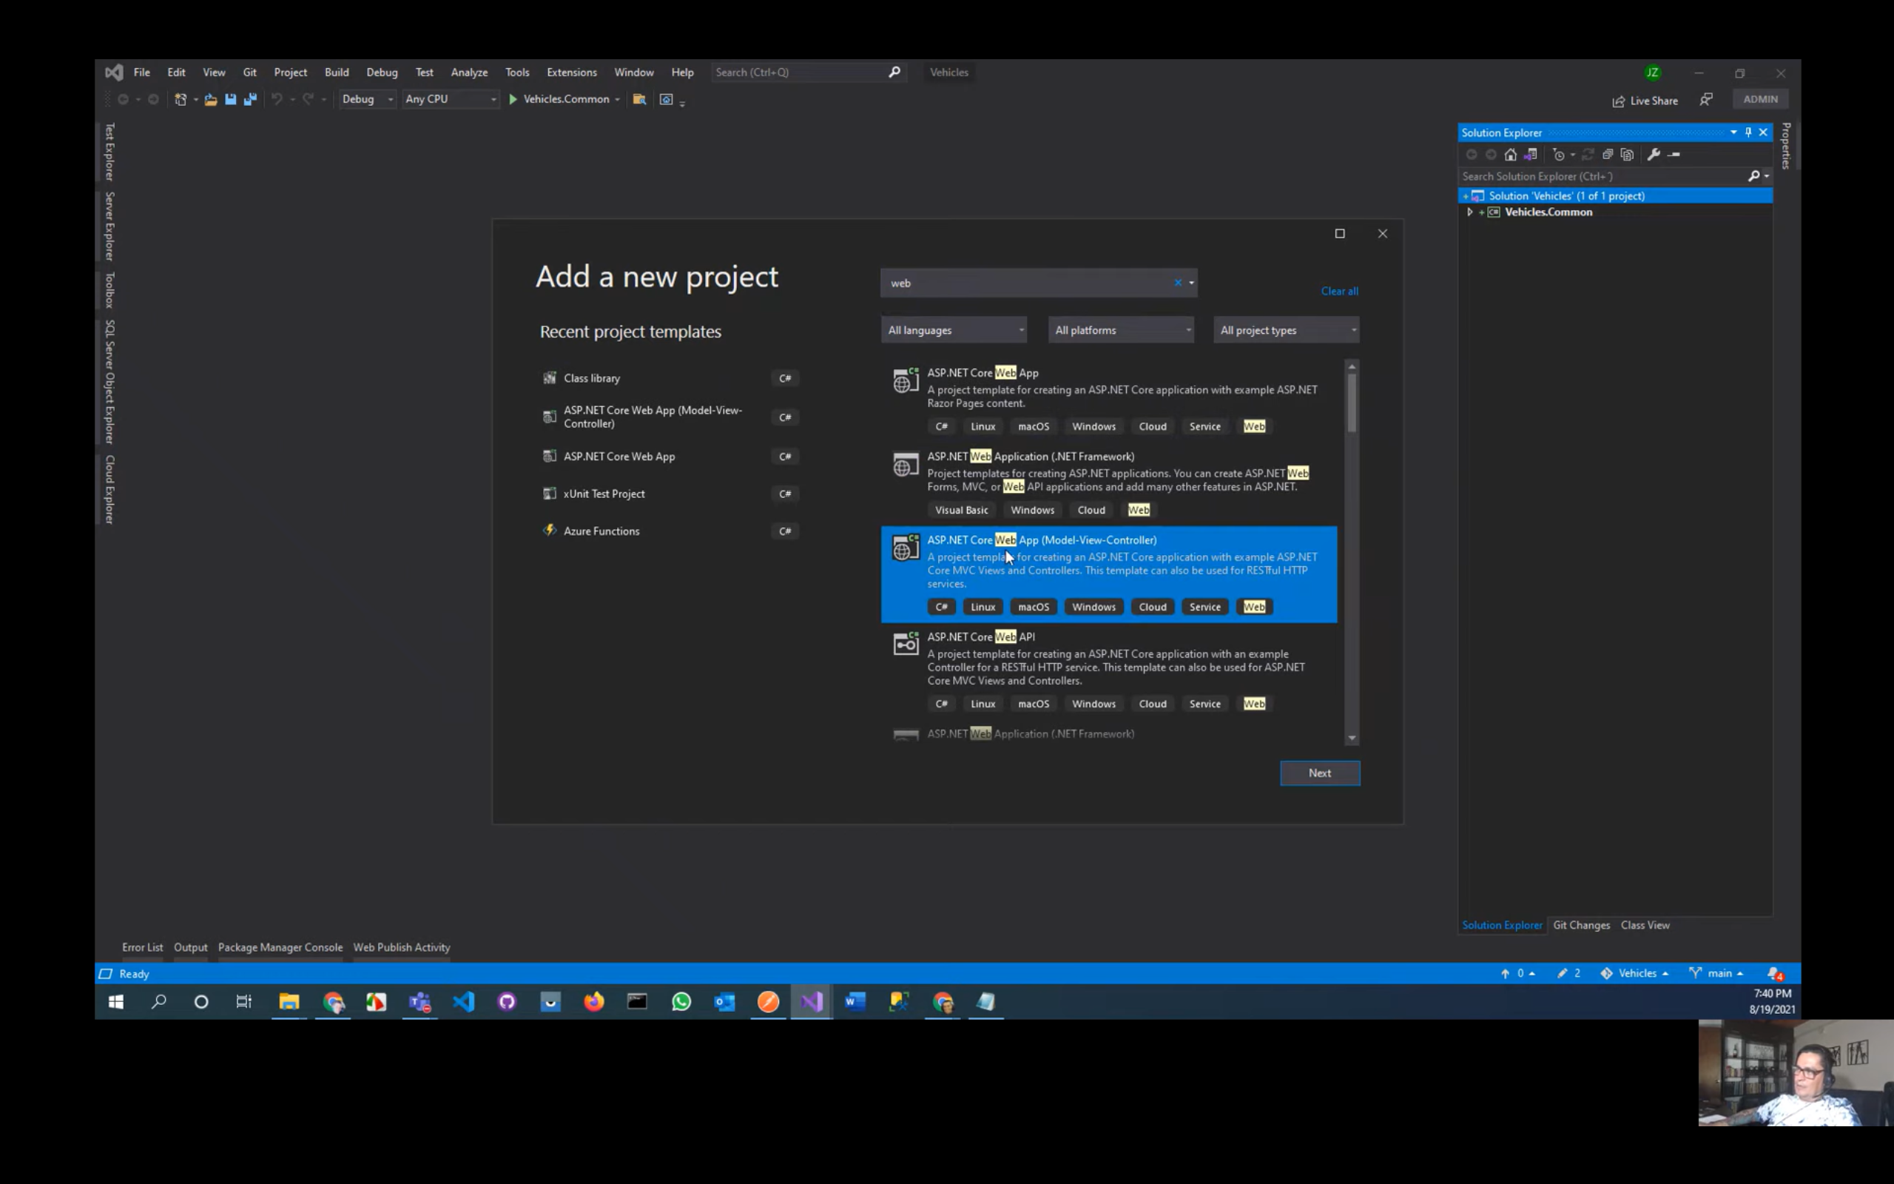

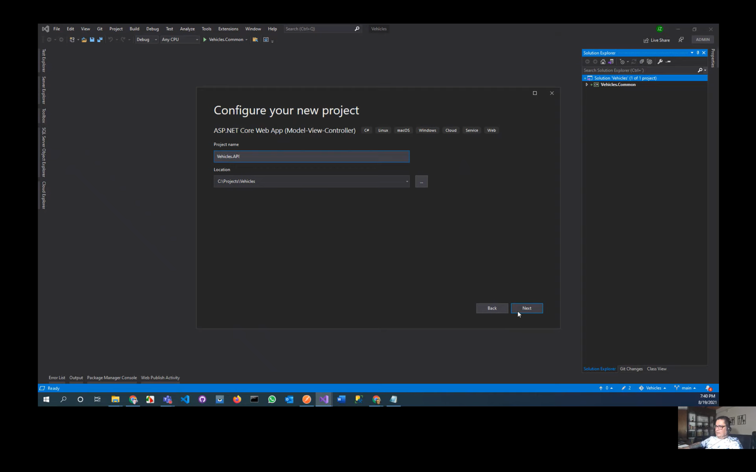

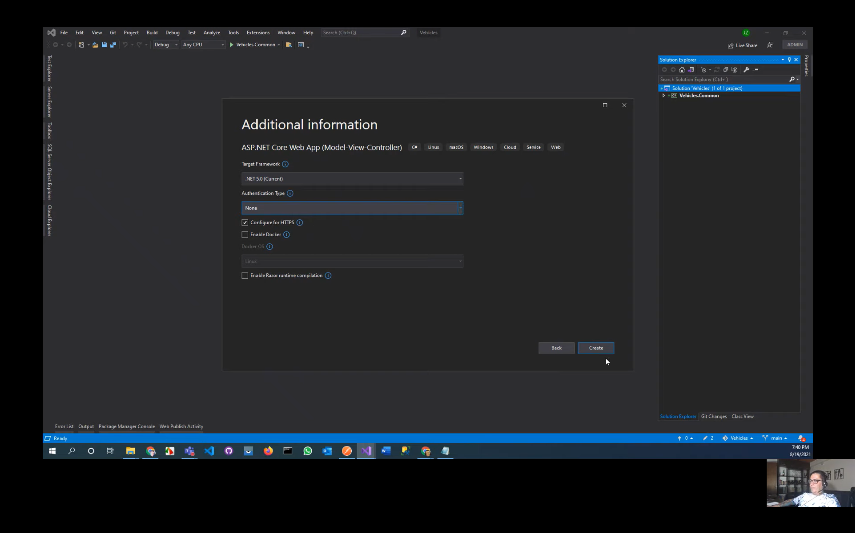

Ejecutar el WebAPI

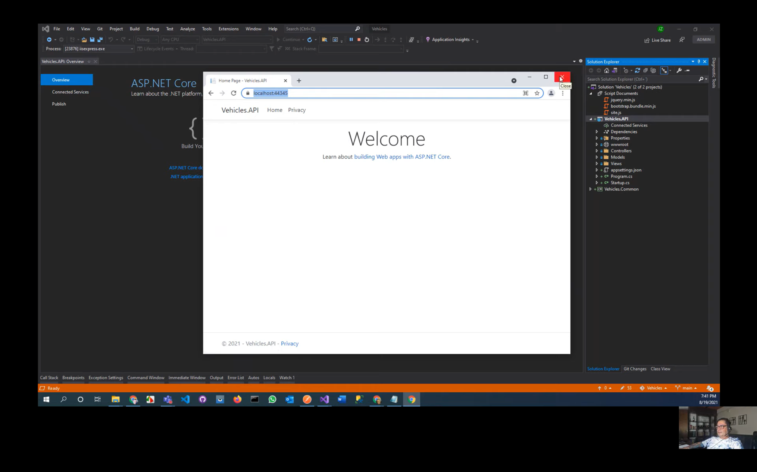

Crear en VehiculosAPI la carpeta DATA – Carpeta Entities – Clase VehicleType

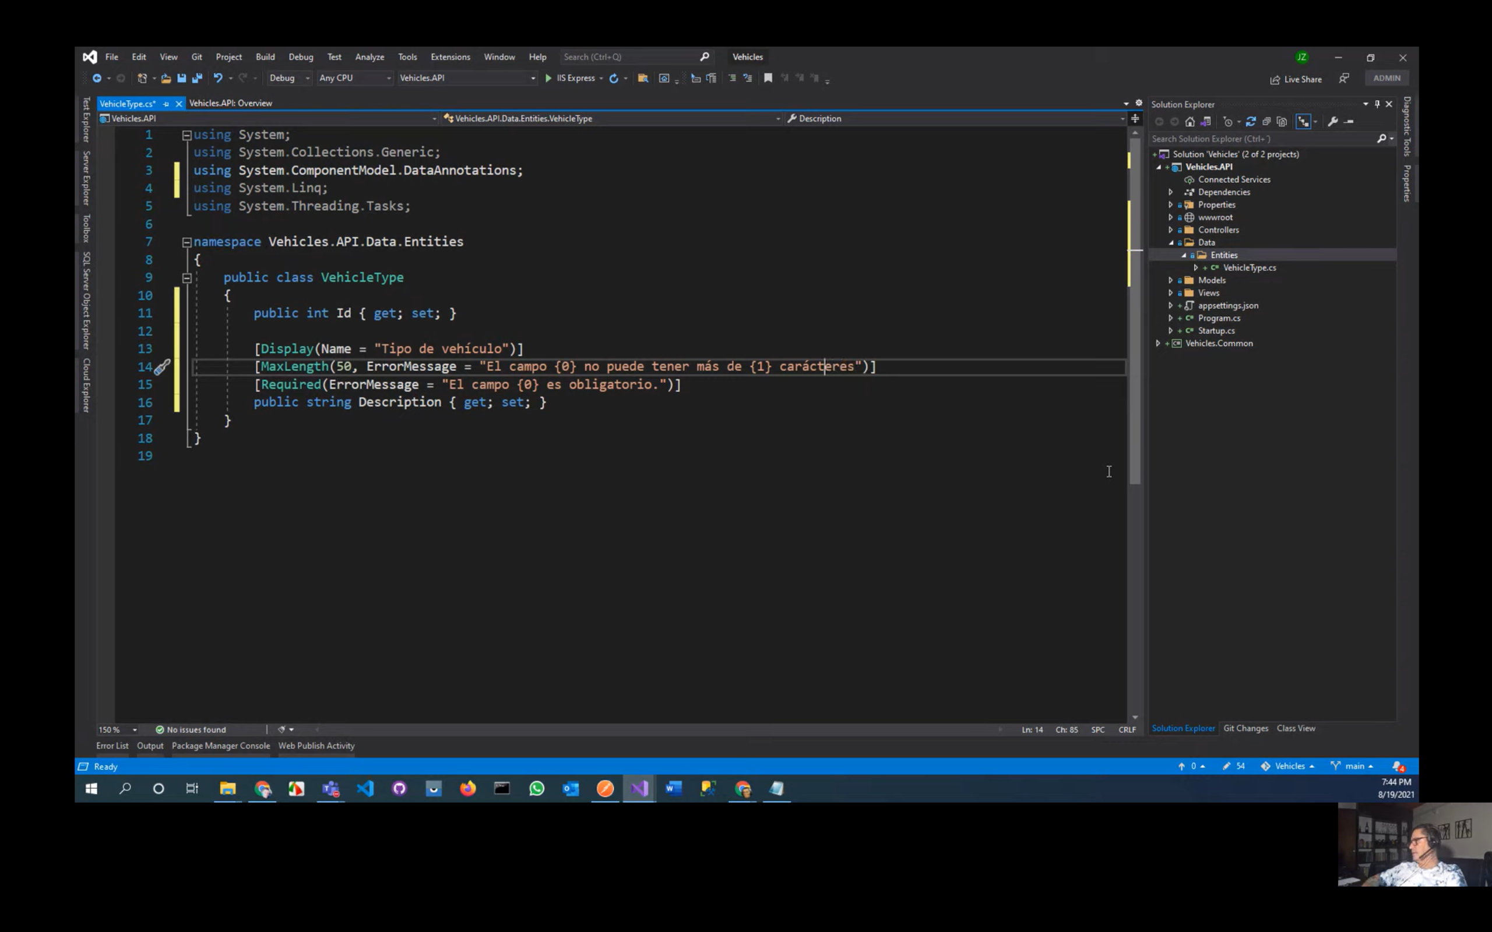

En DATA crear la carpeta DataContext

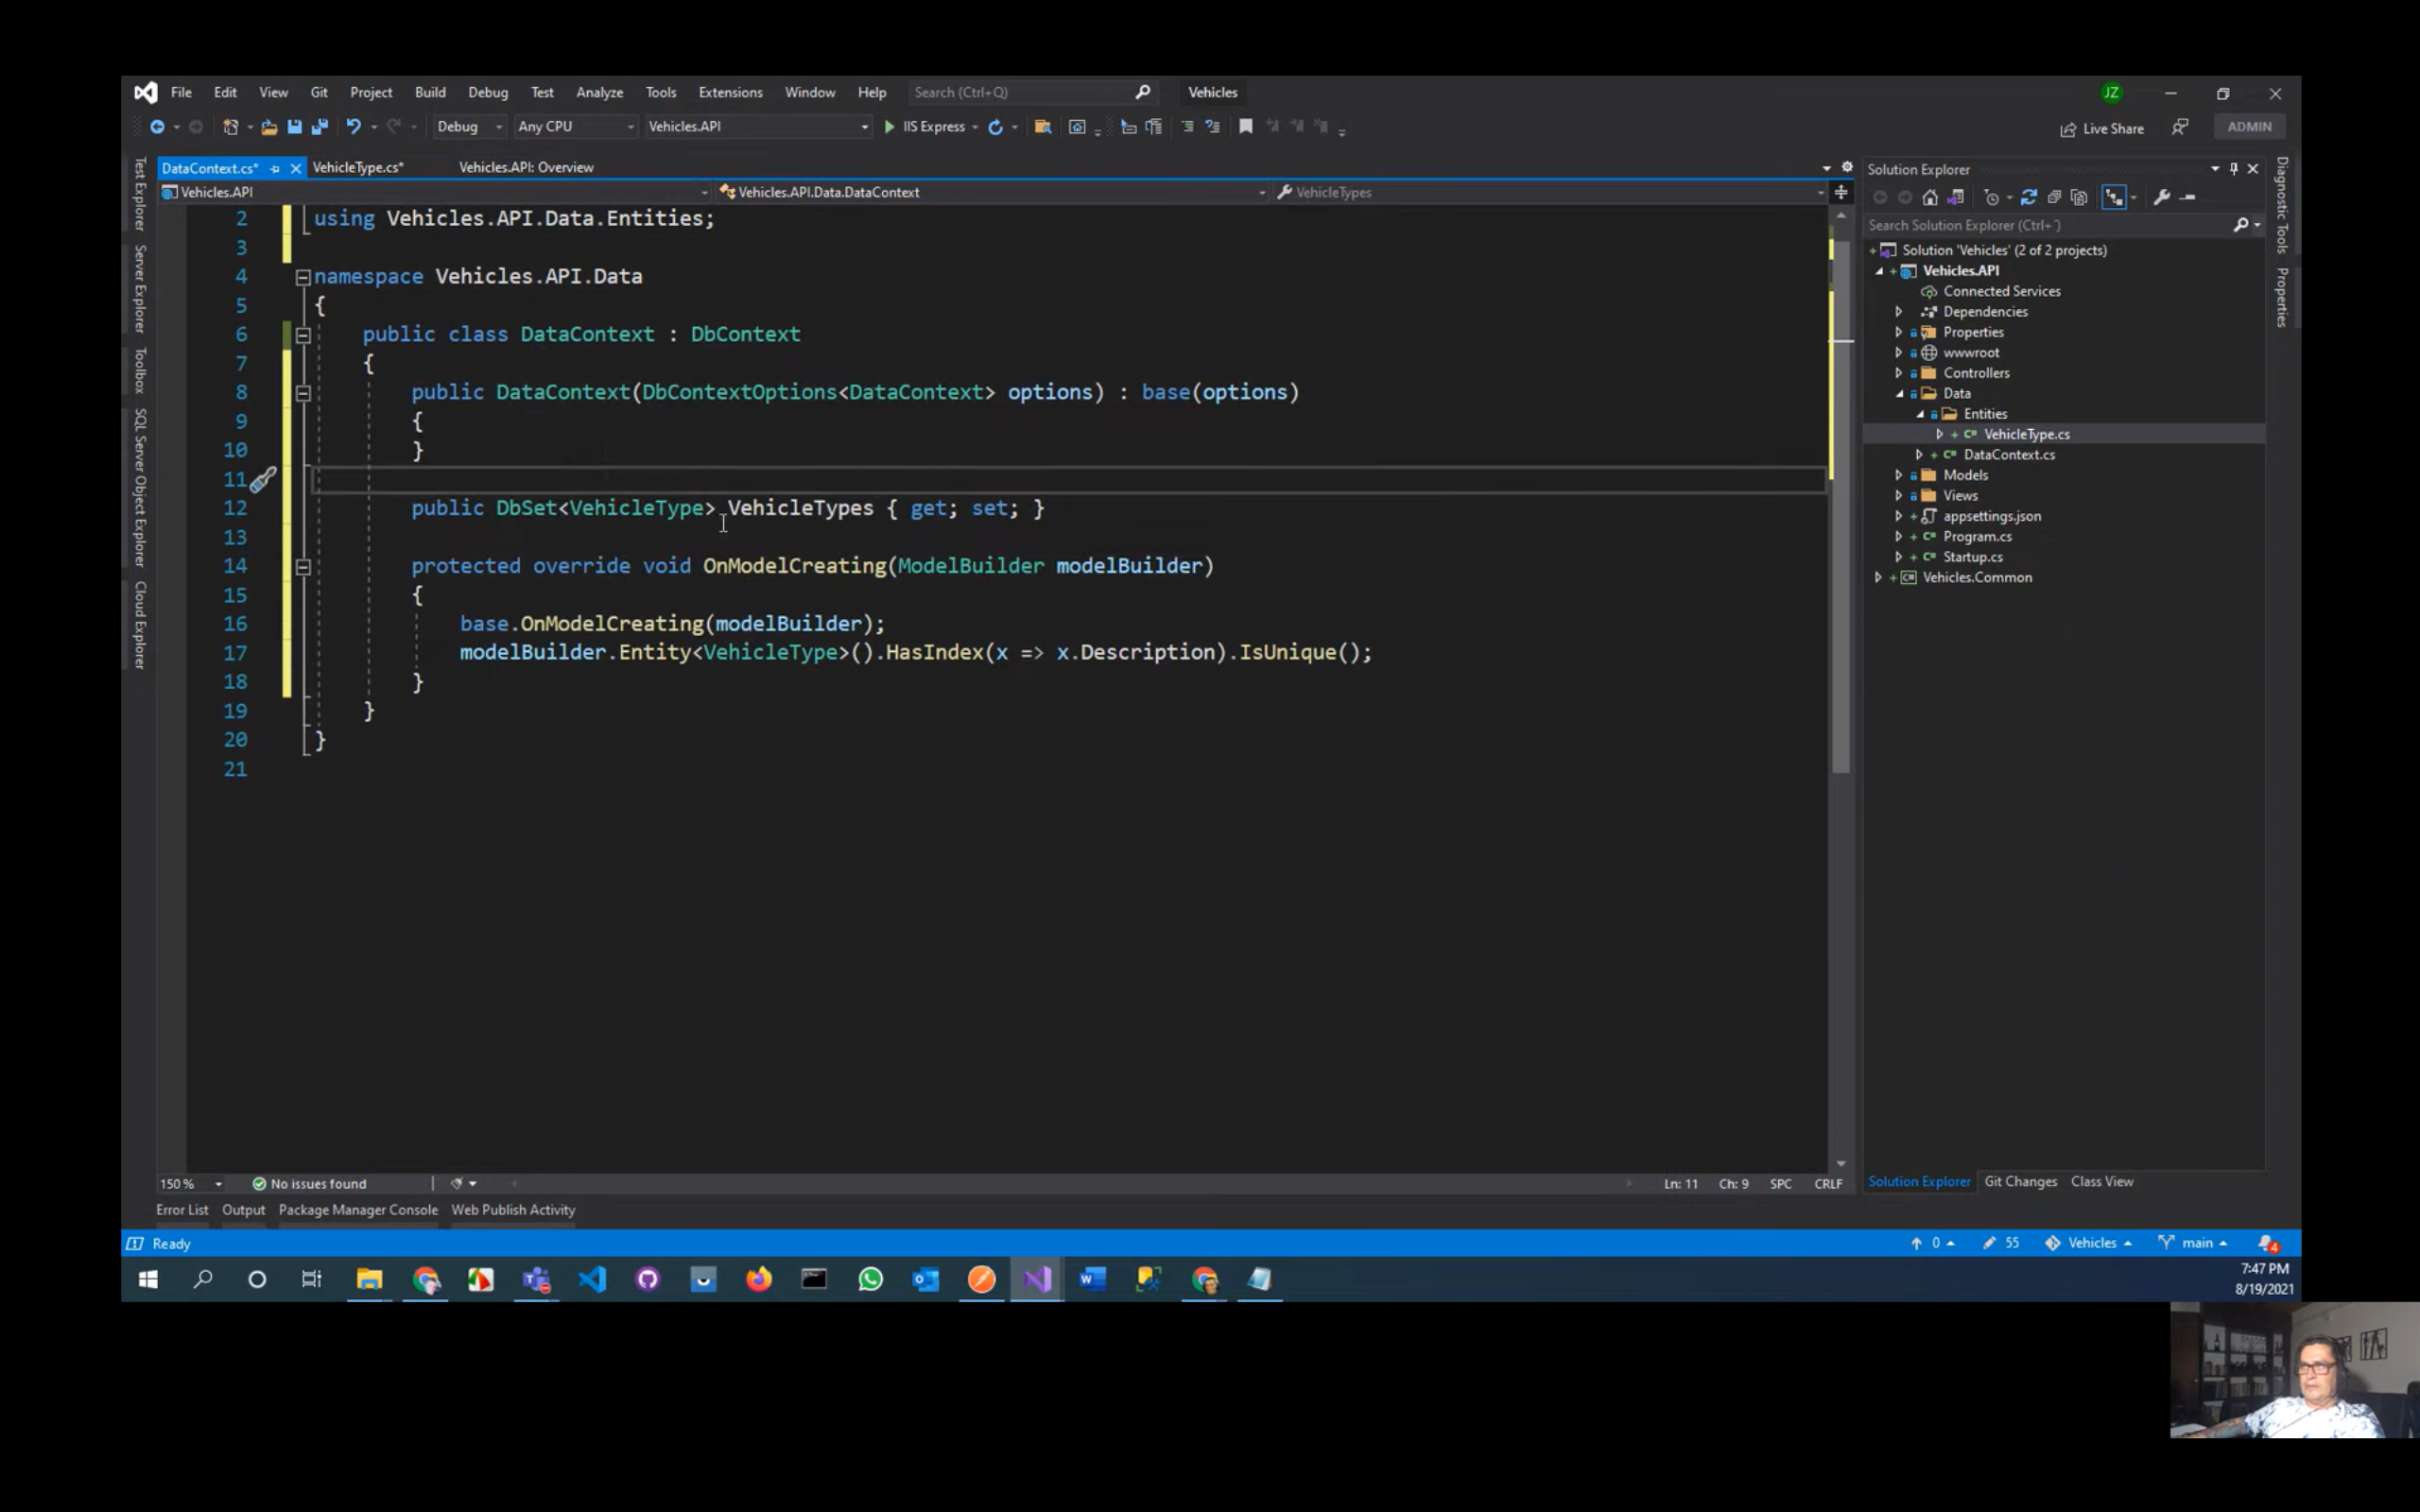

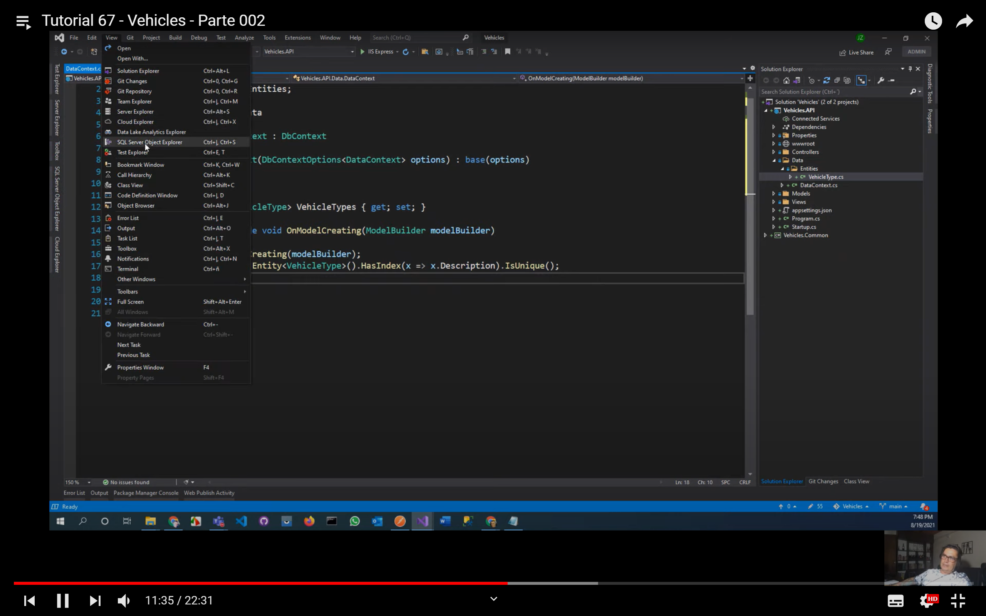

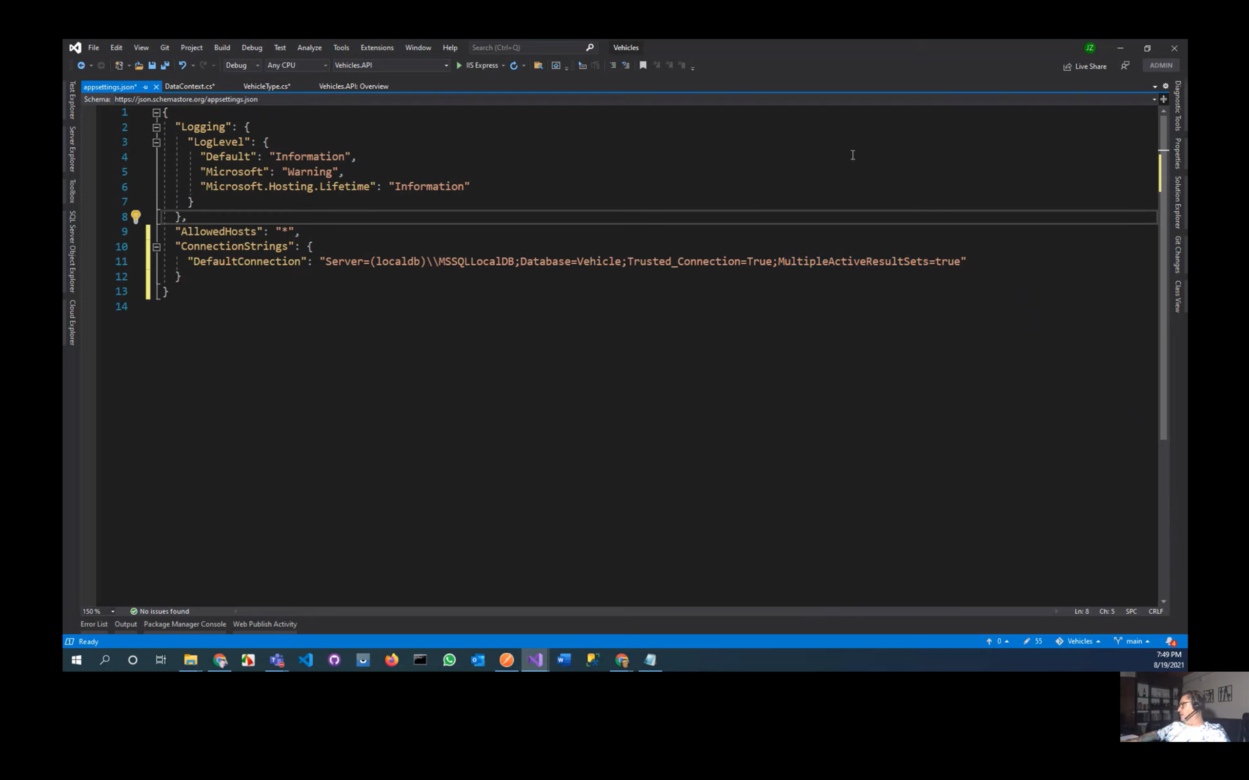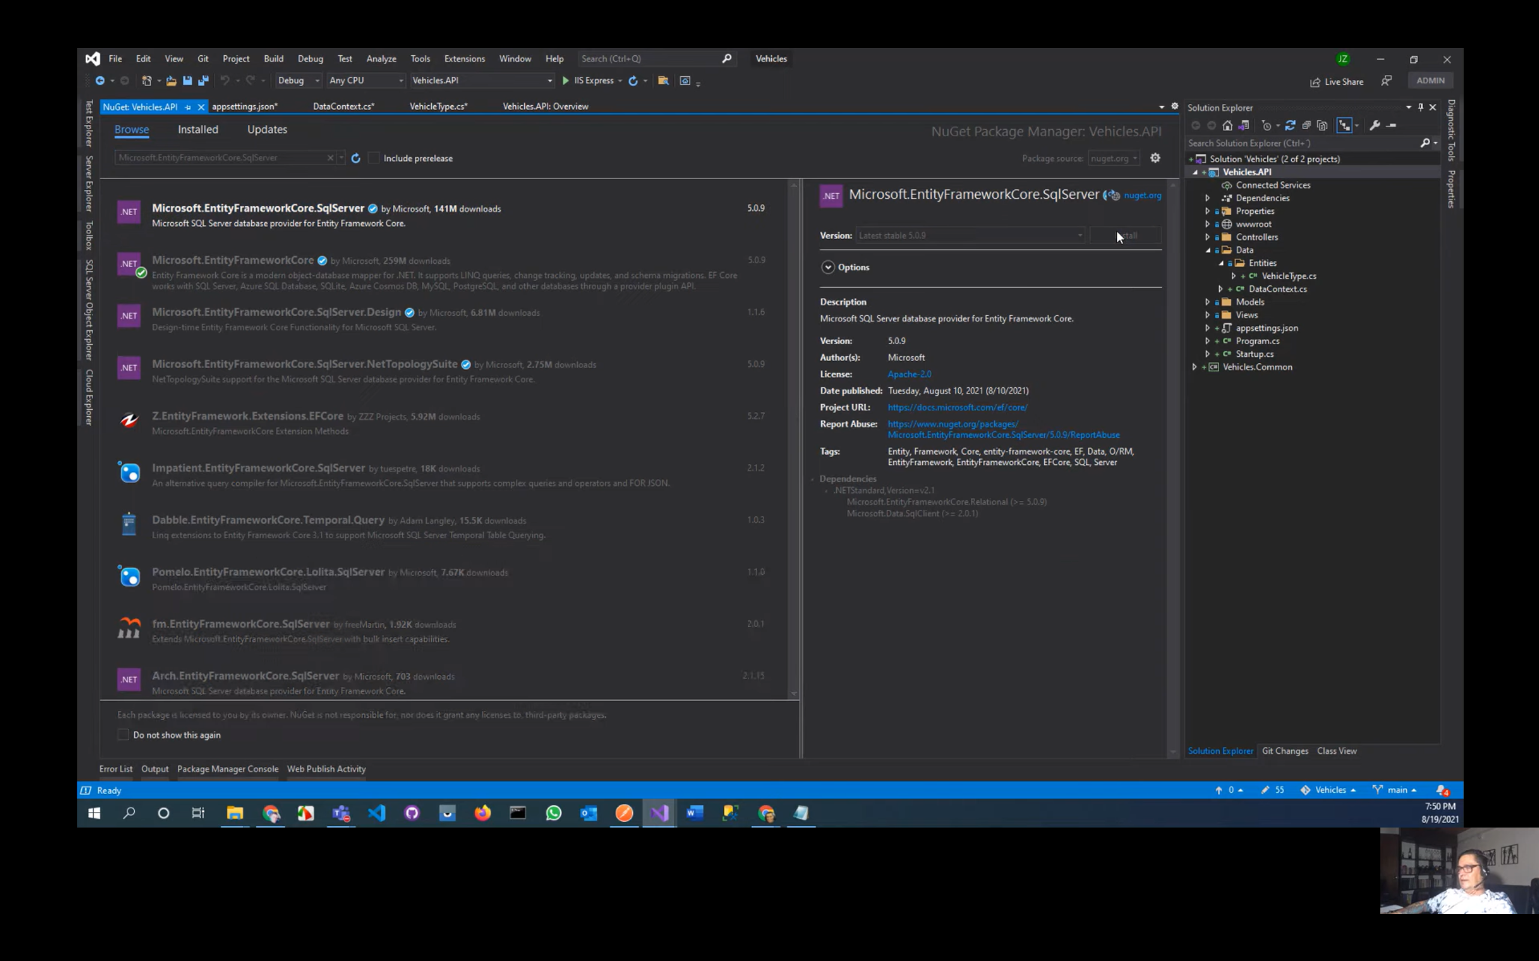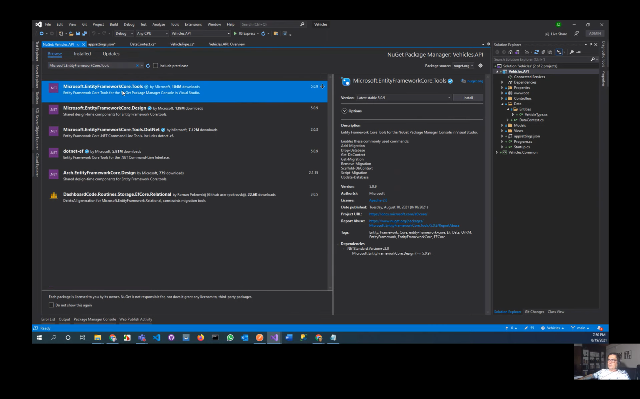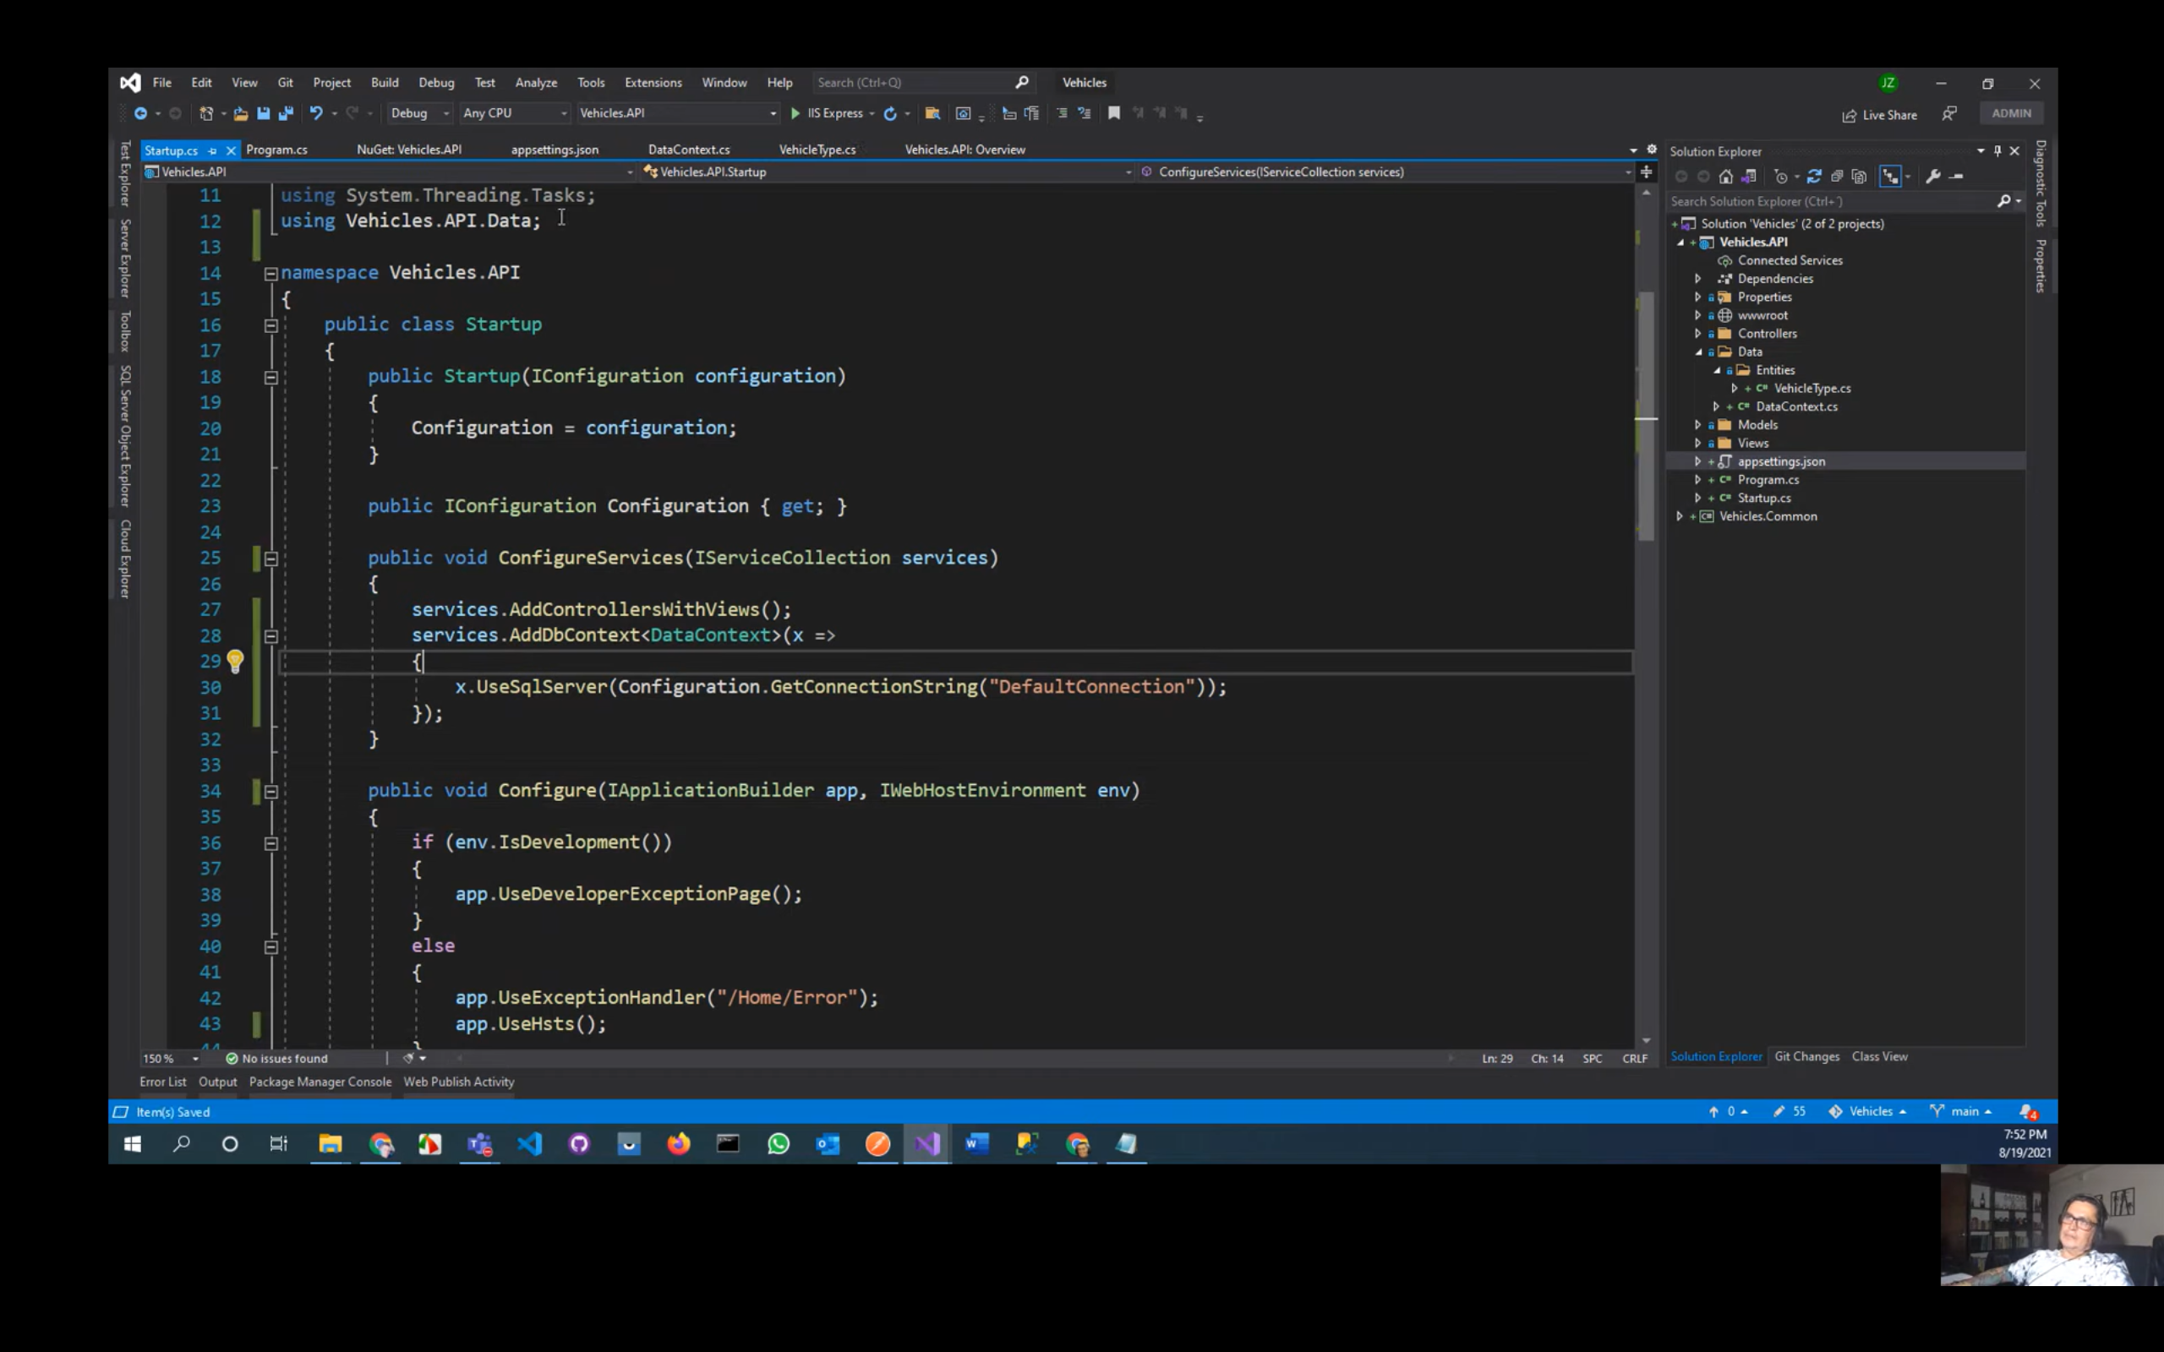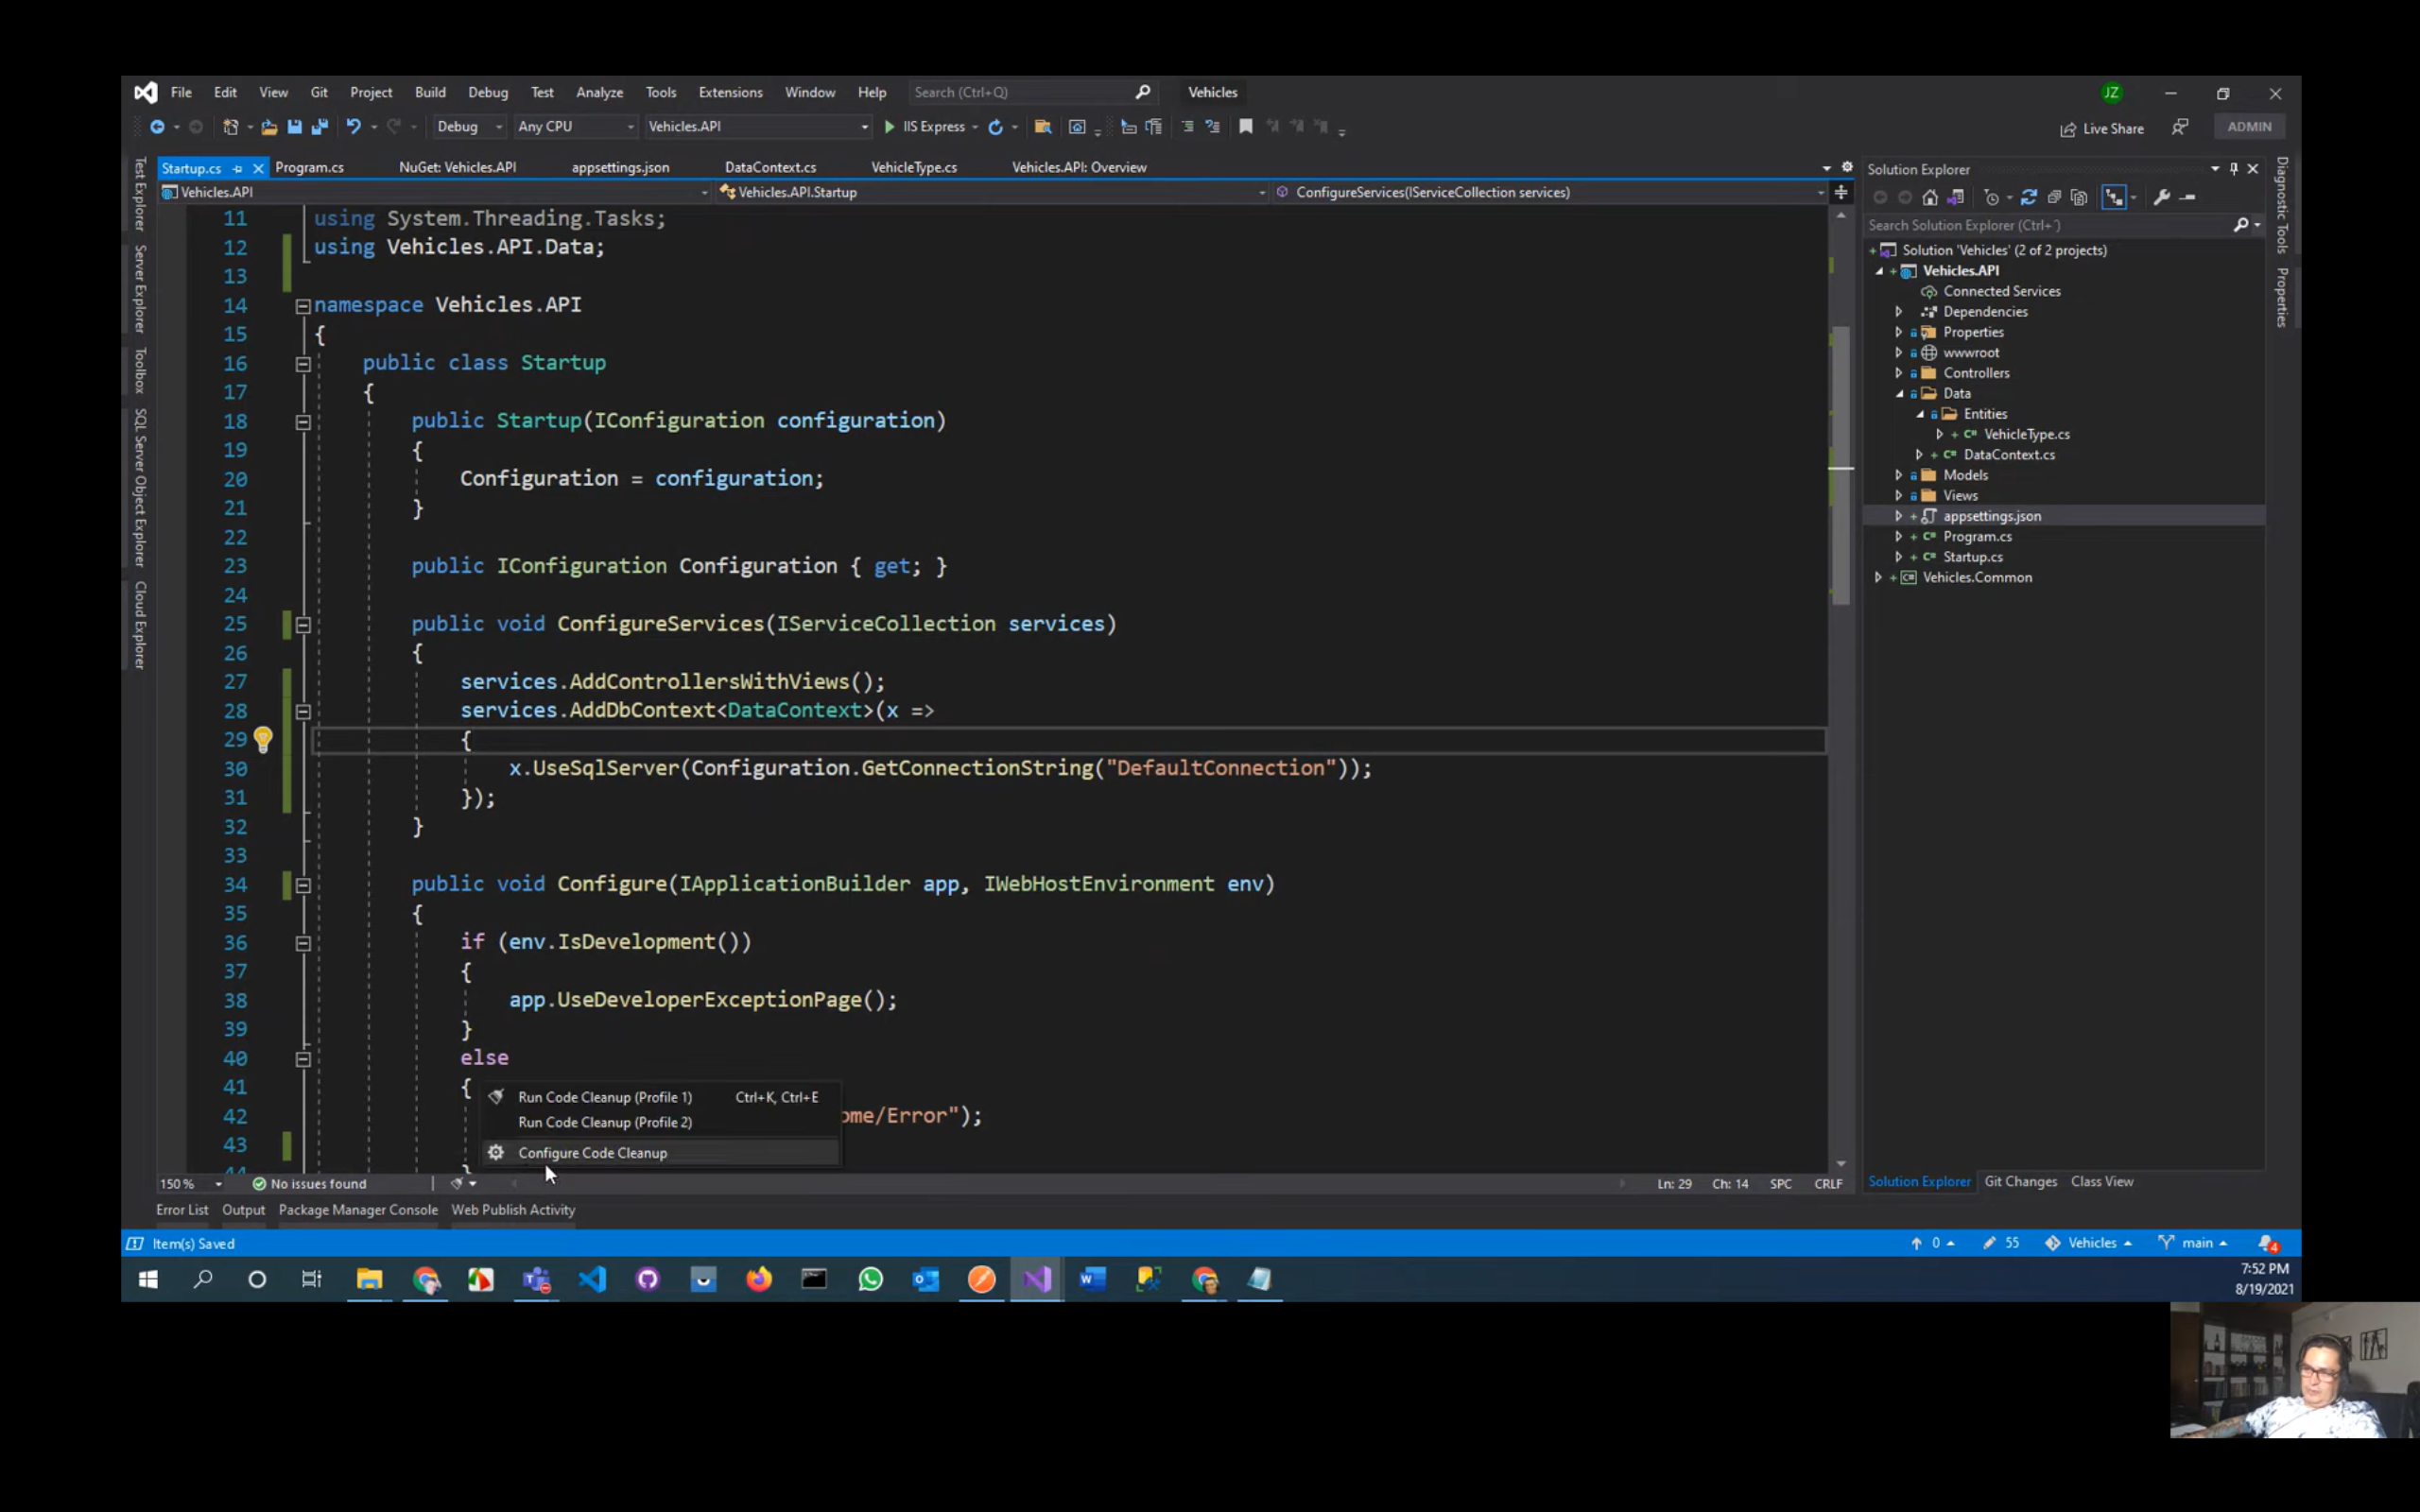

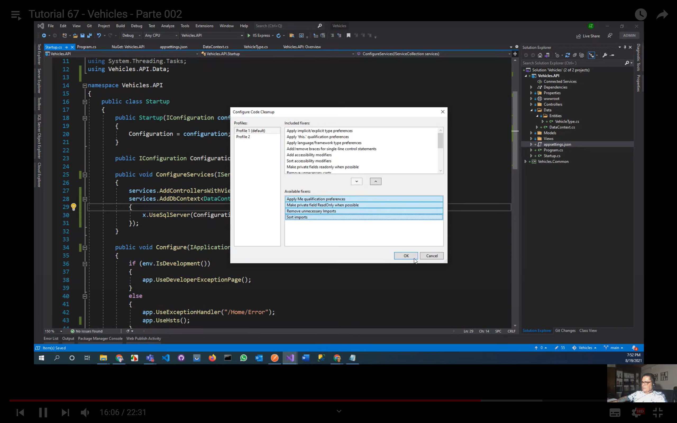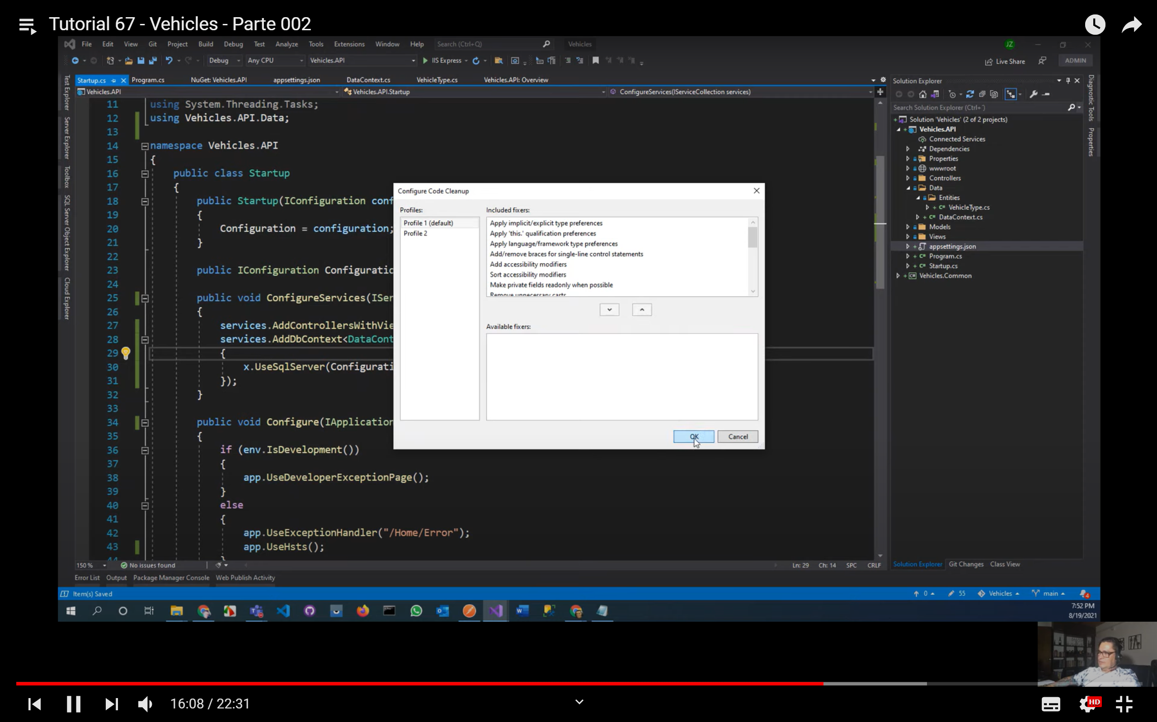

Dar click en la escobita para que se visualize código limpio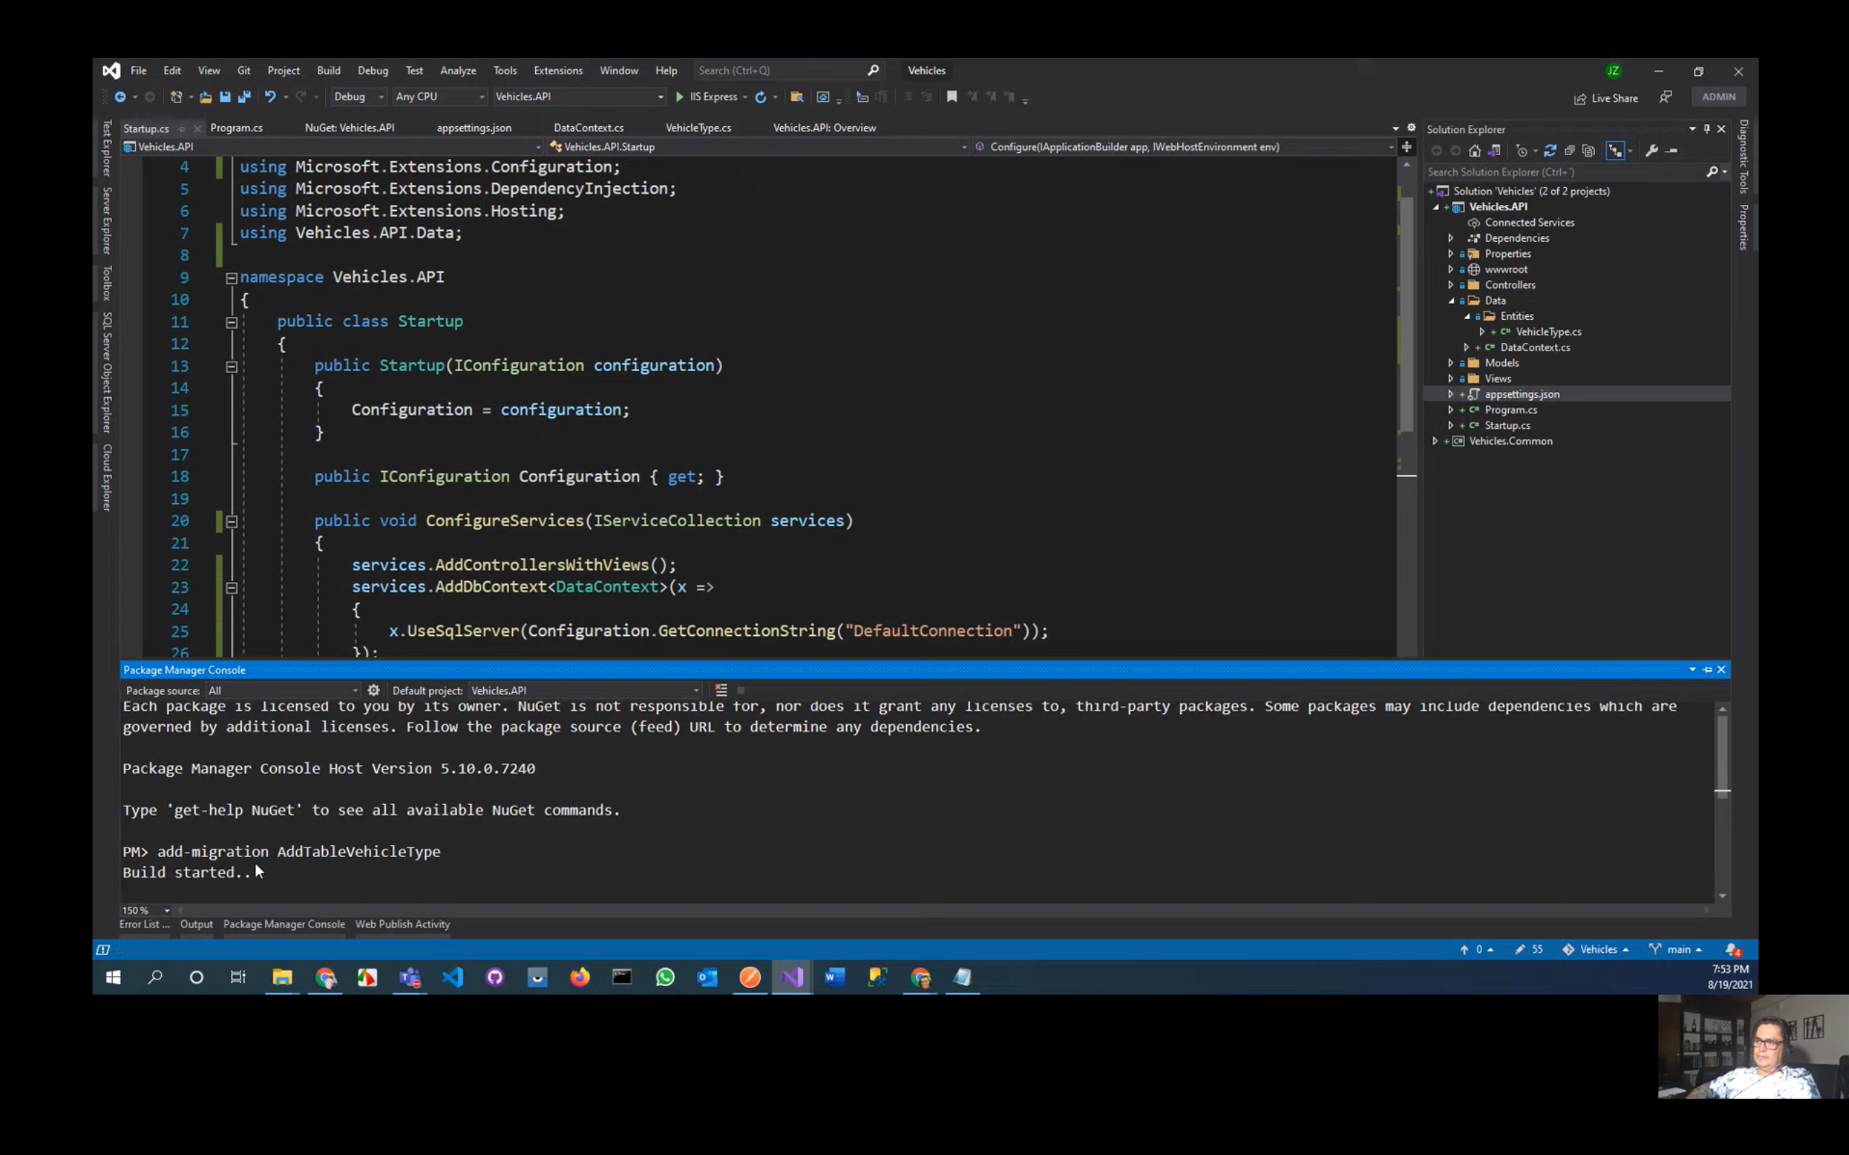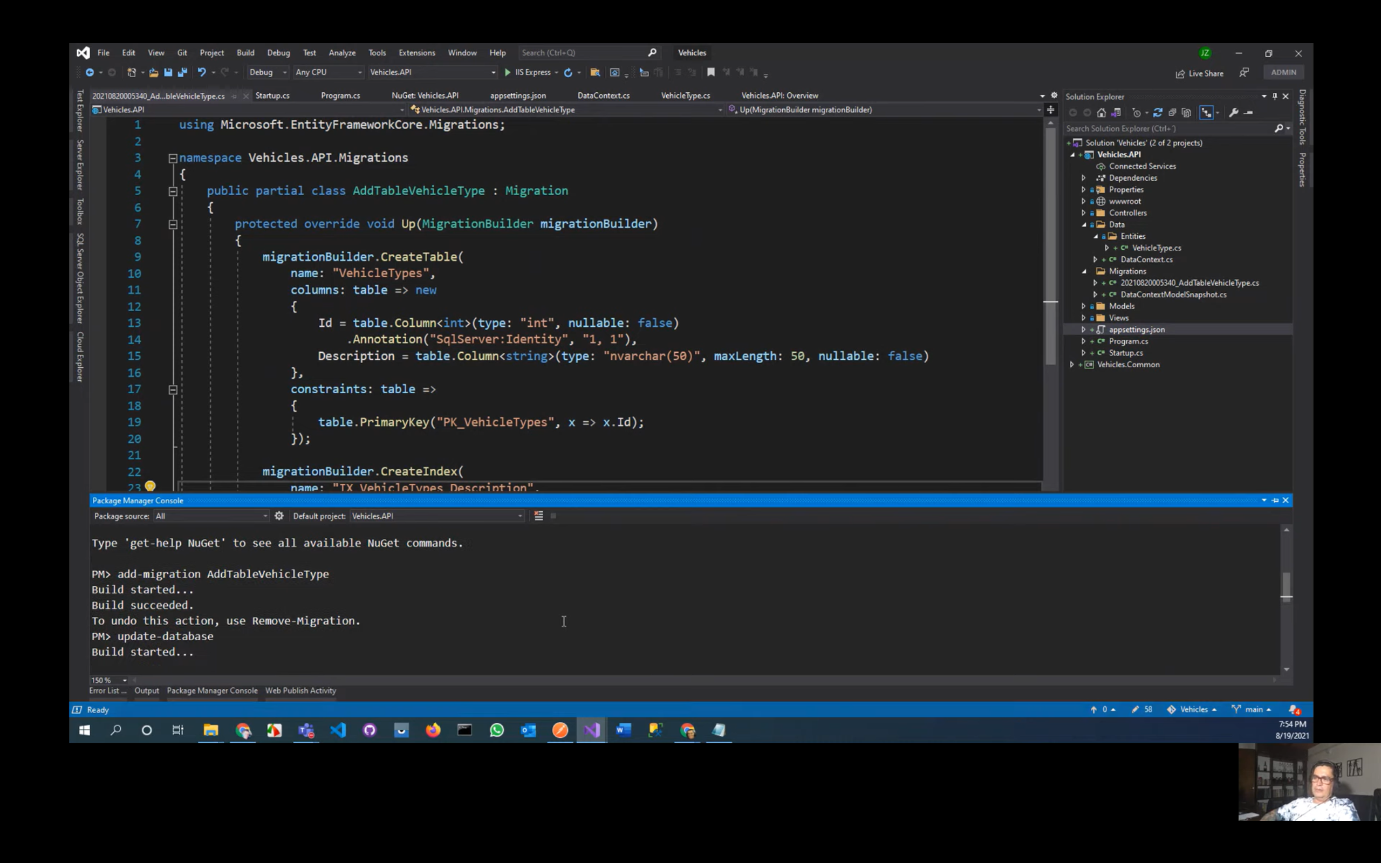

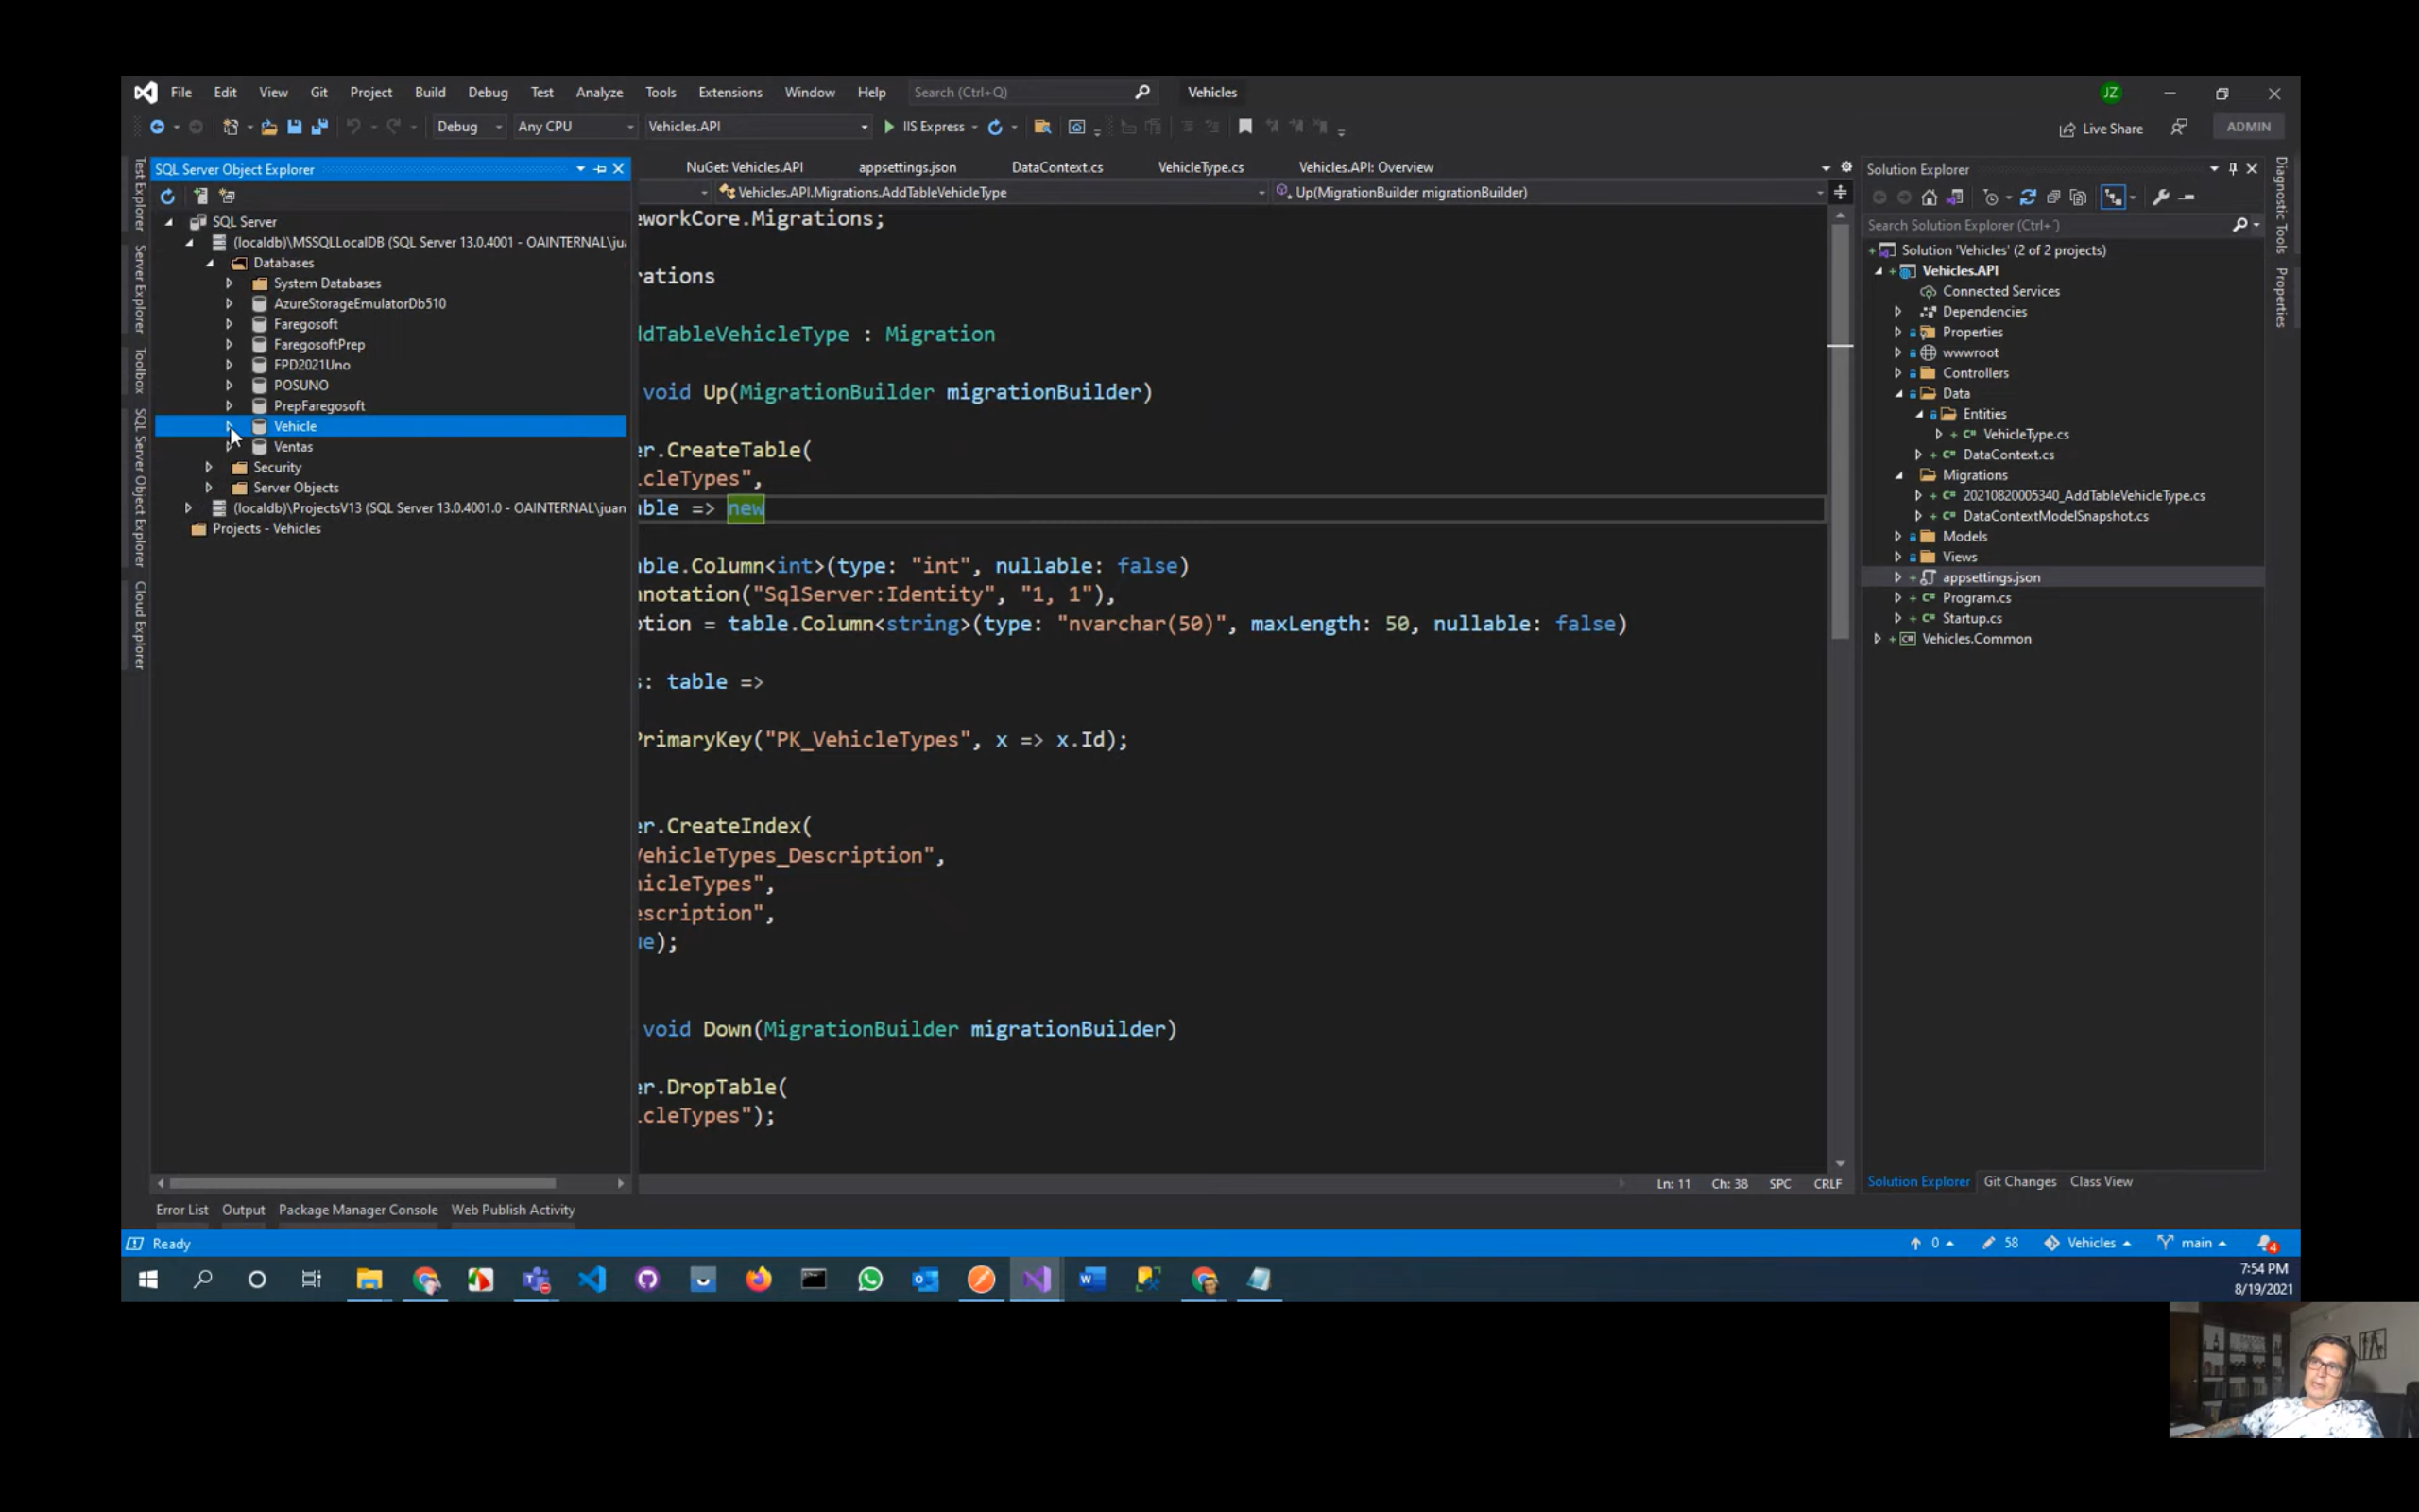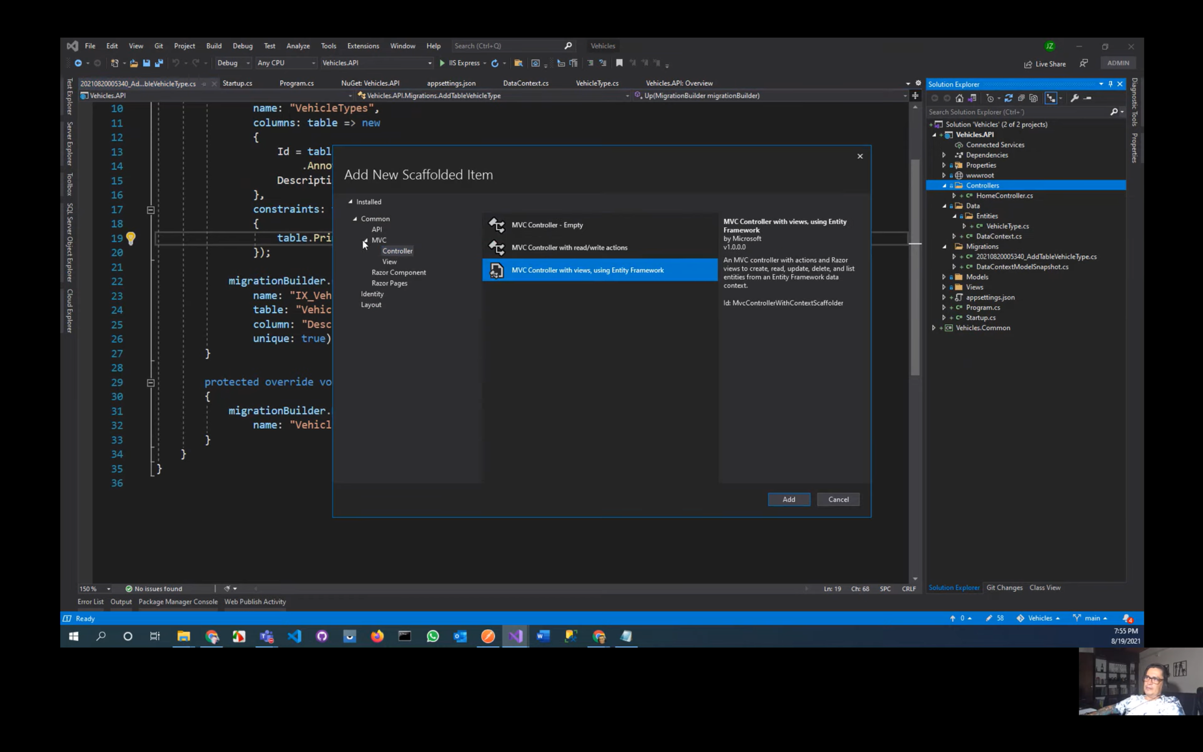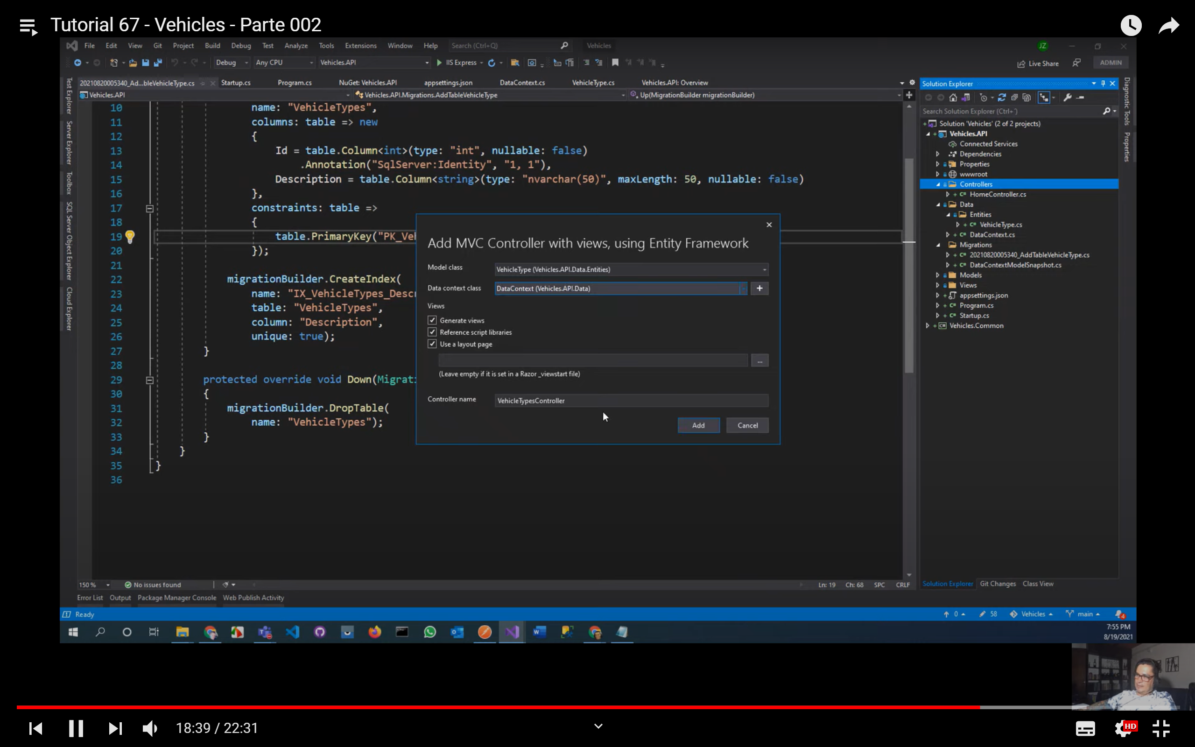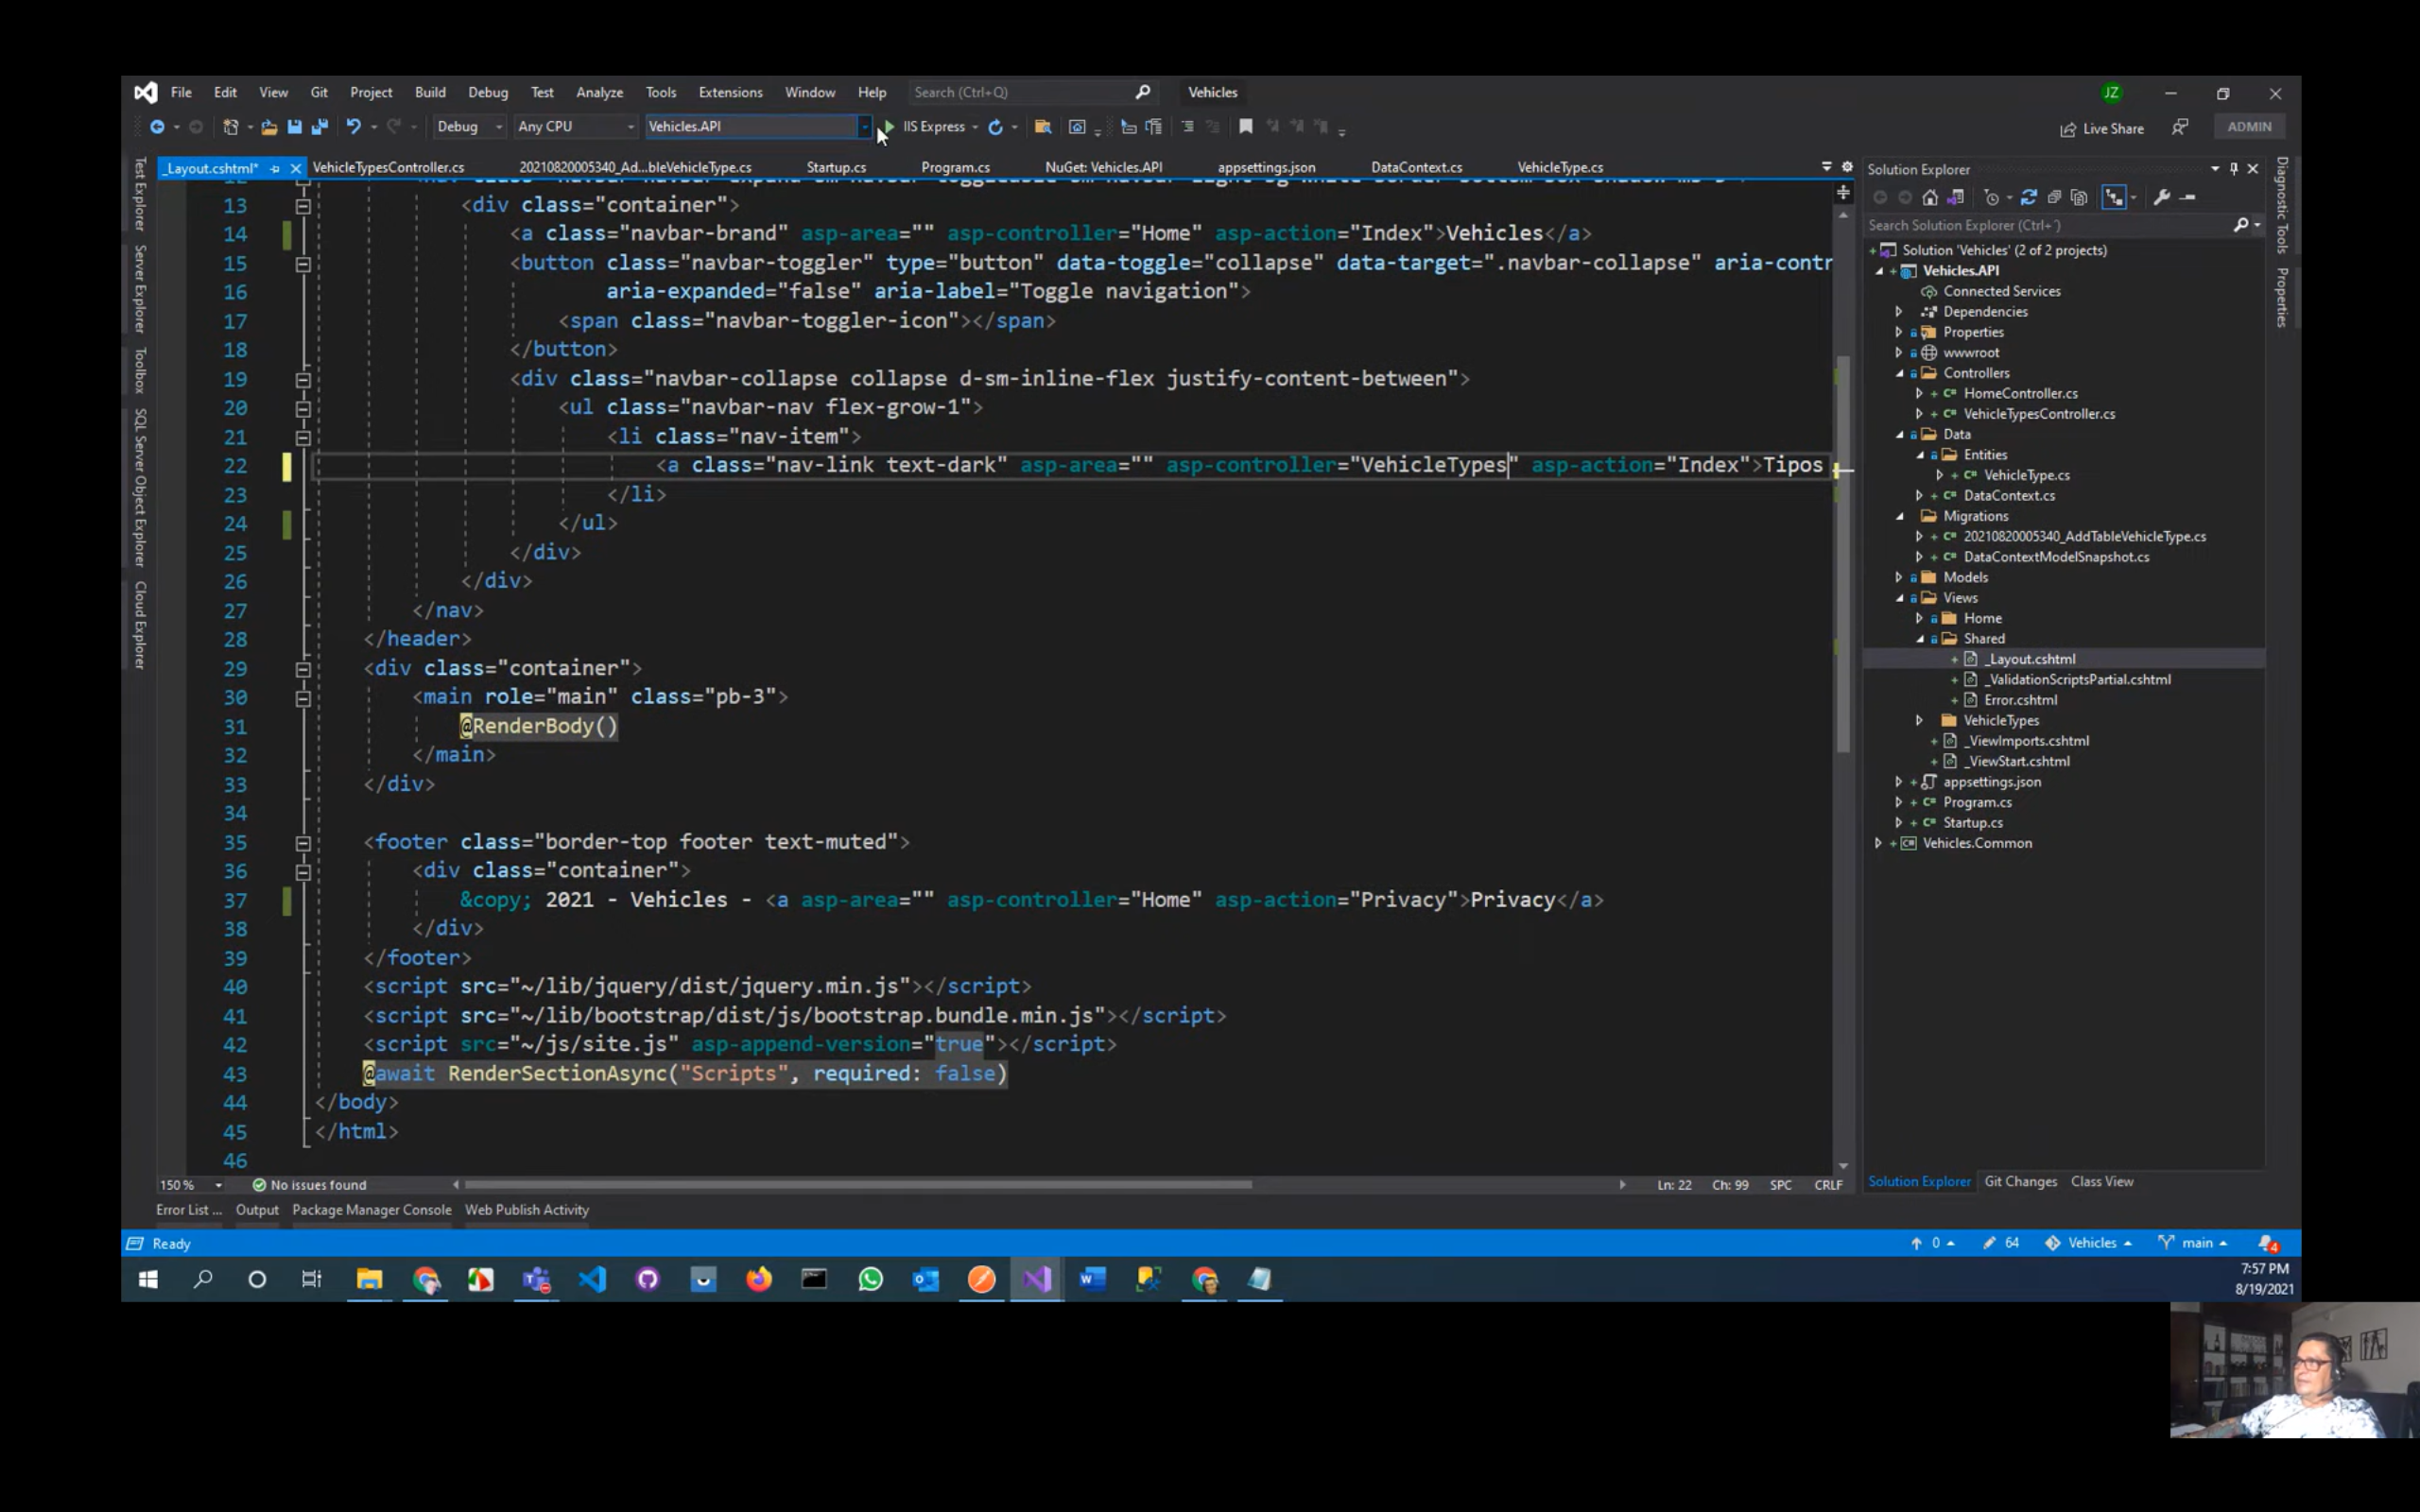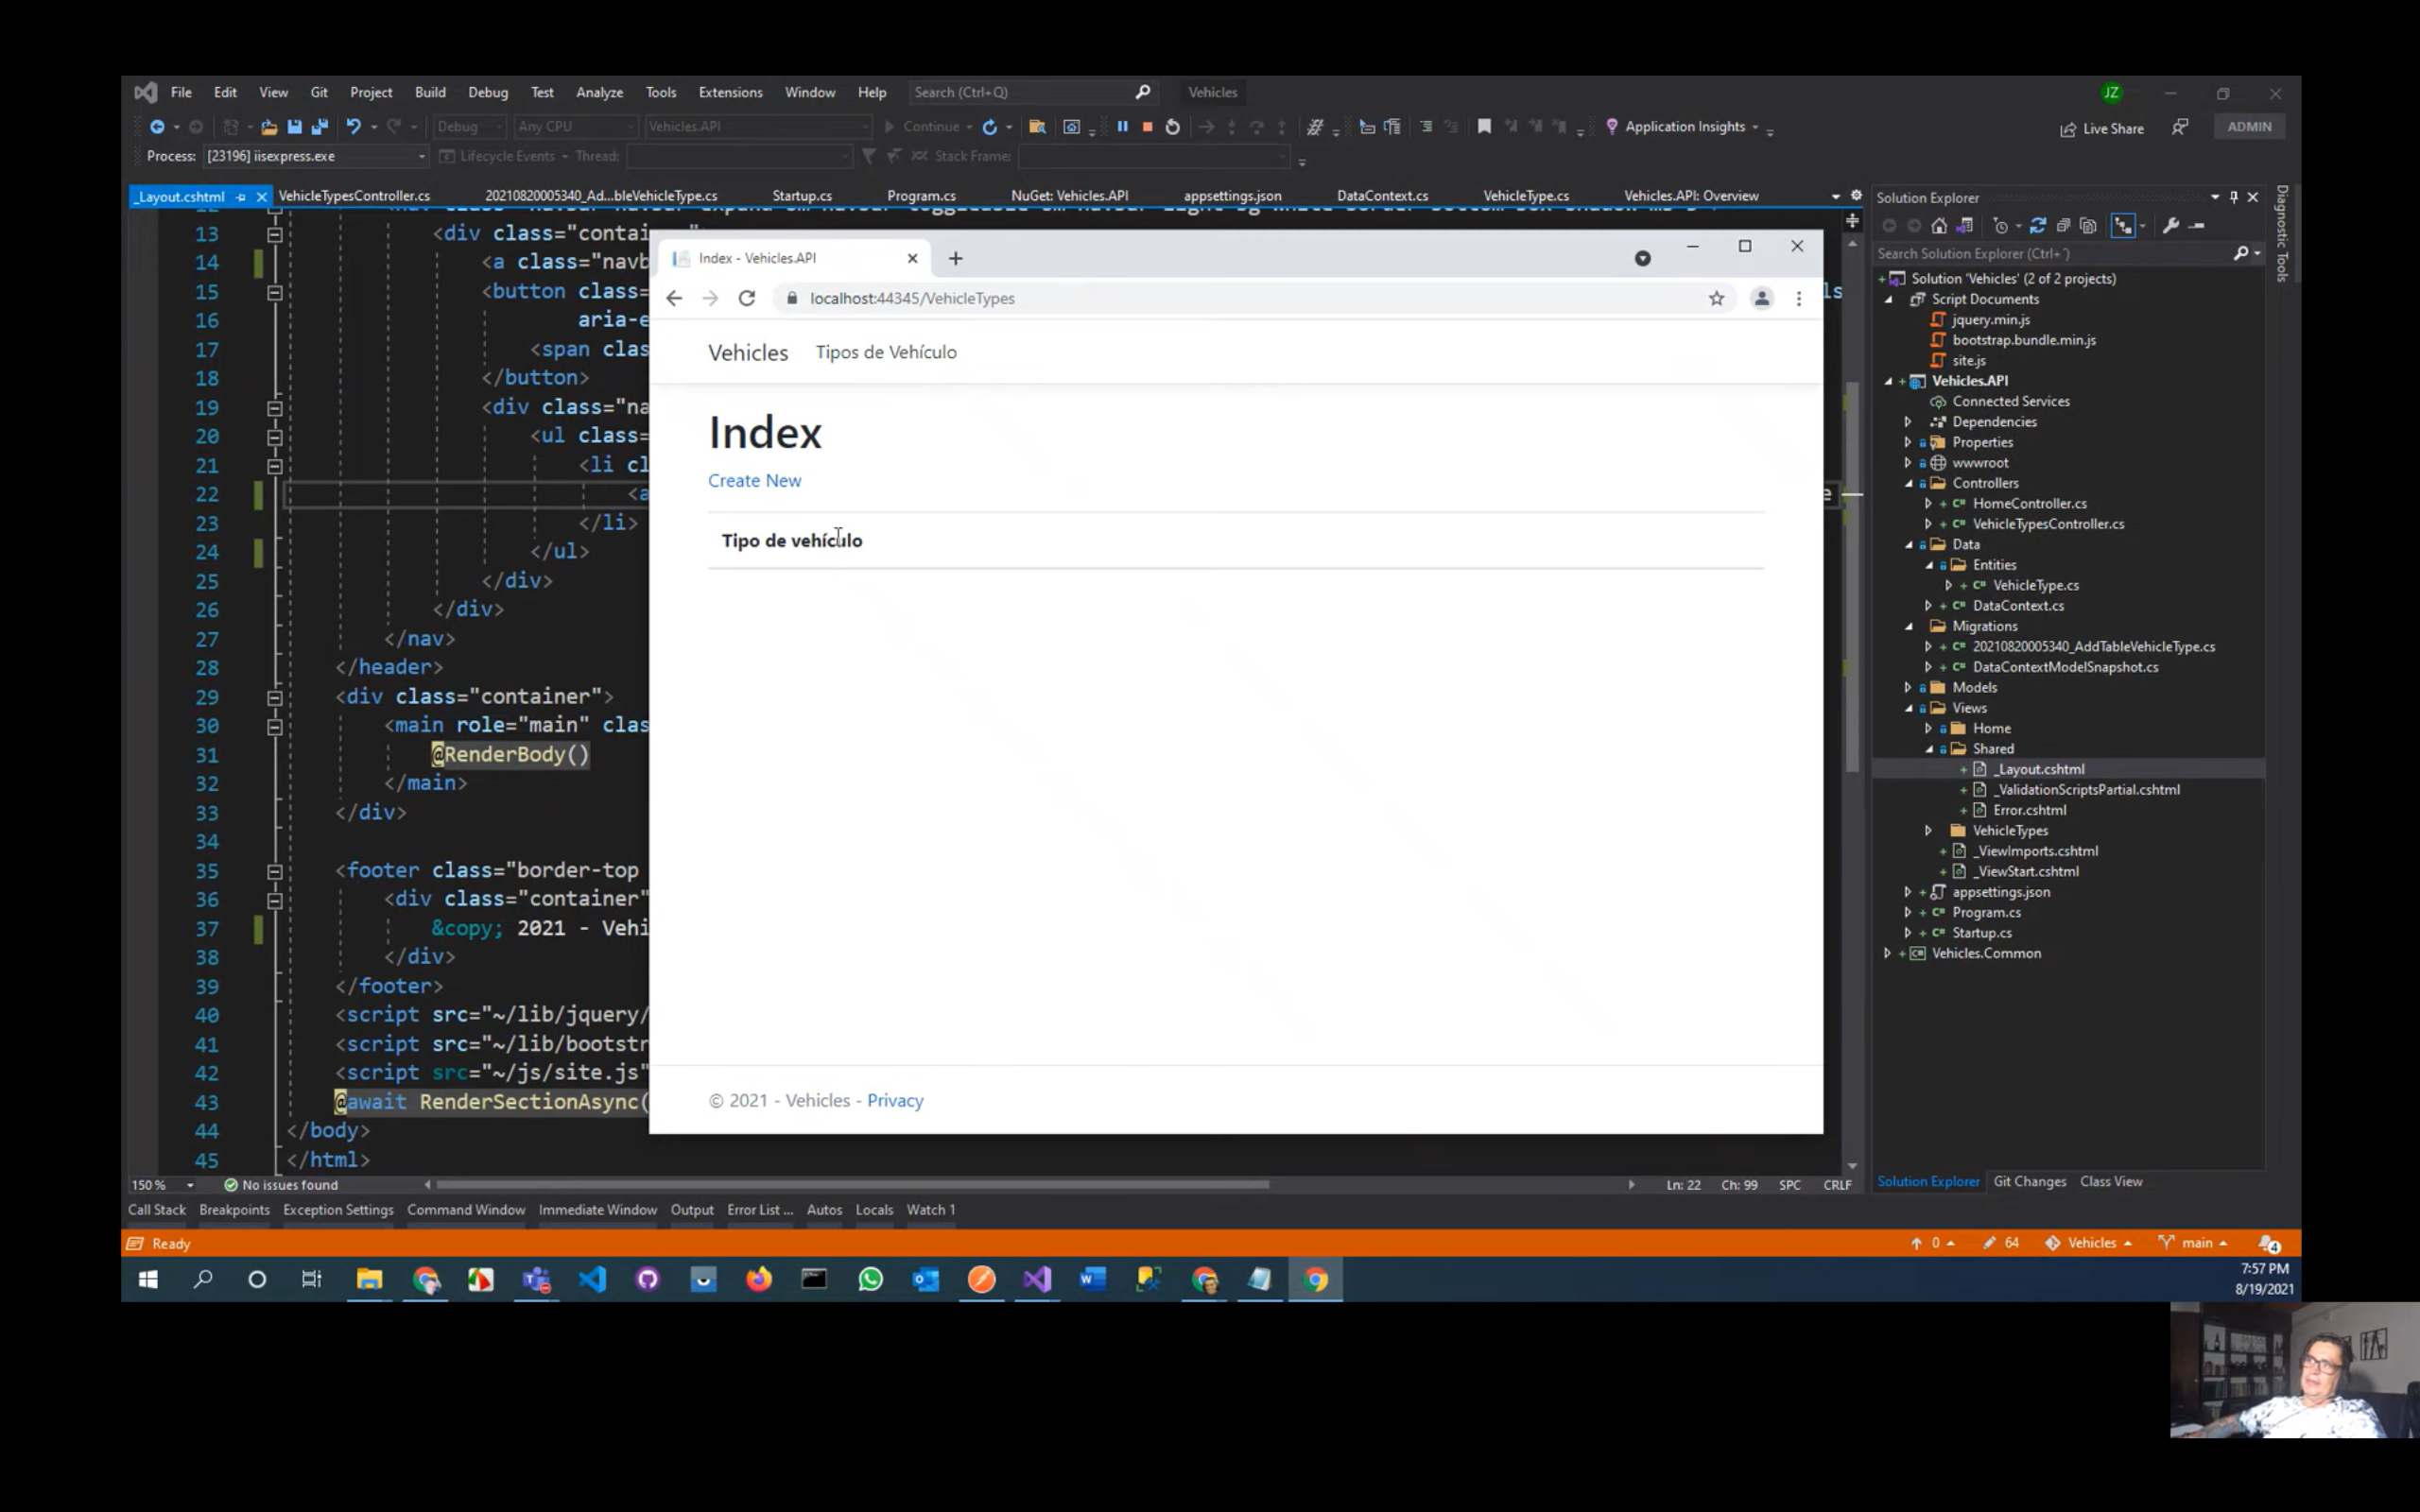

# Video 3 estilos a las page y delete

Dar estilo a las page y dar estilo a tabla

Opcional para dar estilo a la tabla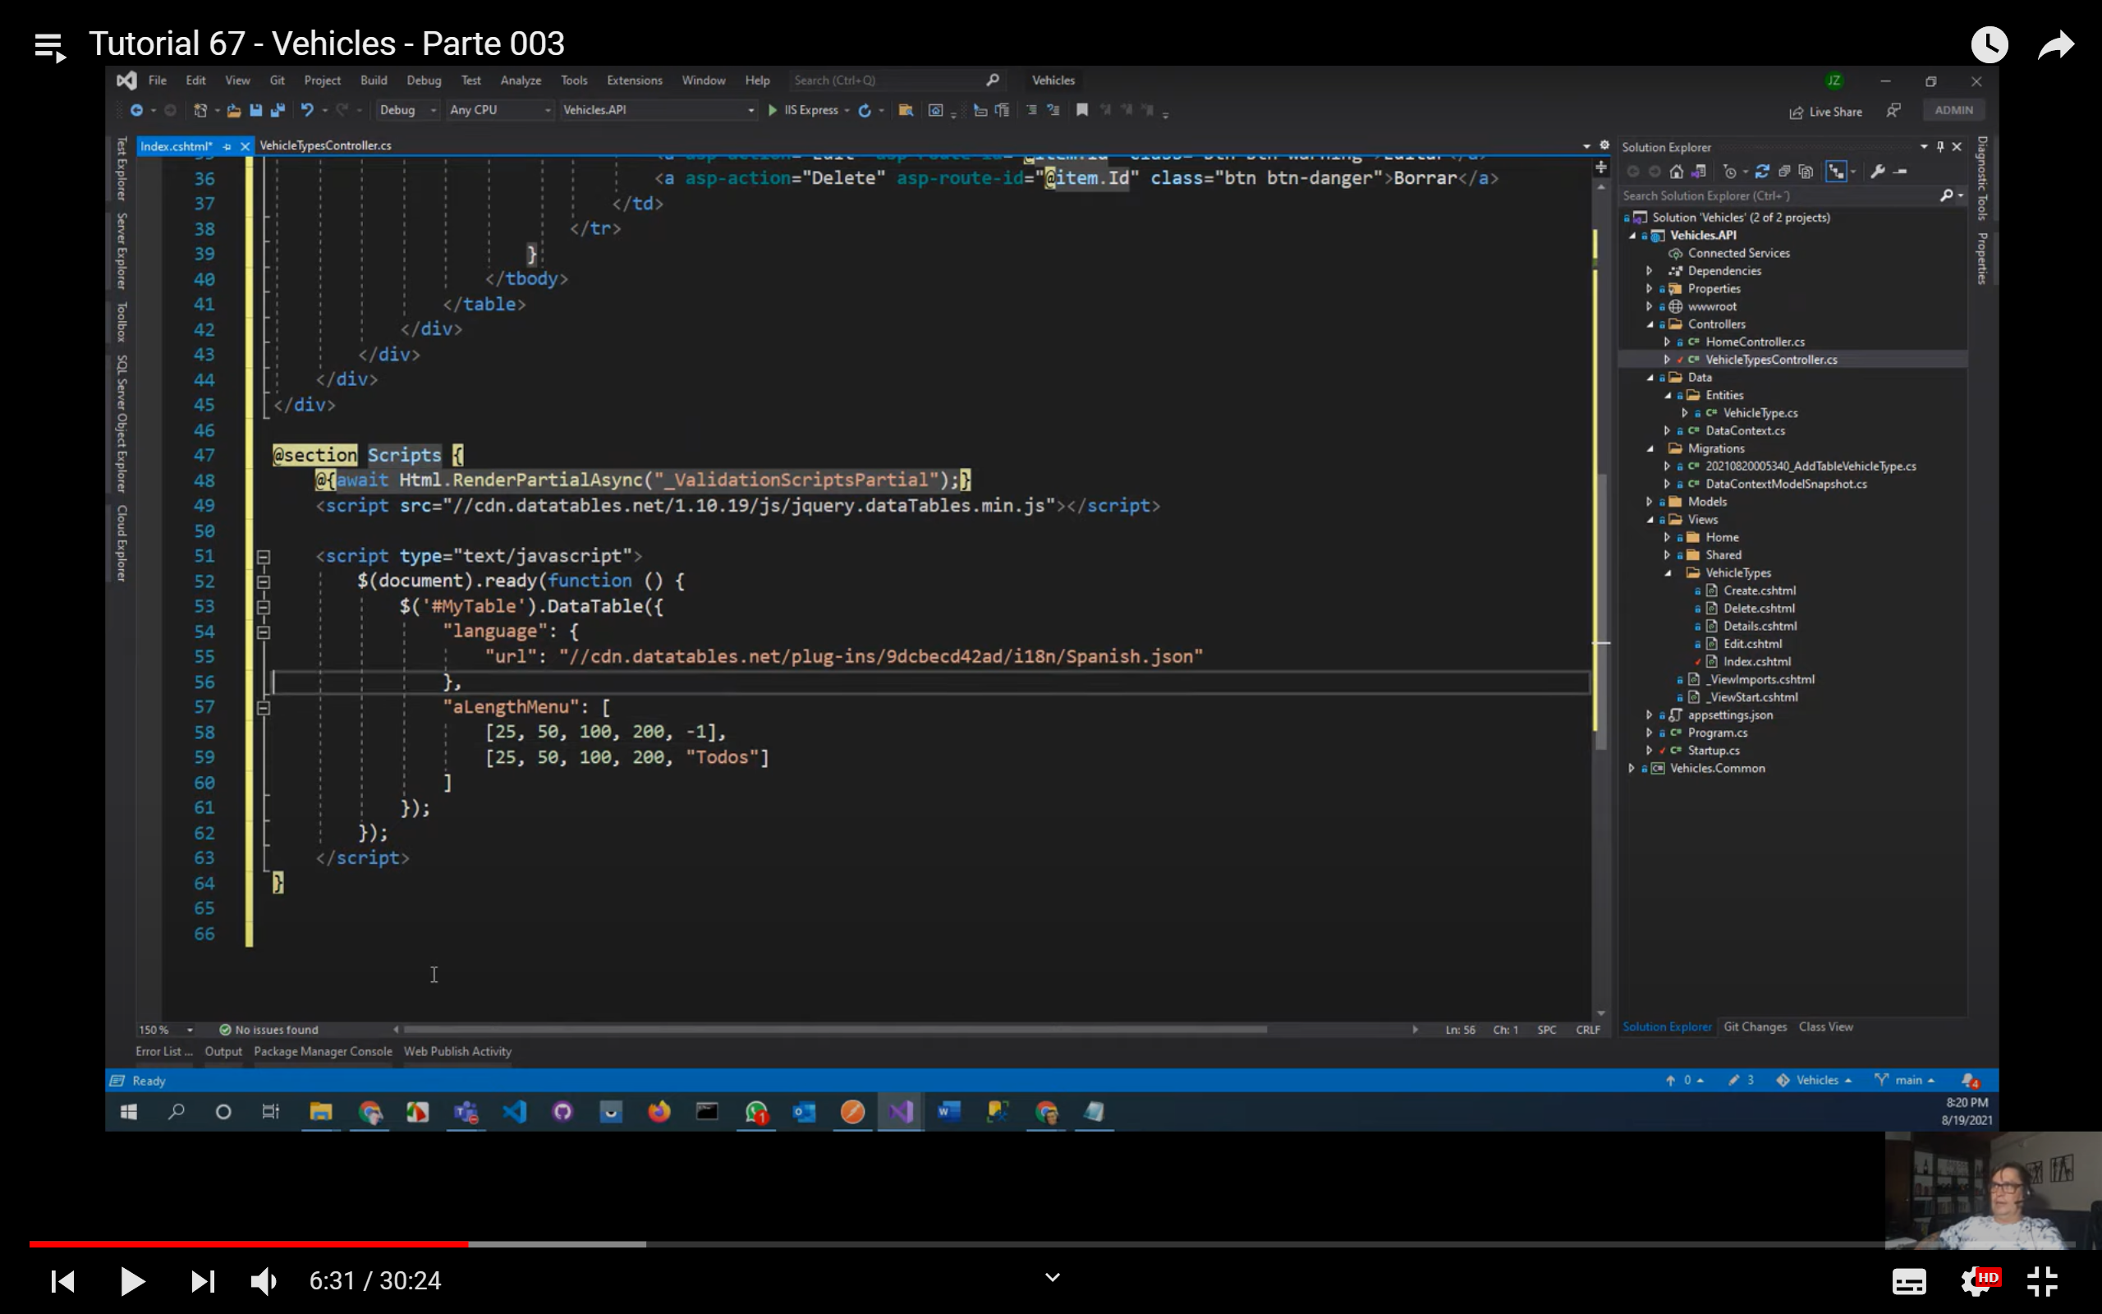

Eliminar el details del controller y de la vista

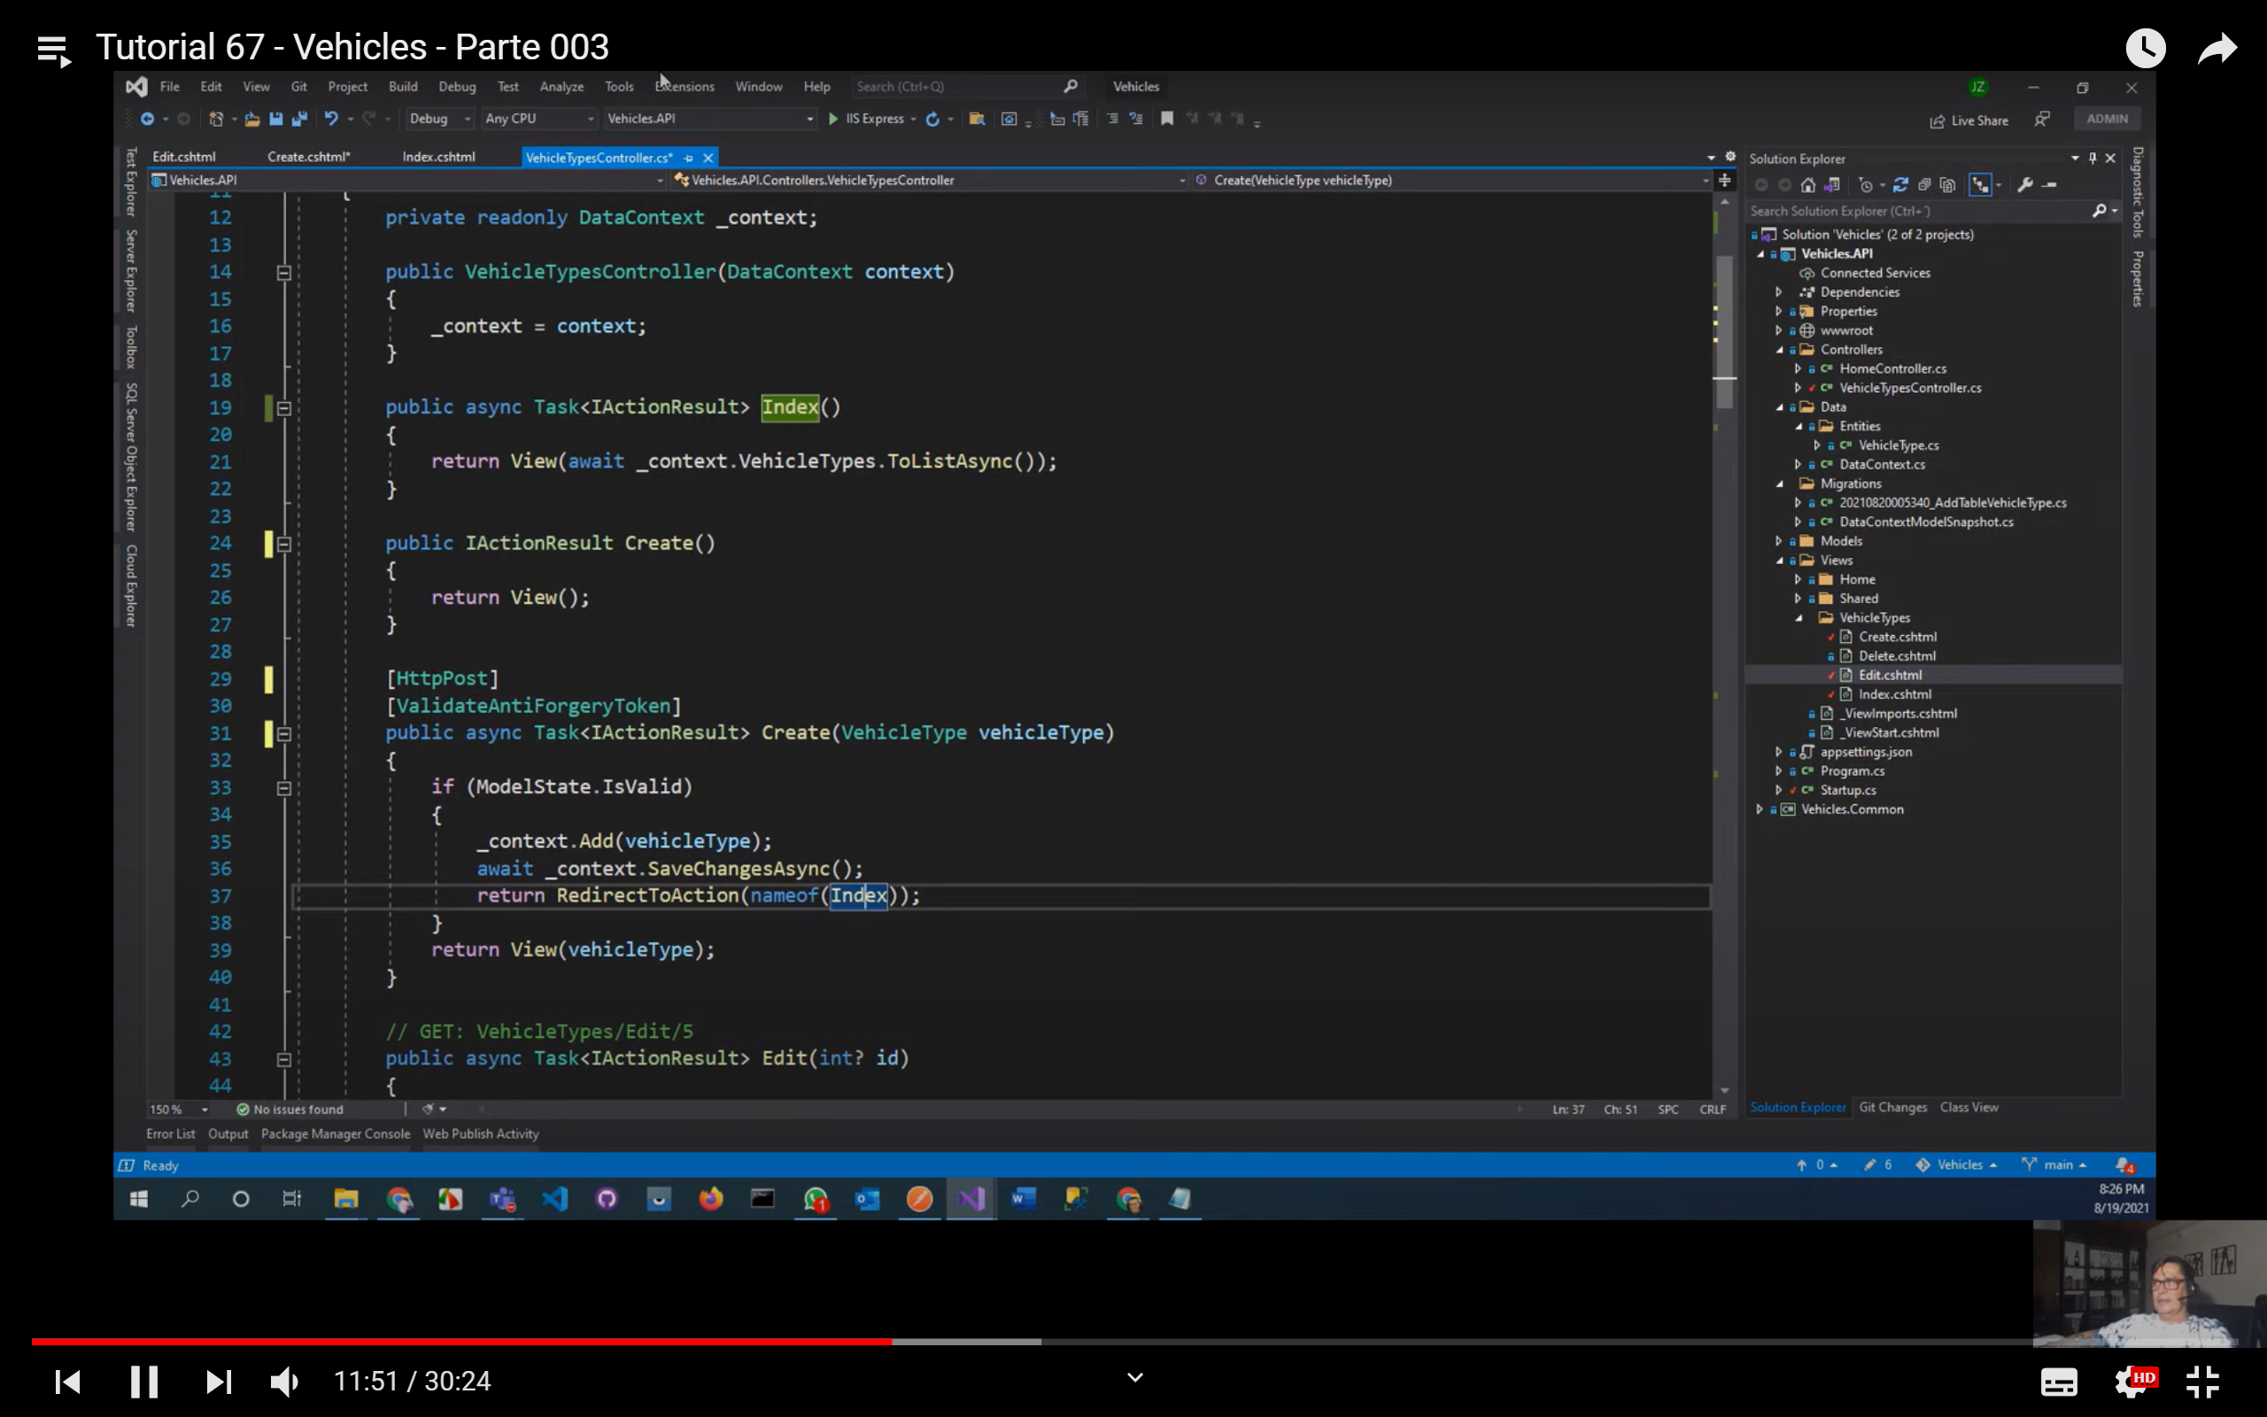

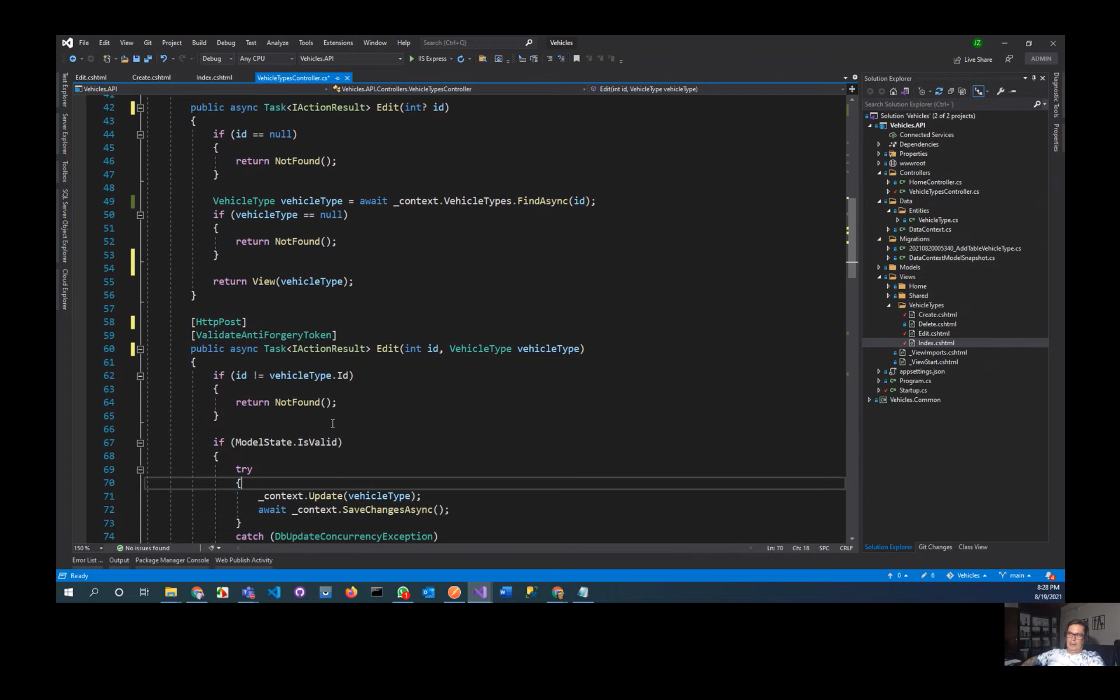

Dar estilo al delete

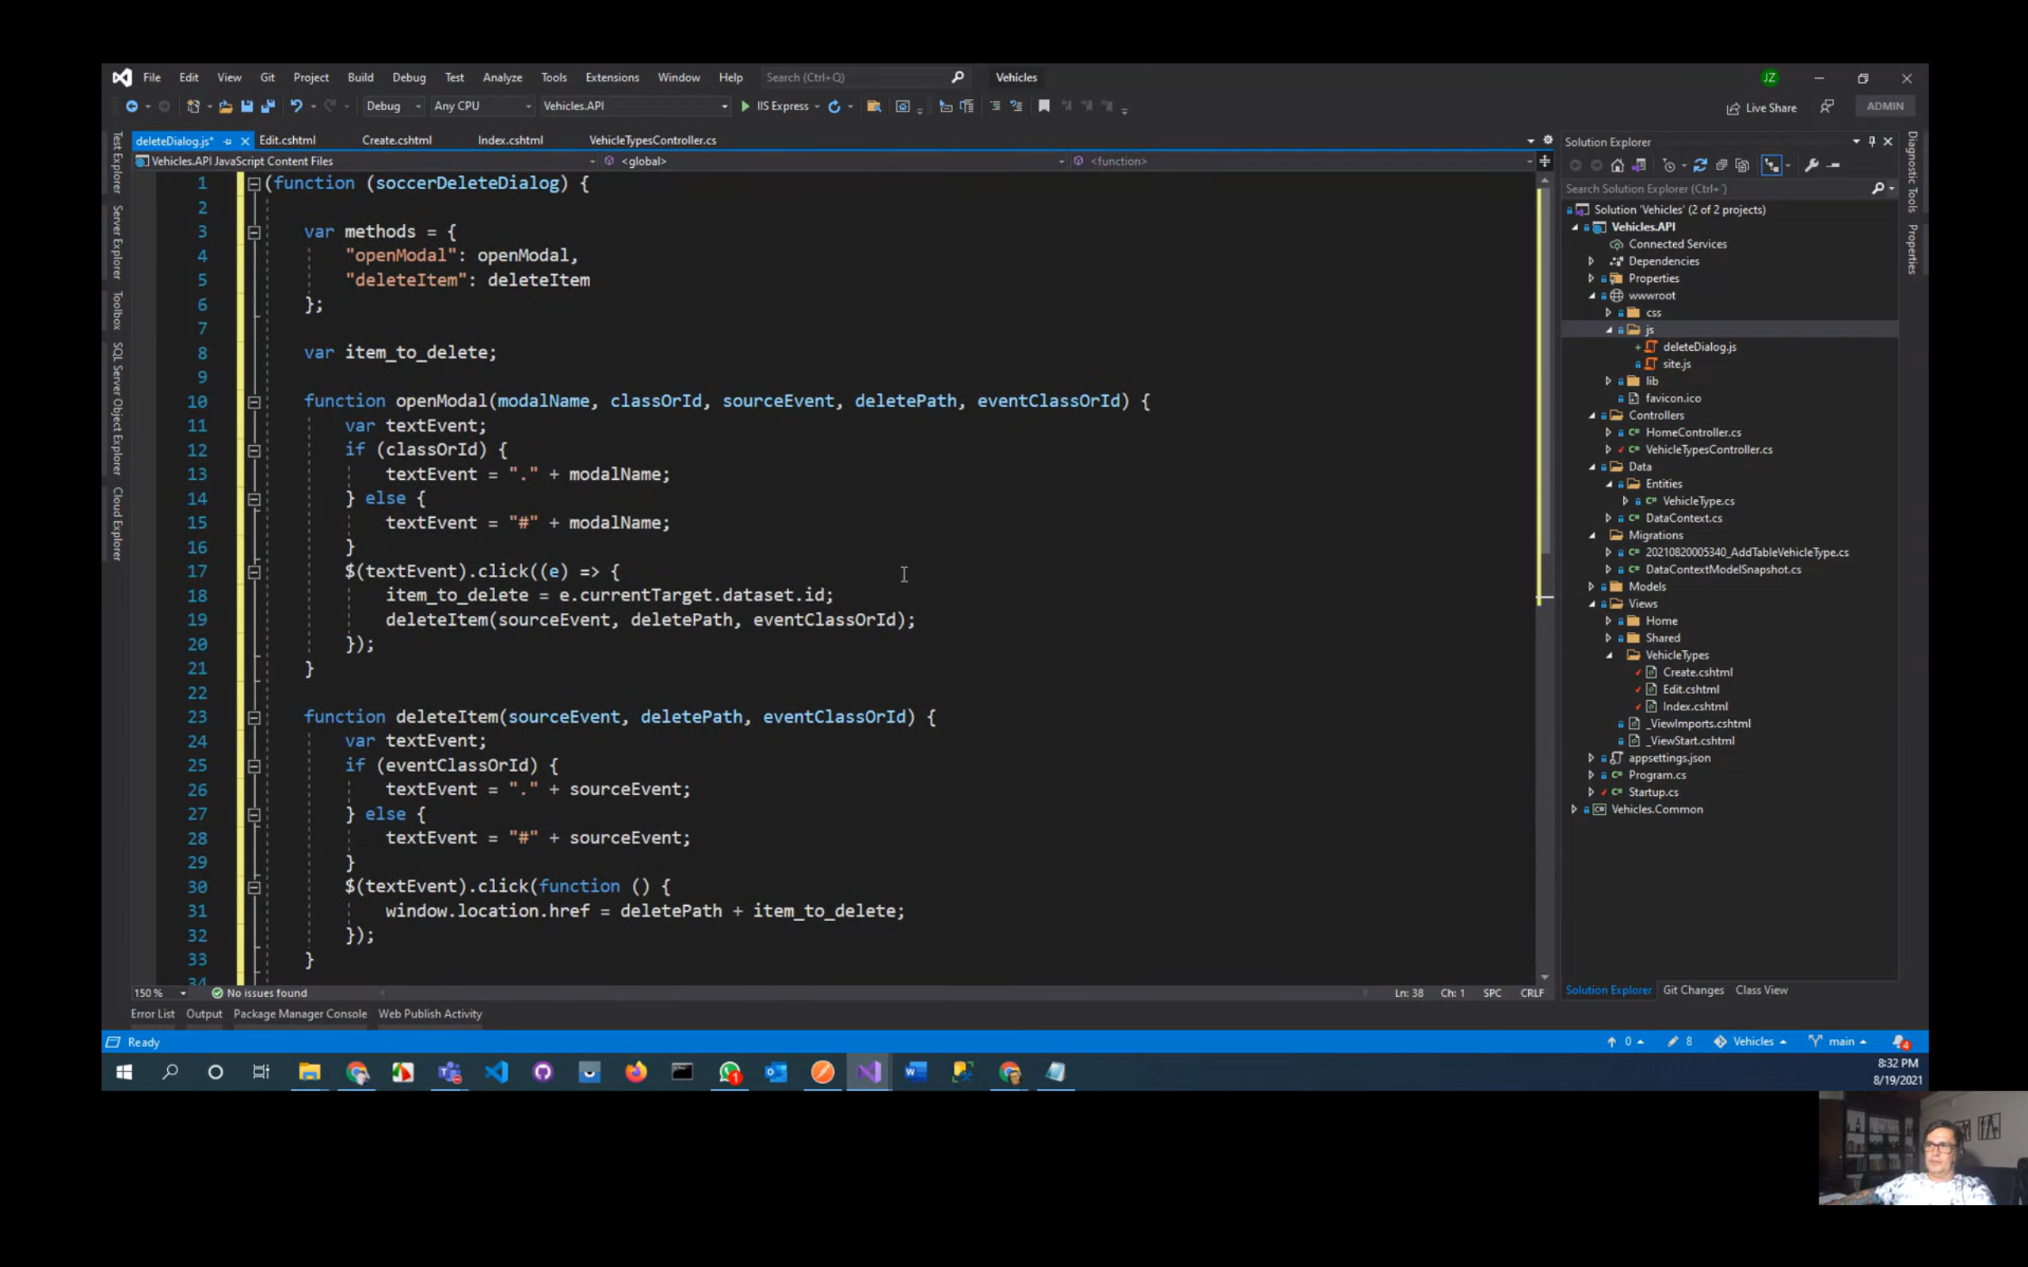

Crear una vista parcial en View-Sher

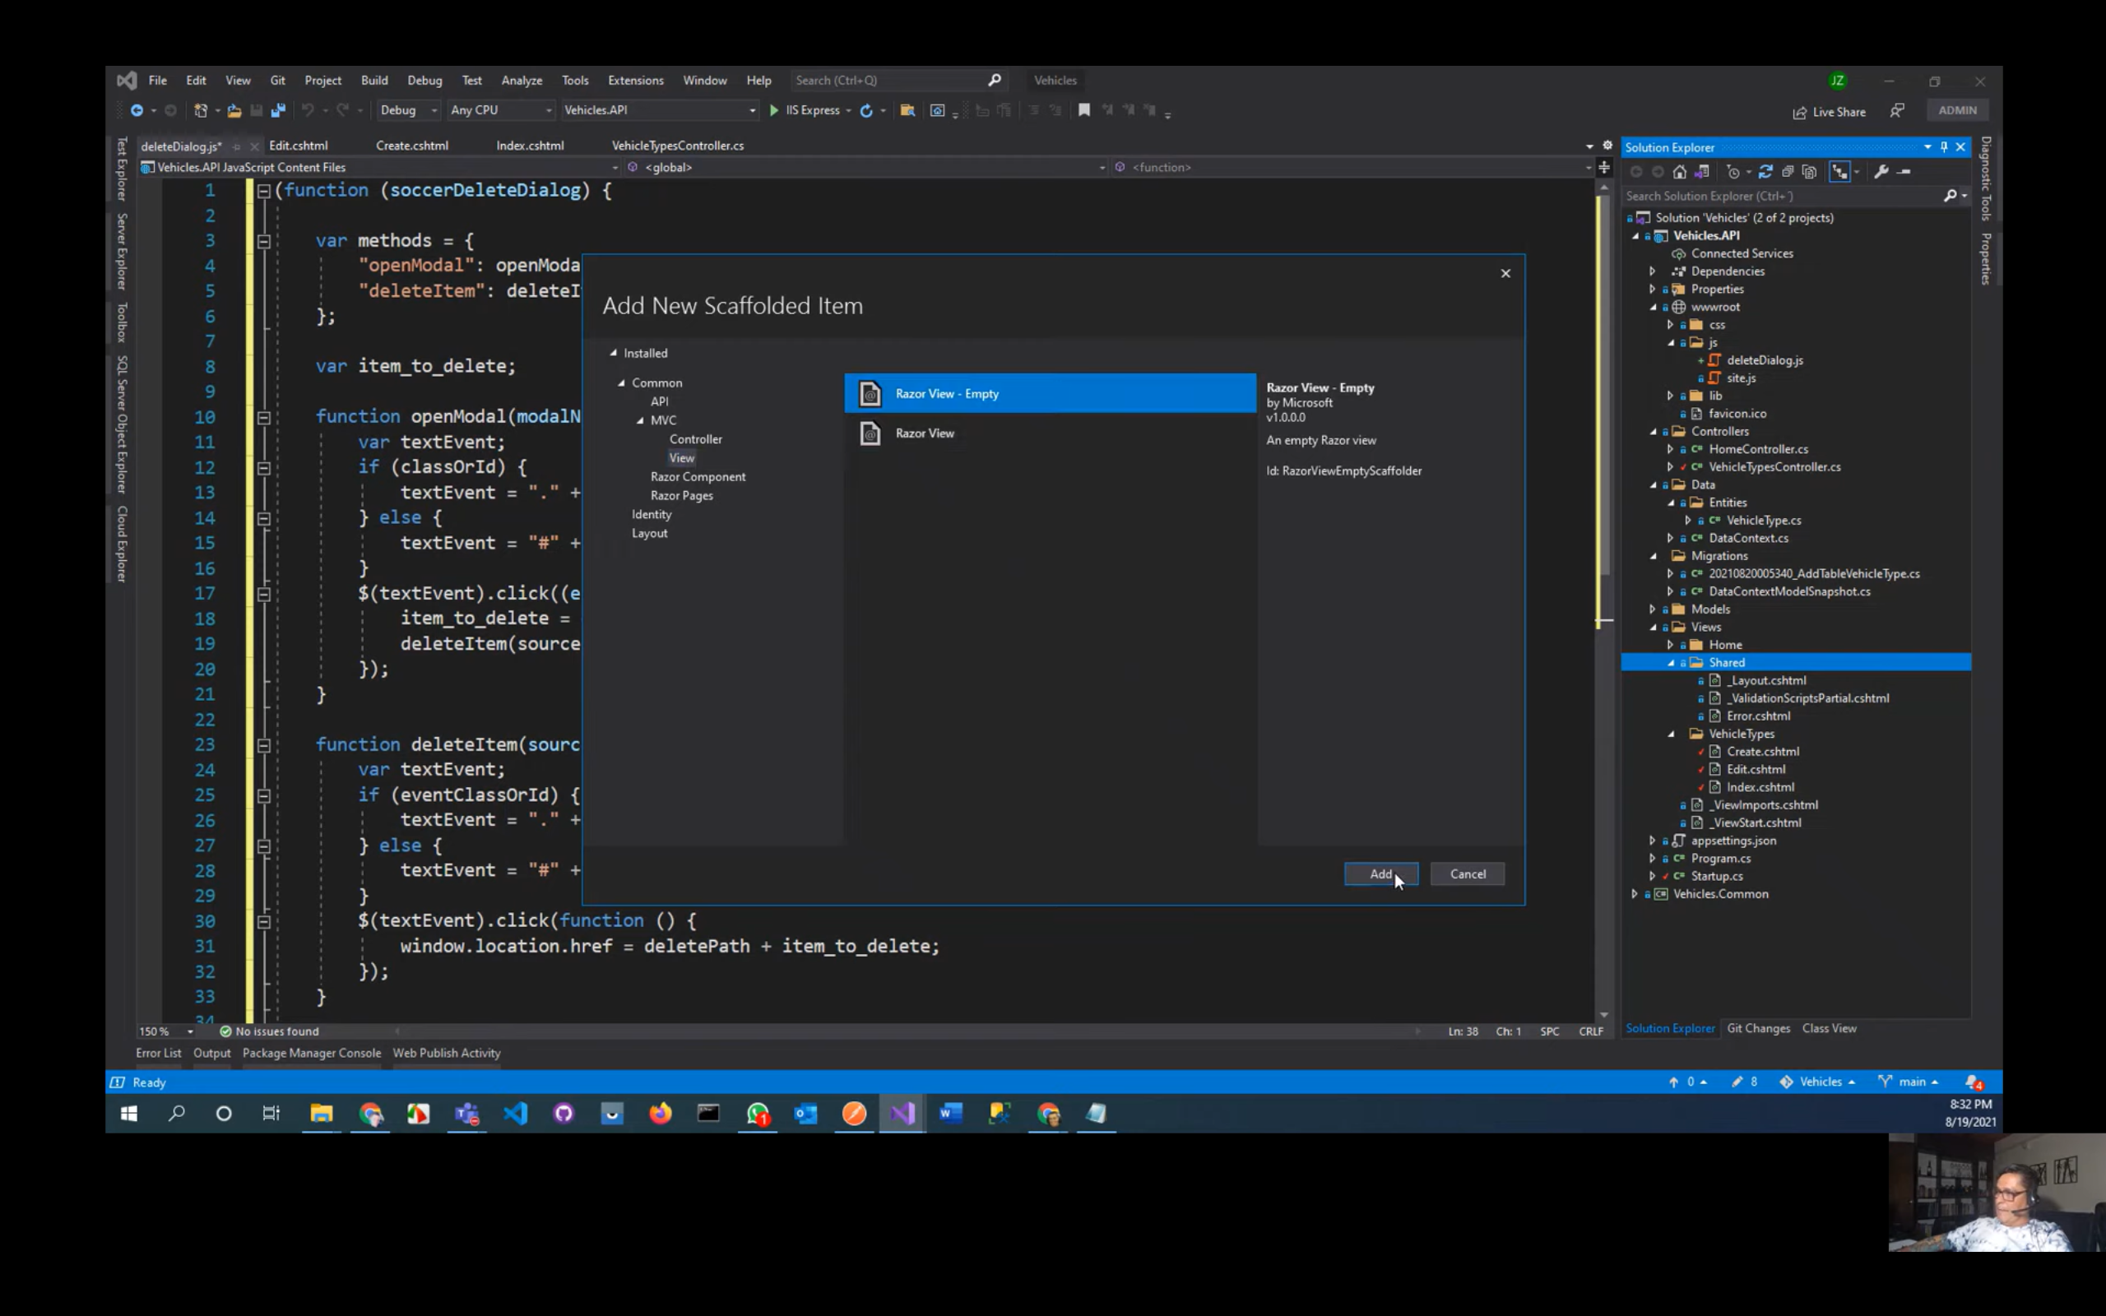

Crear vista parcial para repetir en la carpeta shared para no redundar los mismos campos

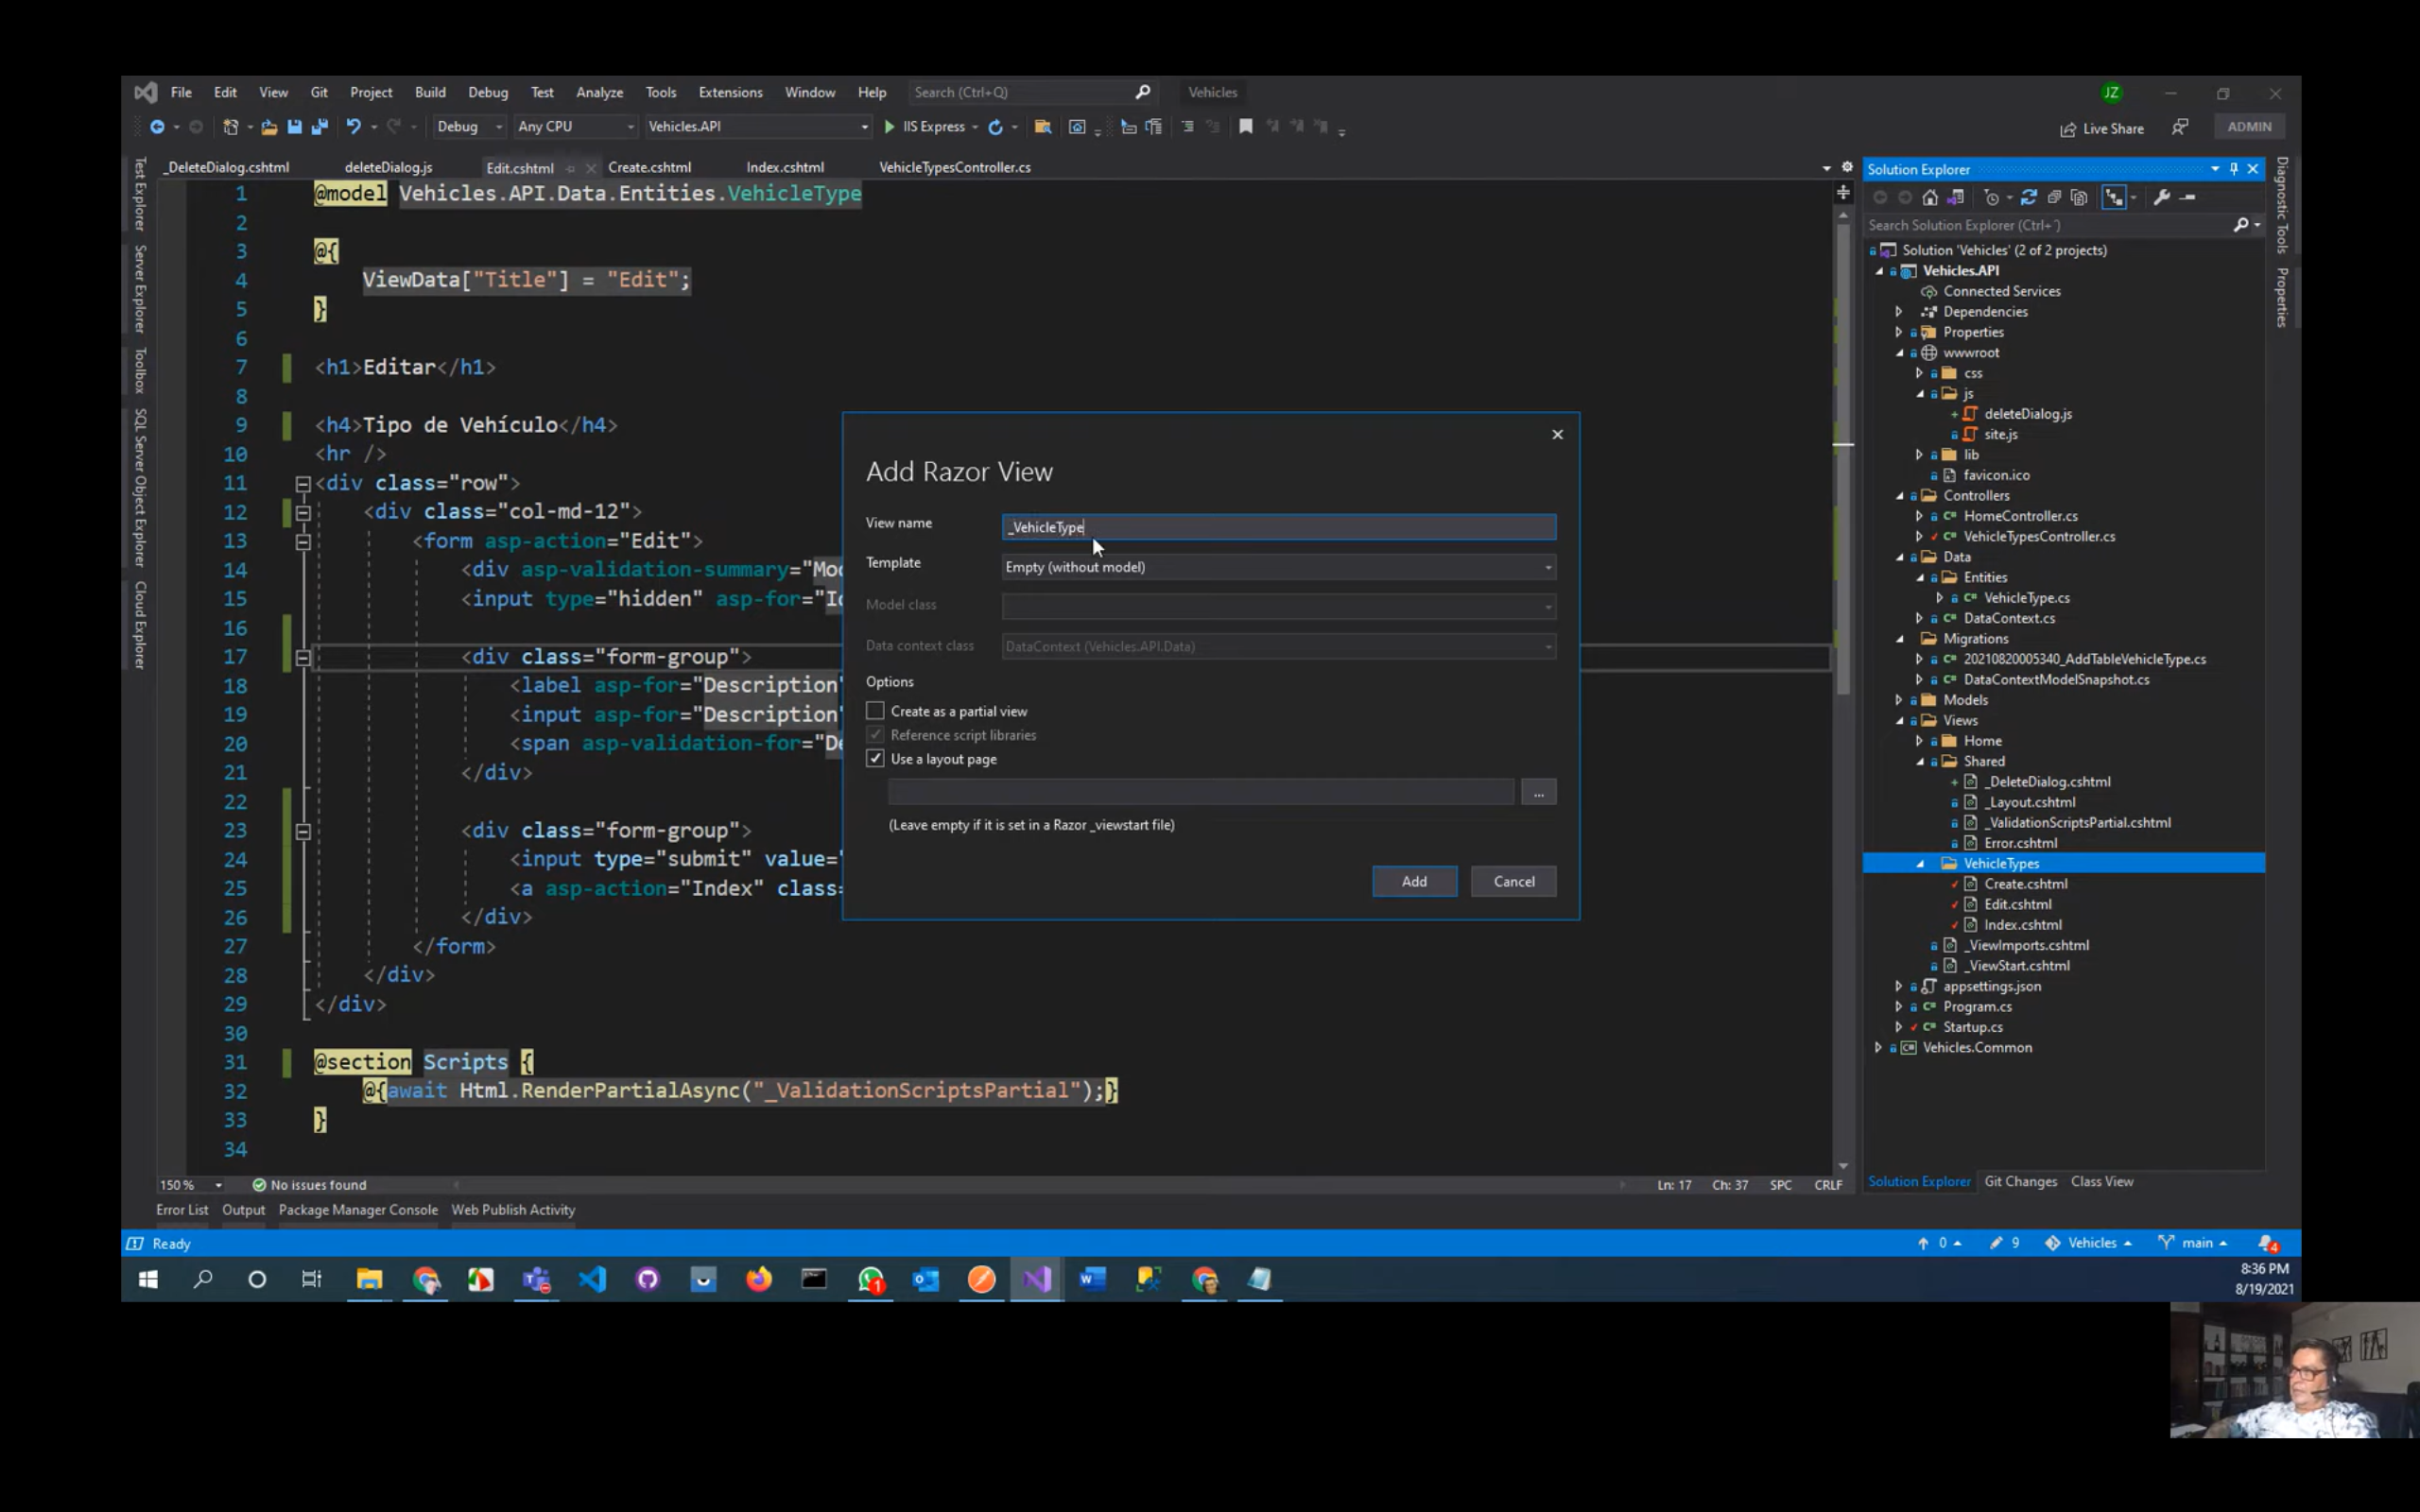

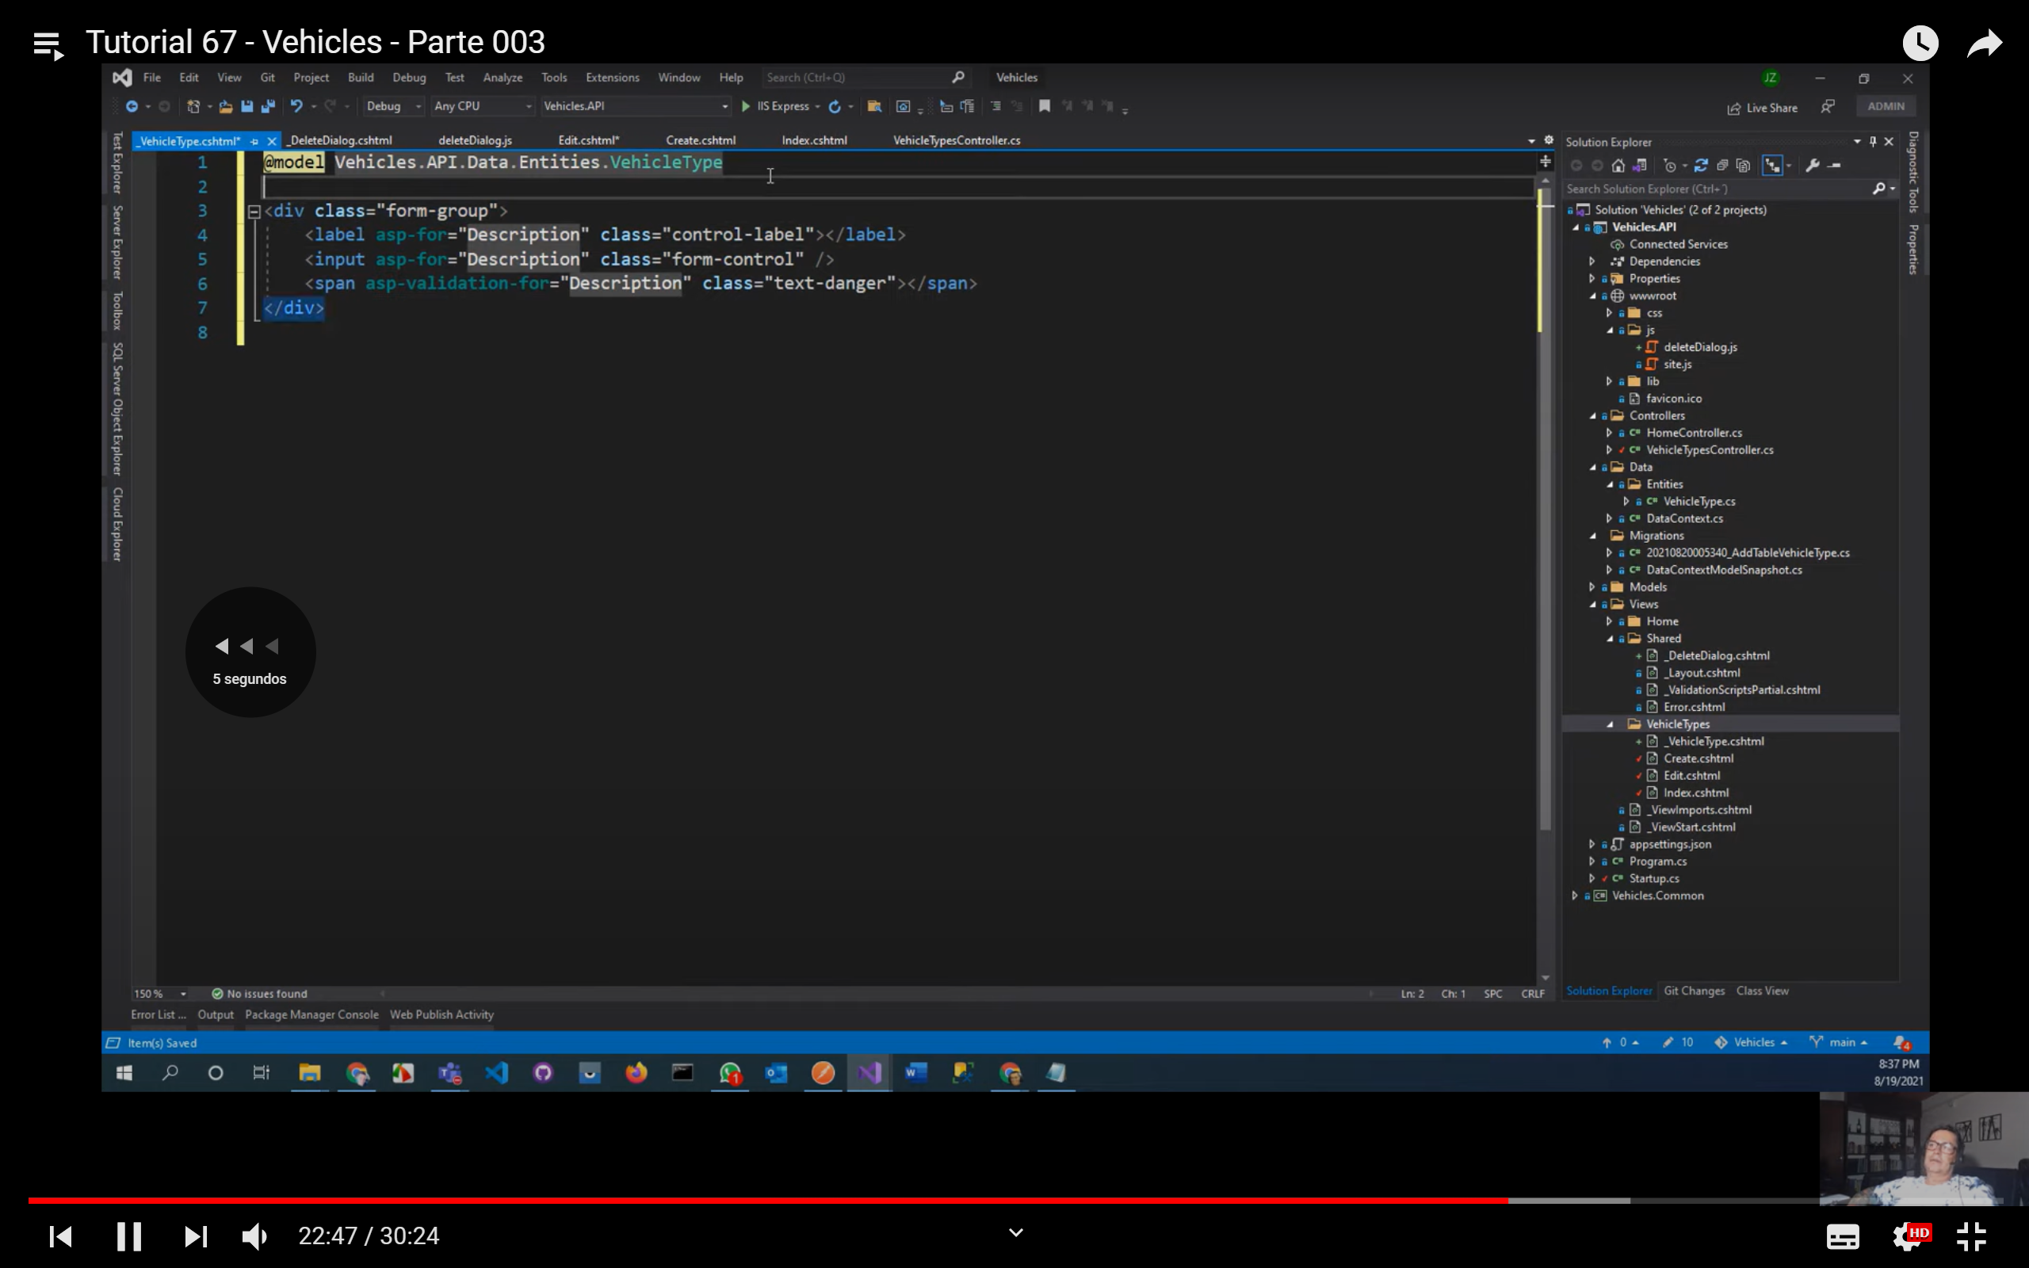

La vista parcial reutilizar en créate y edit

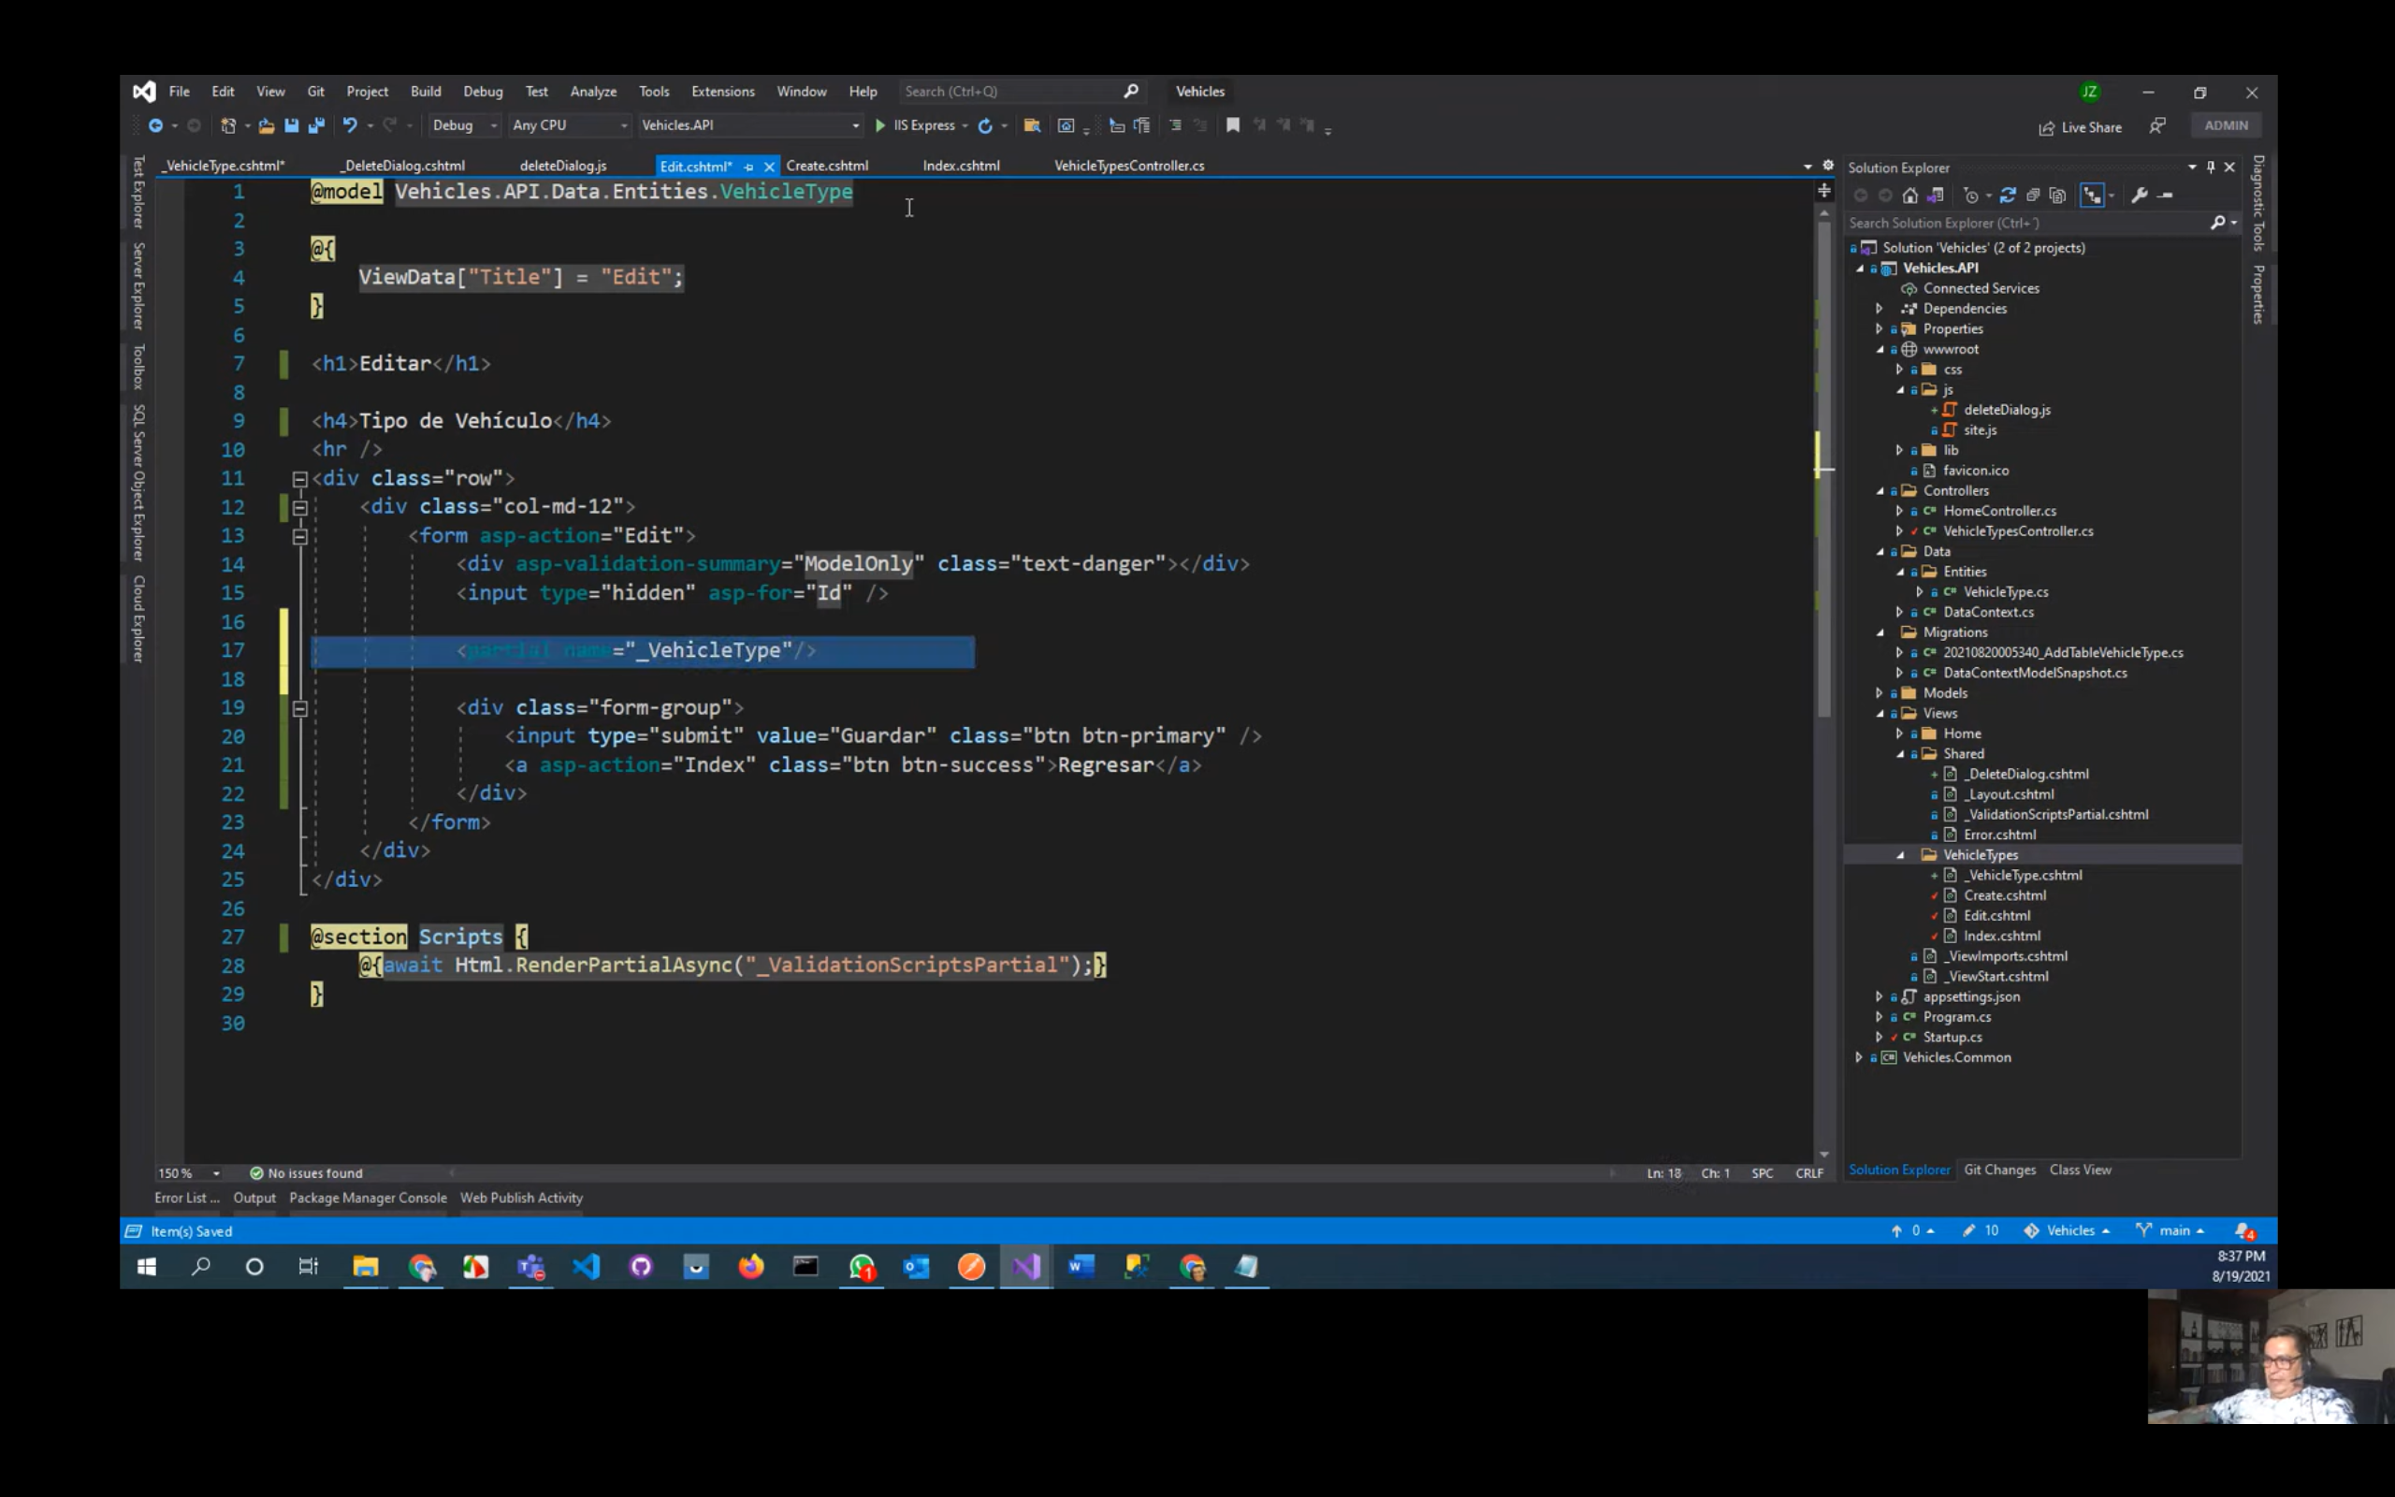

Utilizar ctrl + k + s para utilizar el try cash

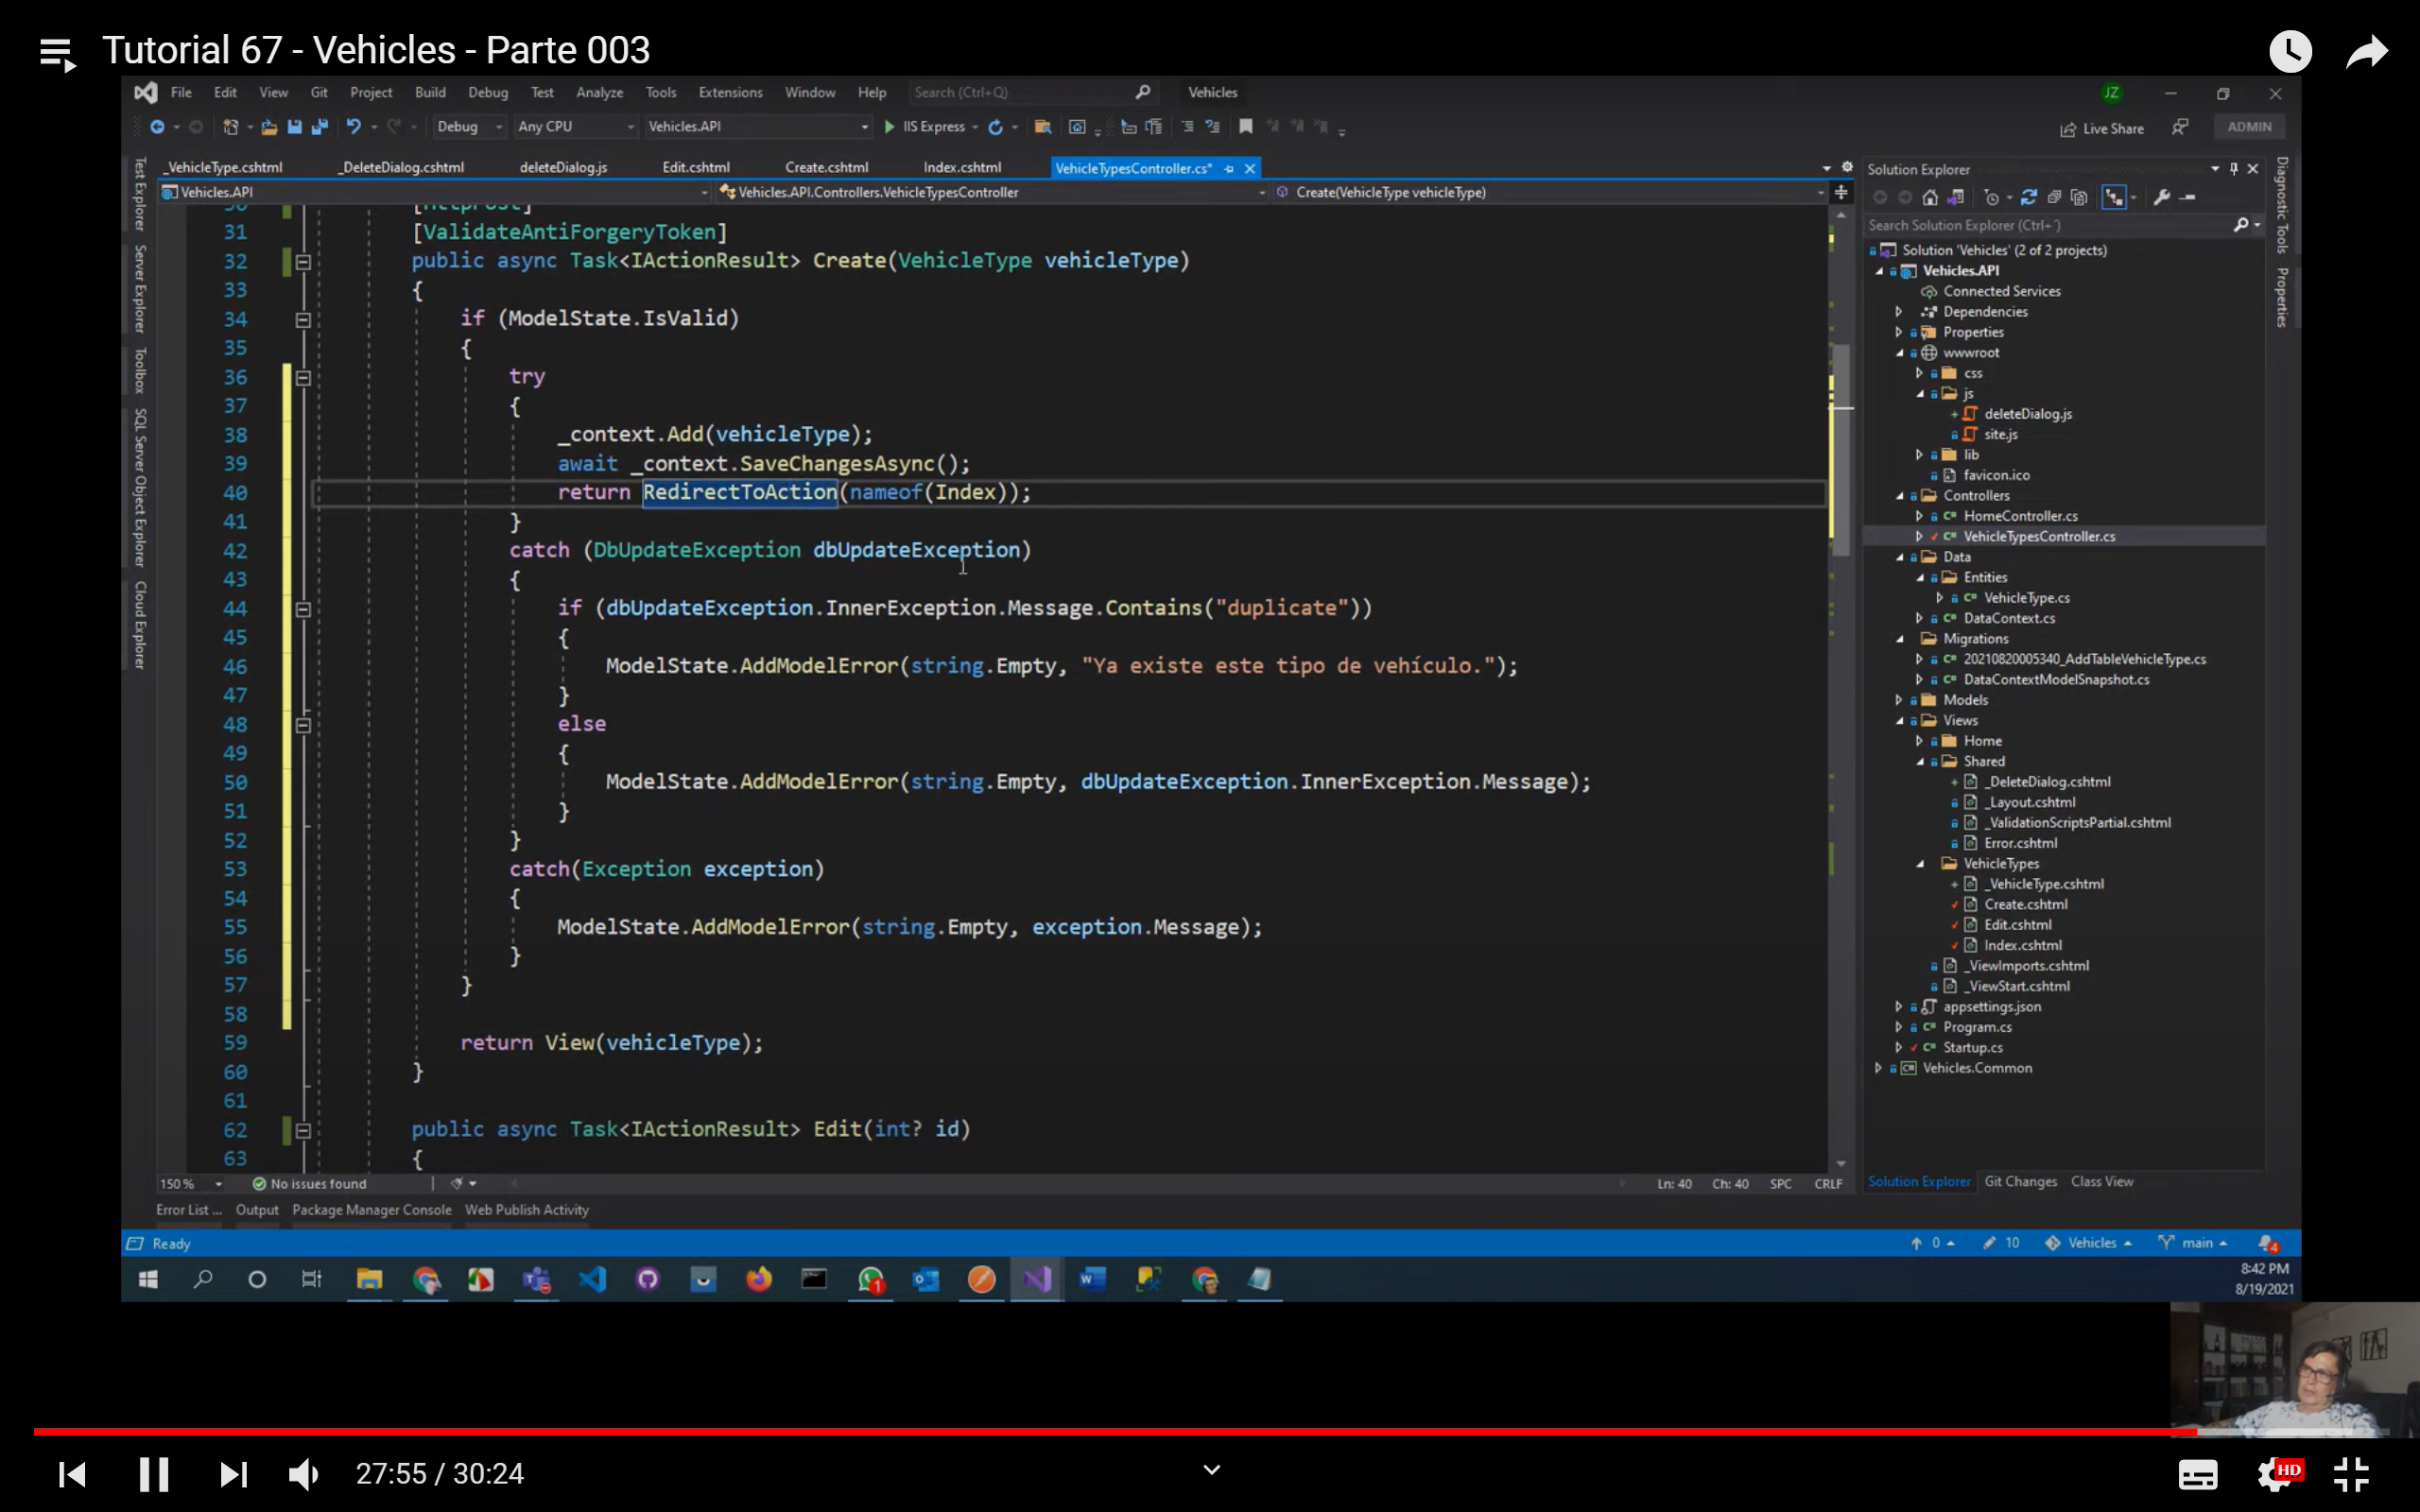

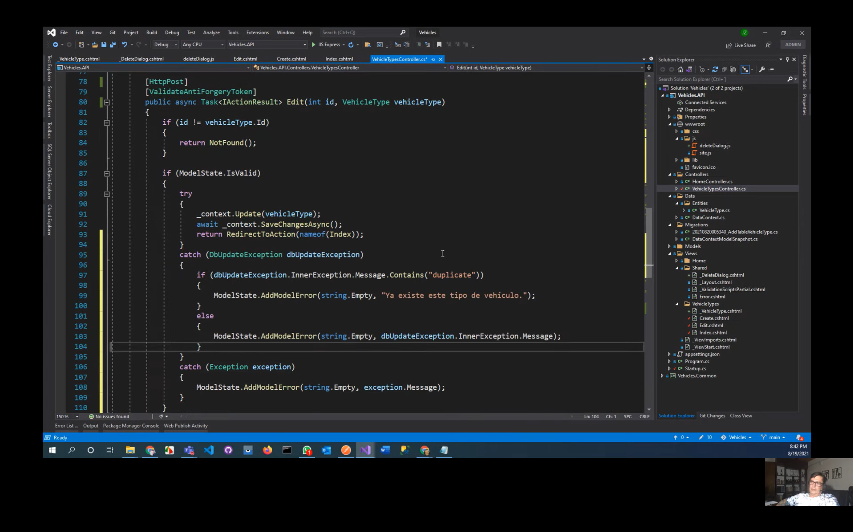

Ejecutar y verificar índices y duplicados

# Video 4 Entidad Procedure, DocumentType, Brand

Crear una entidad Procedure

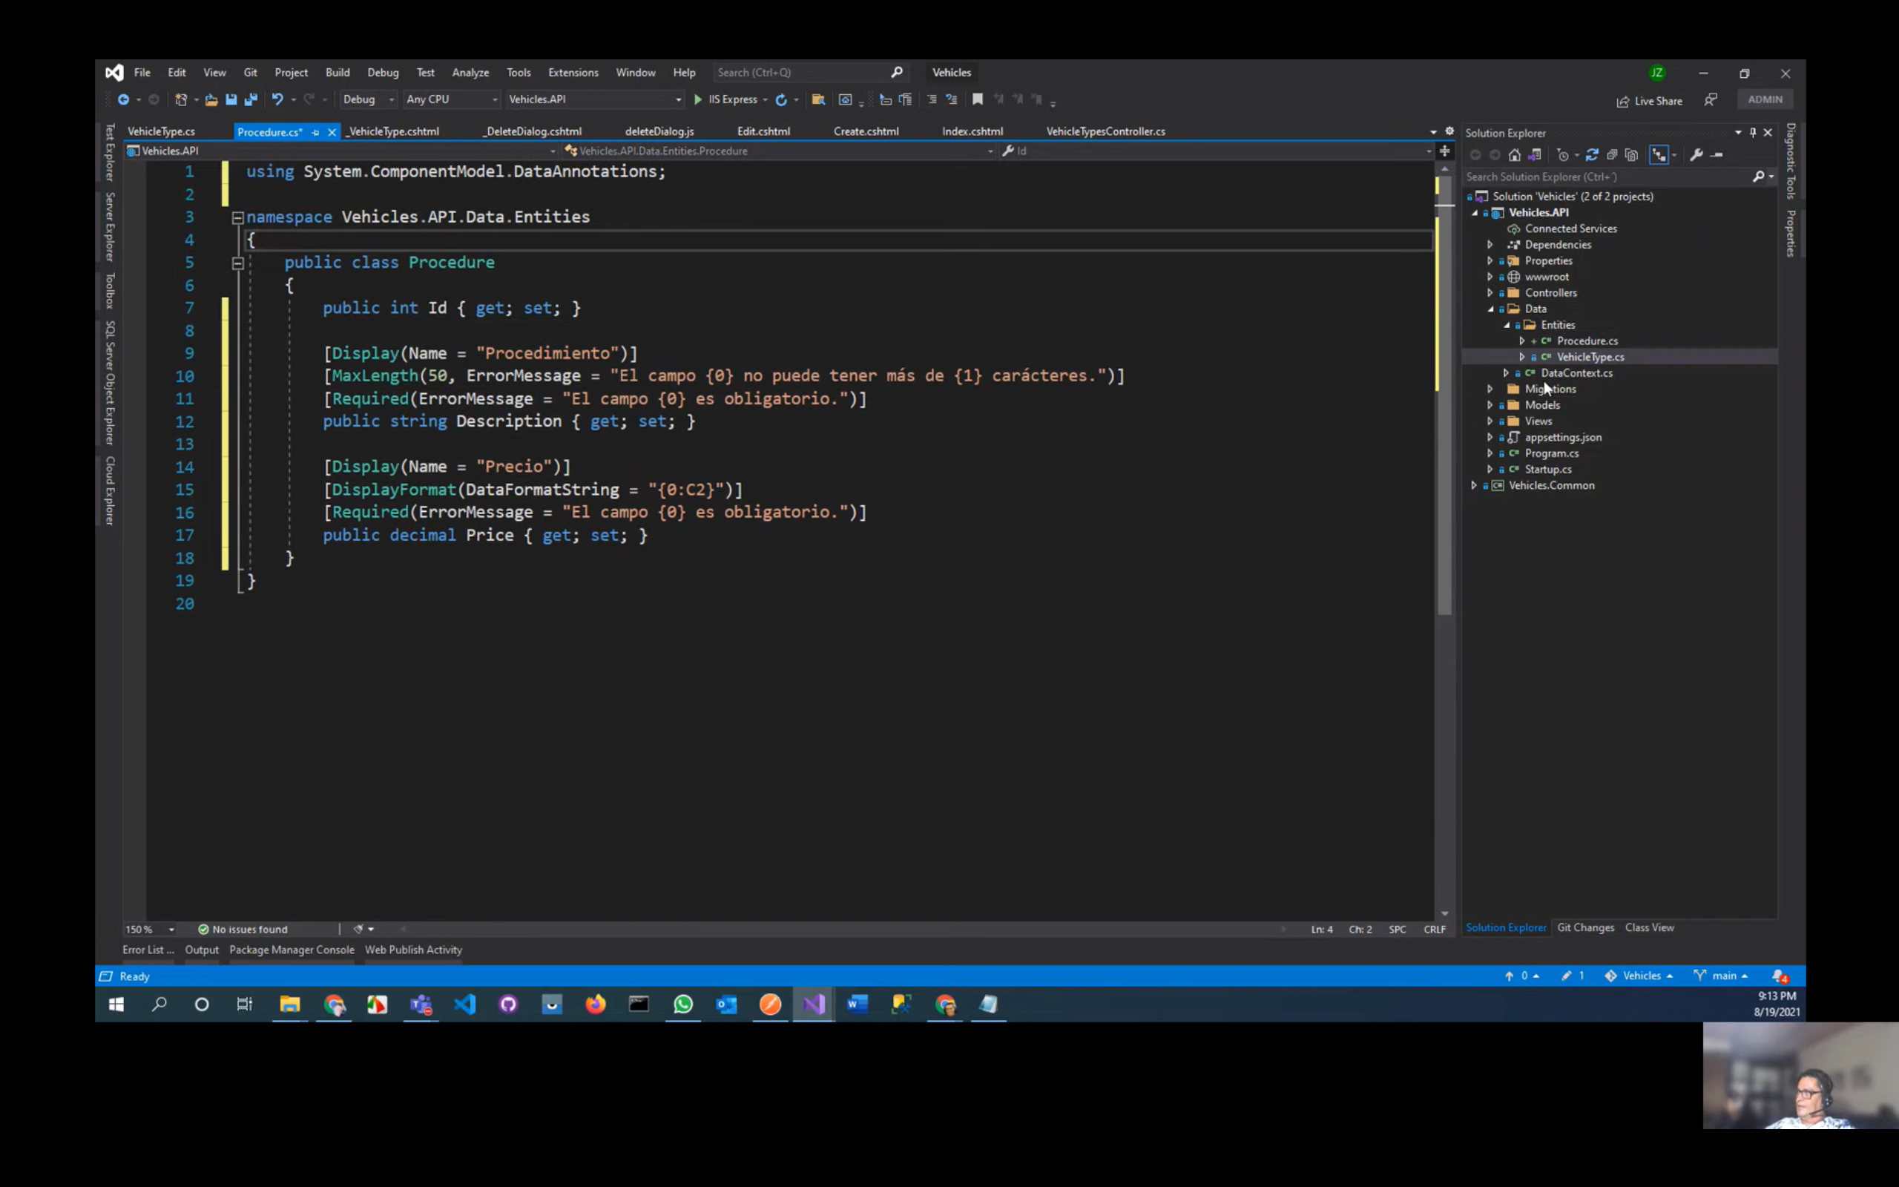

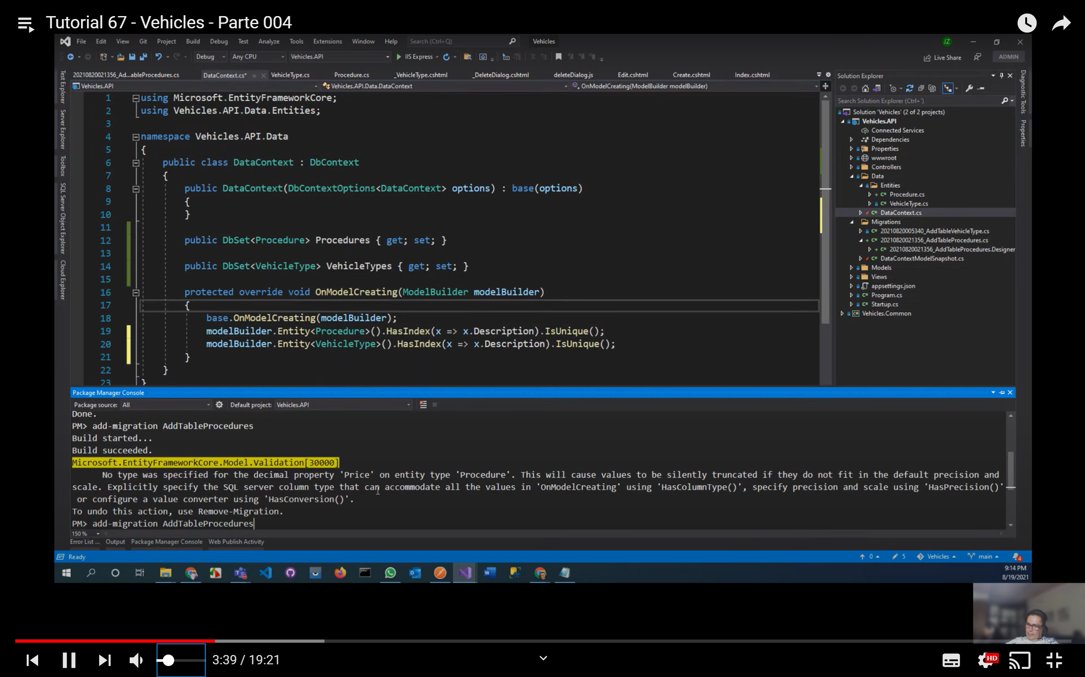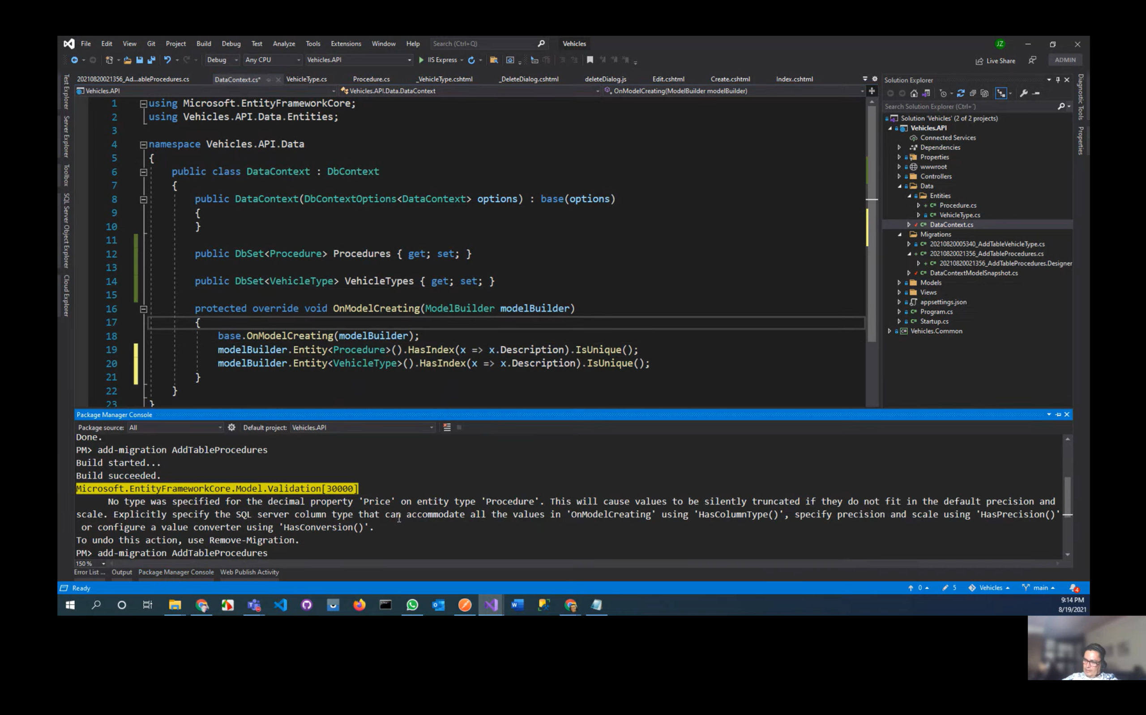

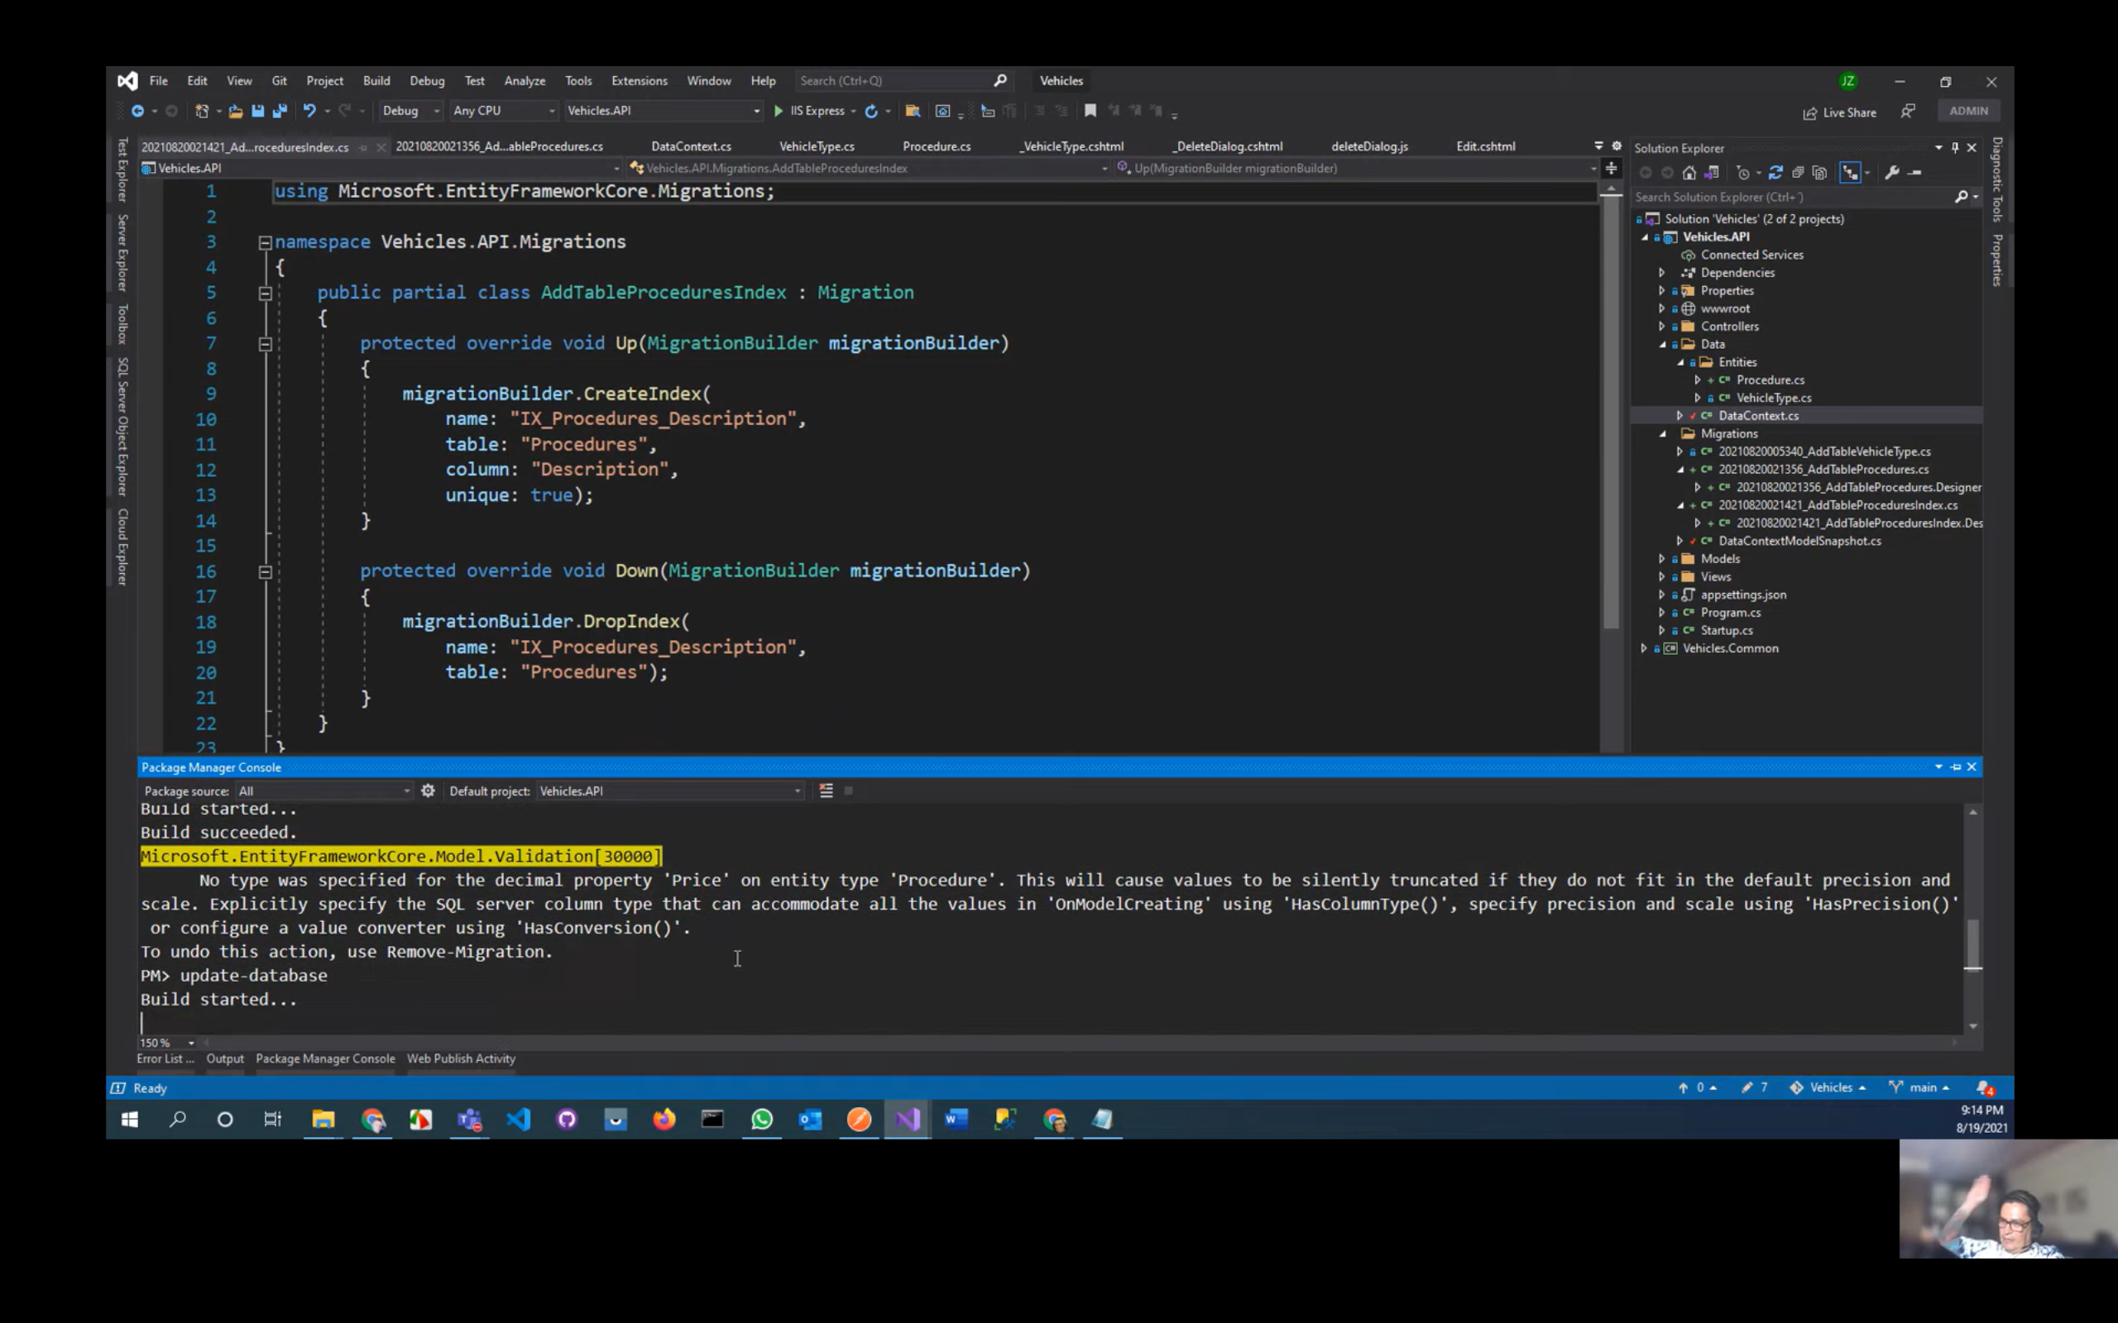

Crear un controller como clase de nombre ProceduresController

* Modificar la vista index y crear una vista de tipo razor view

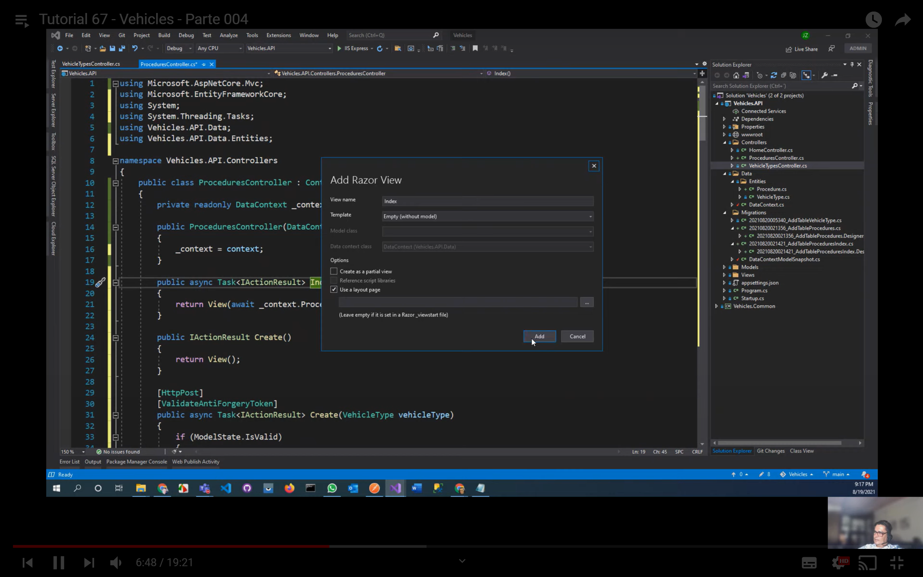

Copiar el index de Vehicle a Procedure y modificar

* Crear el menú para Procedure
* 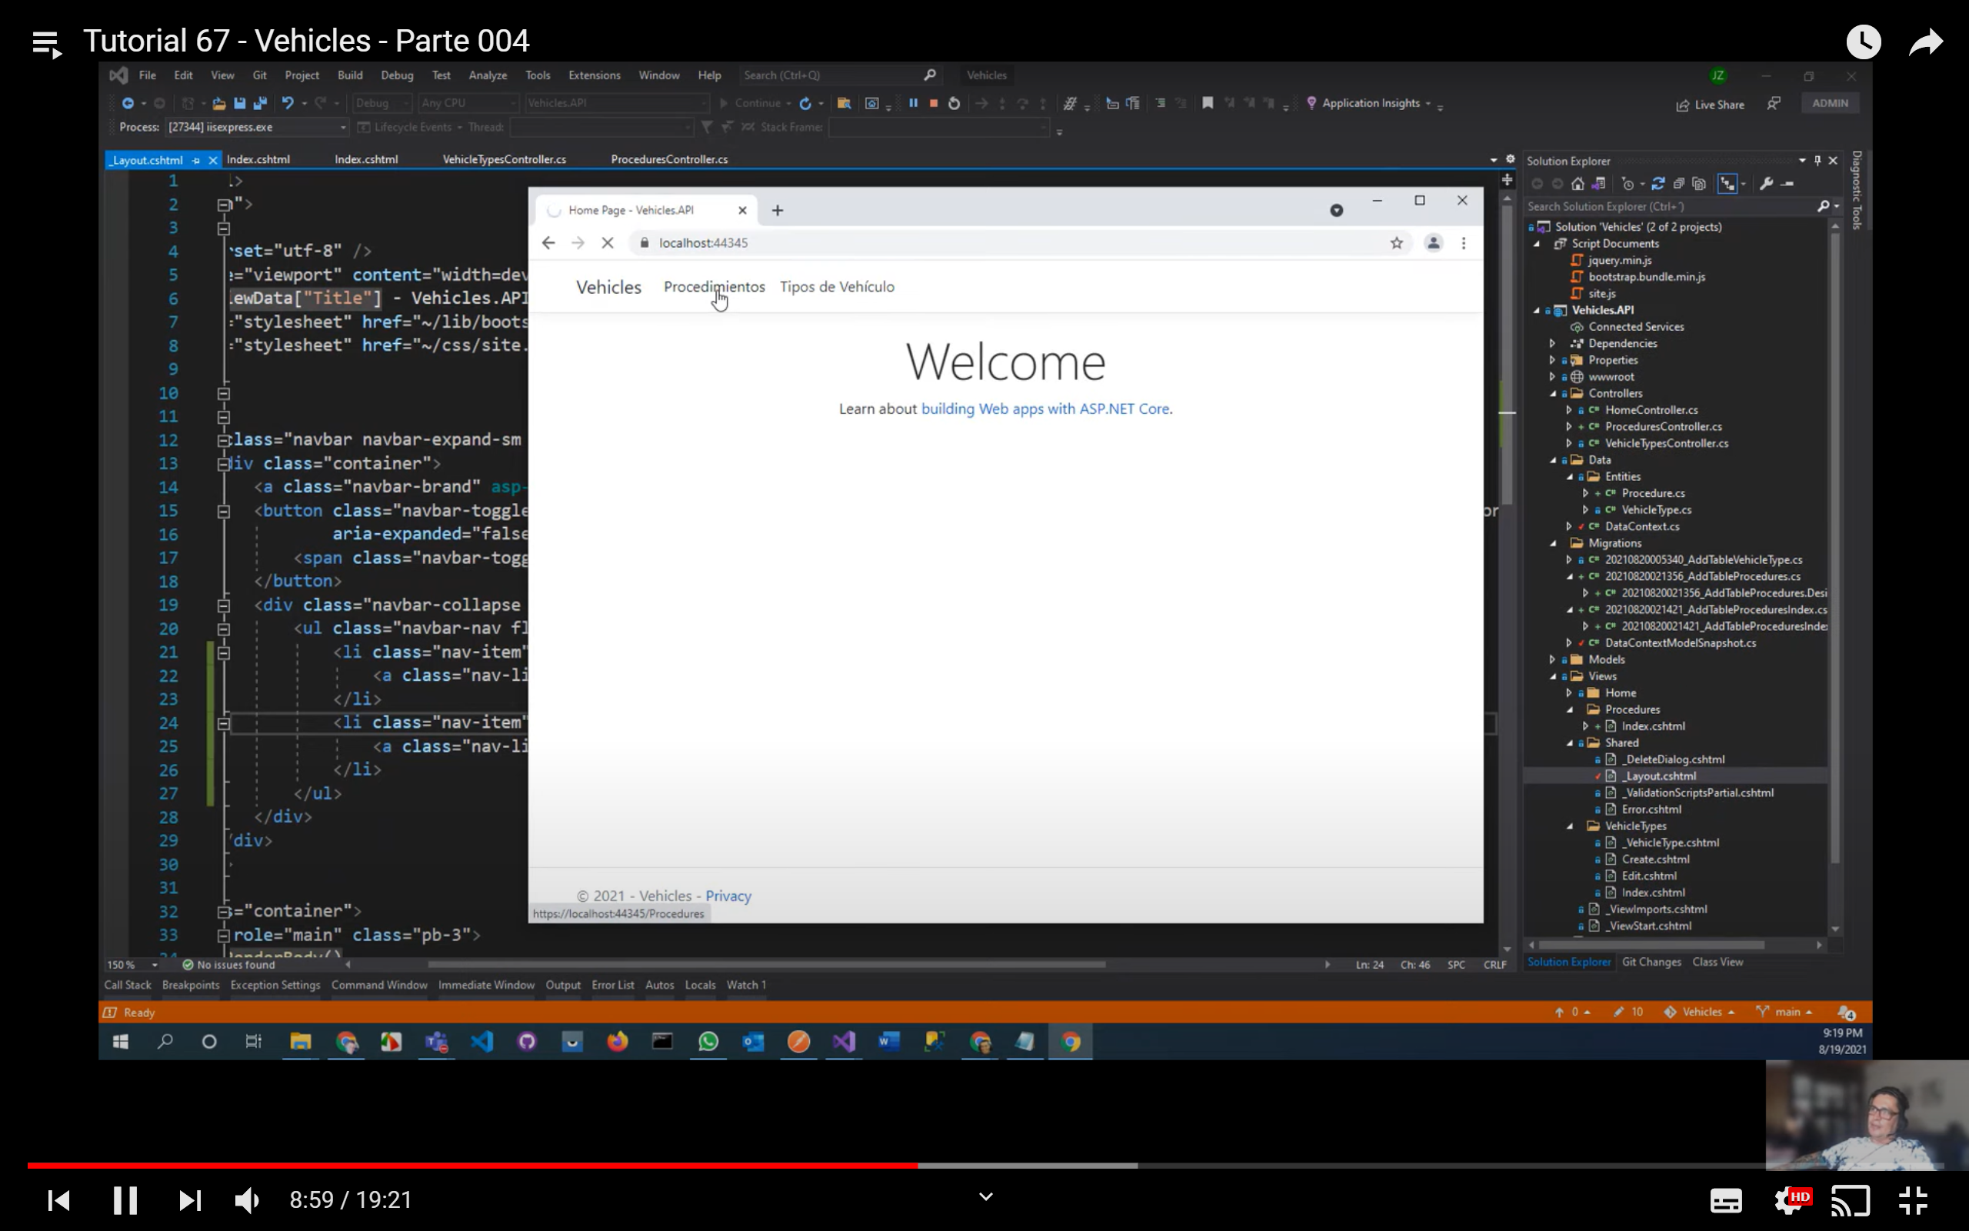
* Crear en la carpeta Procedure una vista común de tipo Razor View Empty de nombre _Procedure

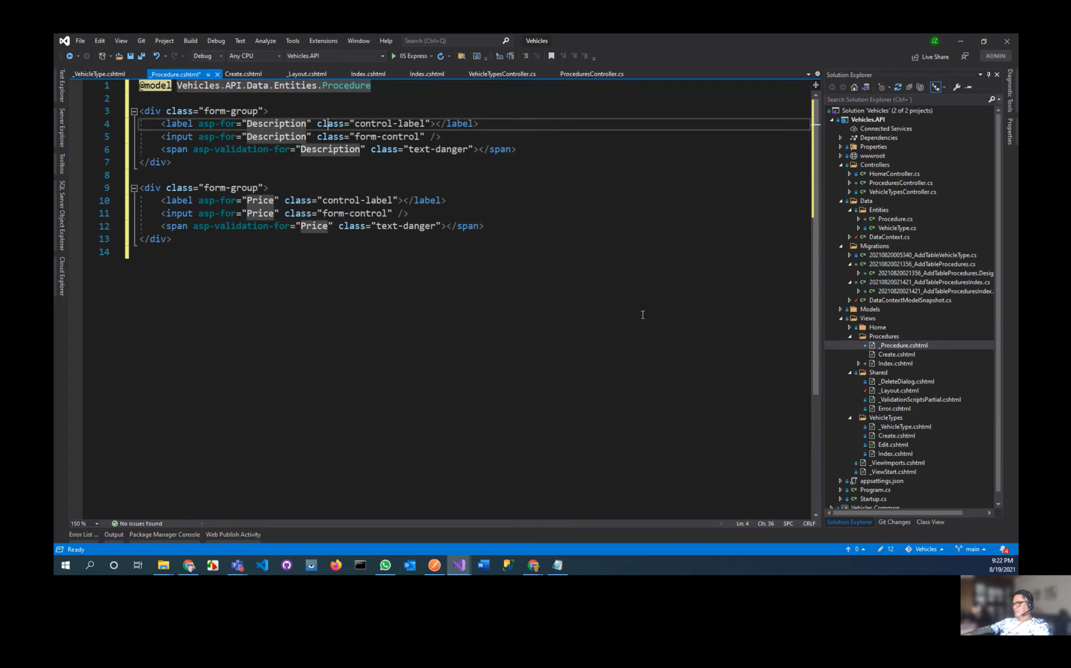

* Modificar el método Create y crea su vista correspondiente, copiar el créate de Vehicle a Procedure y modificar

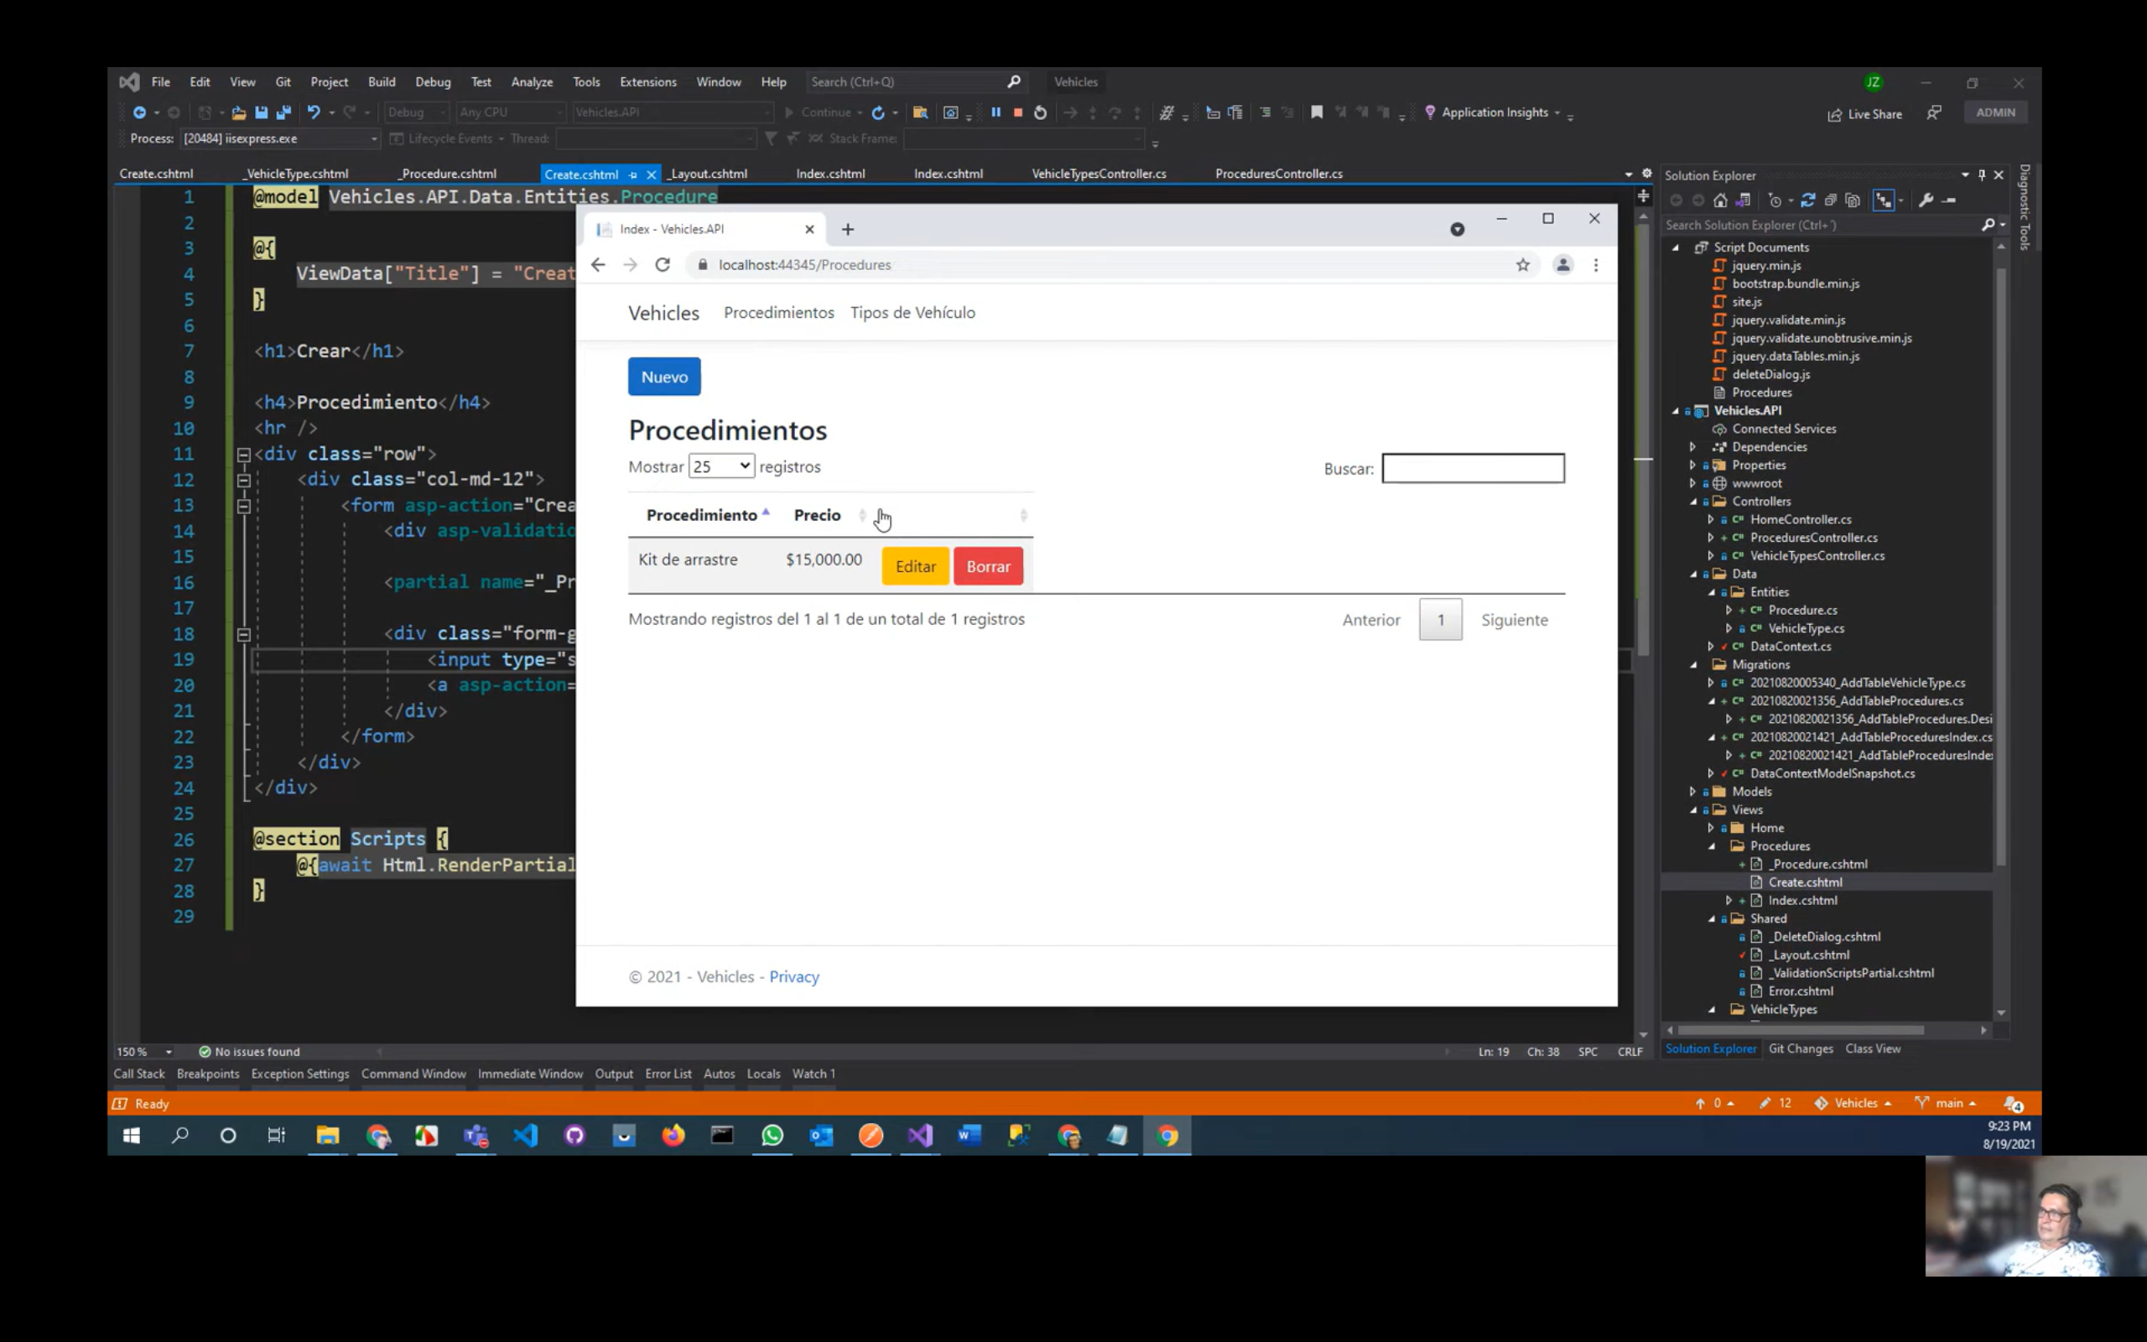

Modificar el método Edit y crear su vista

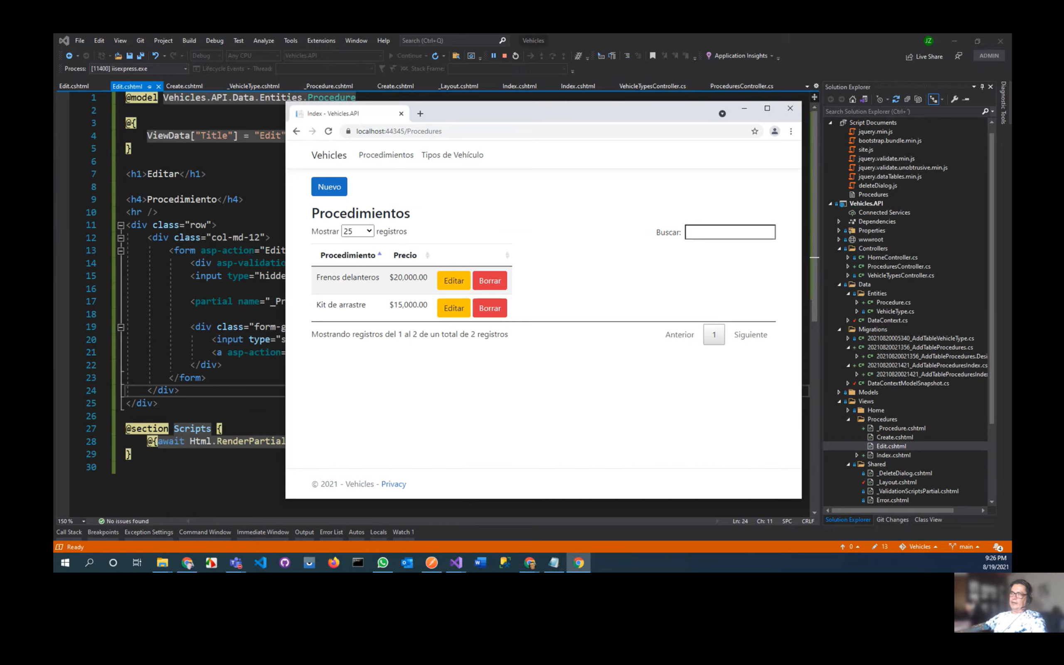

Modificar el método Delete y probar

# Video 5 Creación del Seader

Crear en Data->una clase SeadDB

Crear un constructor que devuelva un datacontext

Crear métodos para cada entidad del db

Copiar los valores de las entidades del GitHub

Services.AddTransient-> se ejecuta solo una vez

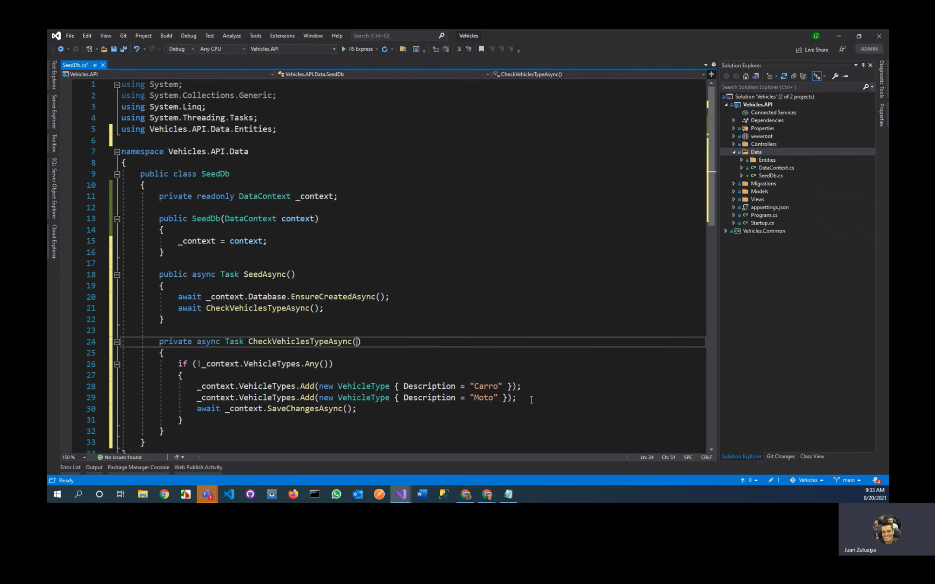

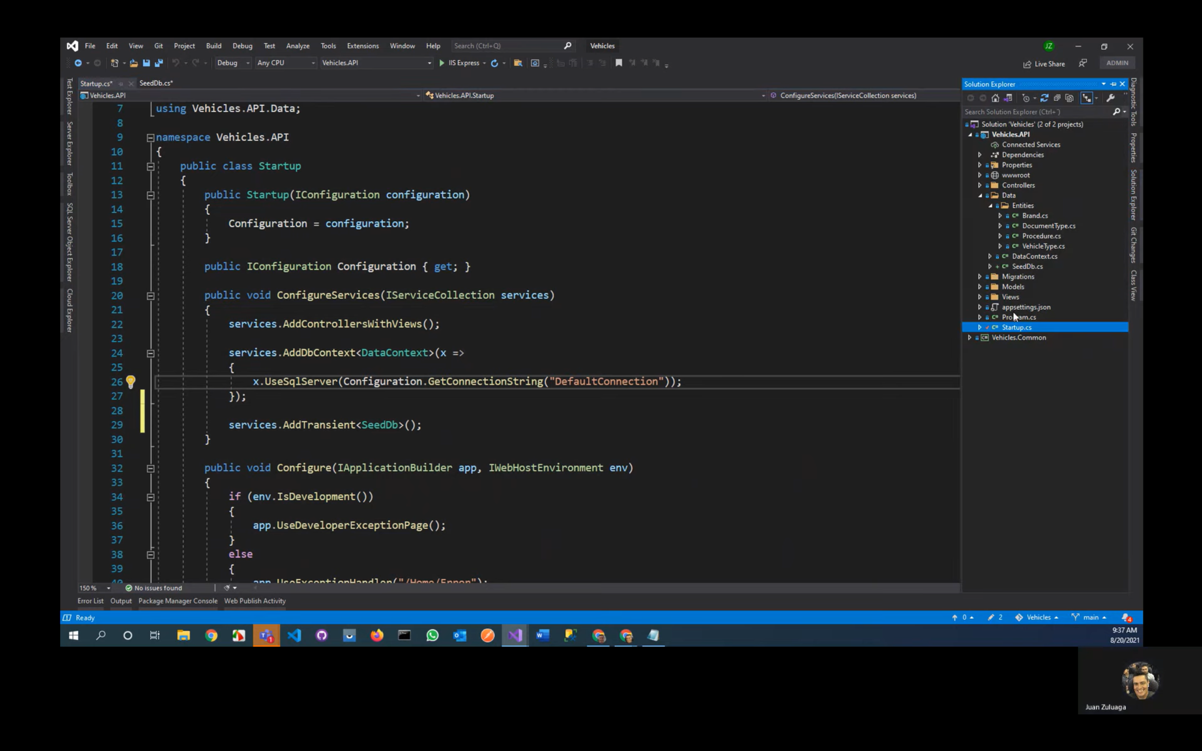

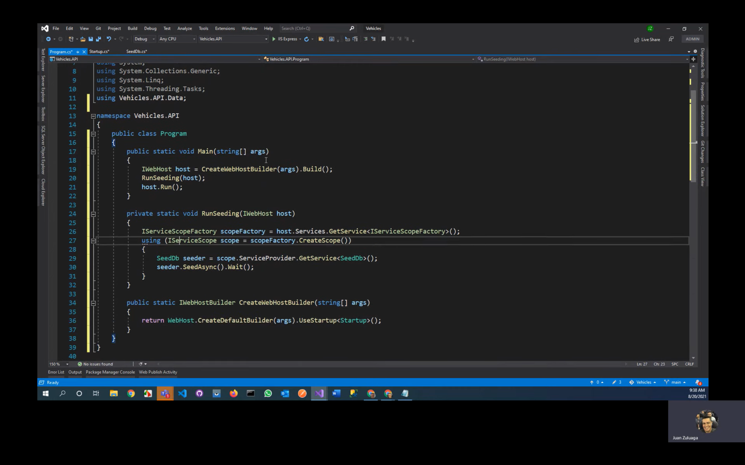

Eliminar la DB, ejecutar y se creará la DB por el SeadDB

# Video 6 Entidad User

* Crear Entidad User : IdentityUser

(FirstName, LastName, DocumentType(display, required), Document, Address(display, maxlength), Image(display)

* DocumentType hereda de la entidad DocumentType y relacionarla con dicha entidad como ICollection

User(1 tipo de documento) -> DocumentType(muchos users)

* Image de tipo GUID
* Crear en wwwroot la carpeta Images y agregar una imagen de nombre NoImage de preferencia de color transparente png
* [Display(Name = "Foto")]
* public string ImageFullPath => ImageId == Guid.Empty

? $"https://vehiclessalazar.azurewebsites.net/images/noimage.png"

: $"https://vehiclessalazar.blob.core.windows.net/users/{ImageId}";

* Crear en el Proyecto Common una carpeta Enums->clase UserType

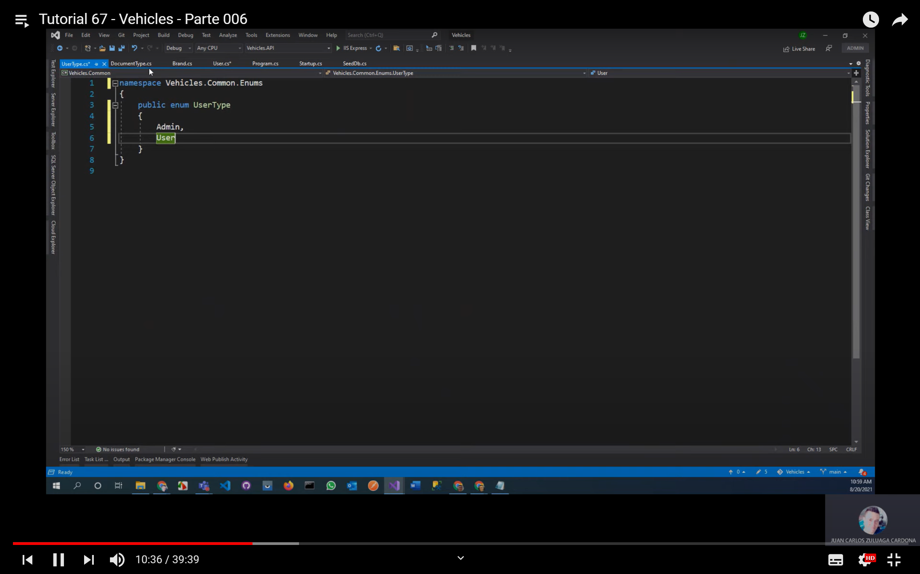

* [Display(Name = "Tipo de usuario")]

public UserType UserType { get; set; }

* [Display(Name = "Usuario")]

public string FullName => $"{FirstName} {LastName}";

* La clase DatContext : IdentityDBContext<User> el cual usa el Using Microsoft:AspNetCore.Identity.EntityFrameworkCore
* En WebAPI crear carpeta Helpers->Interface IUserHelper

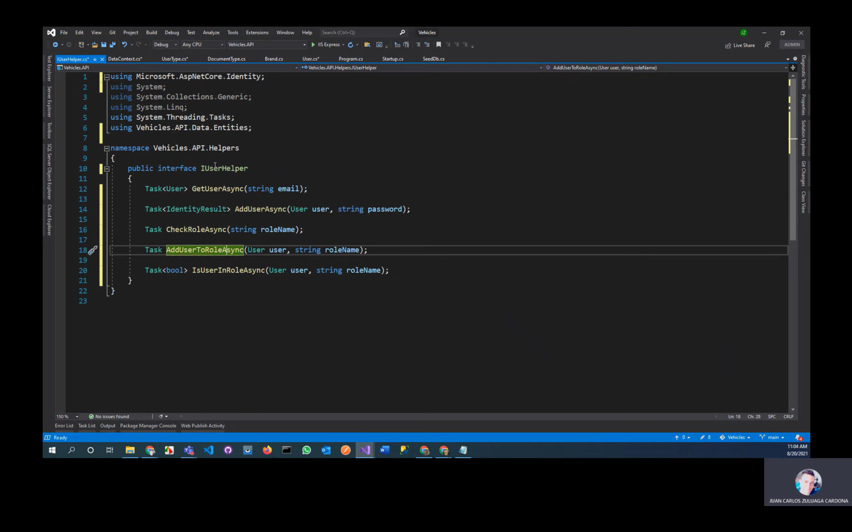

* Crear la clase UserHelper e implementar de IUserHelper

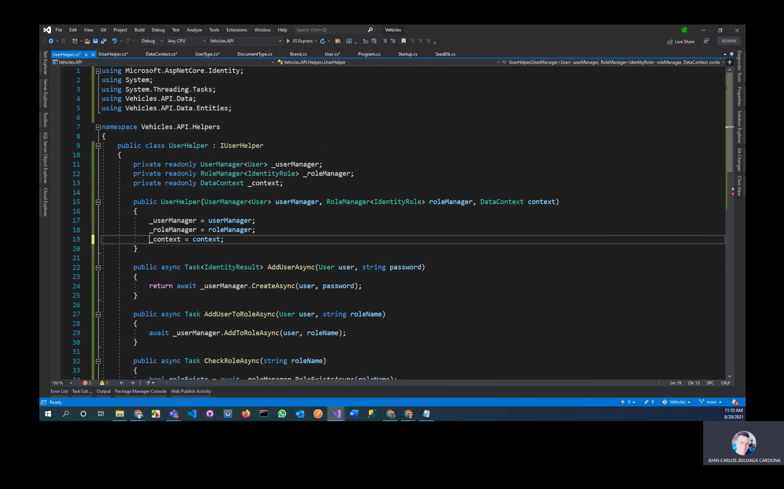

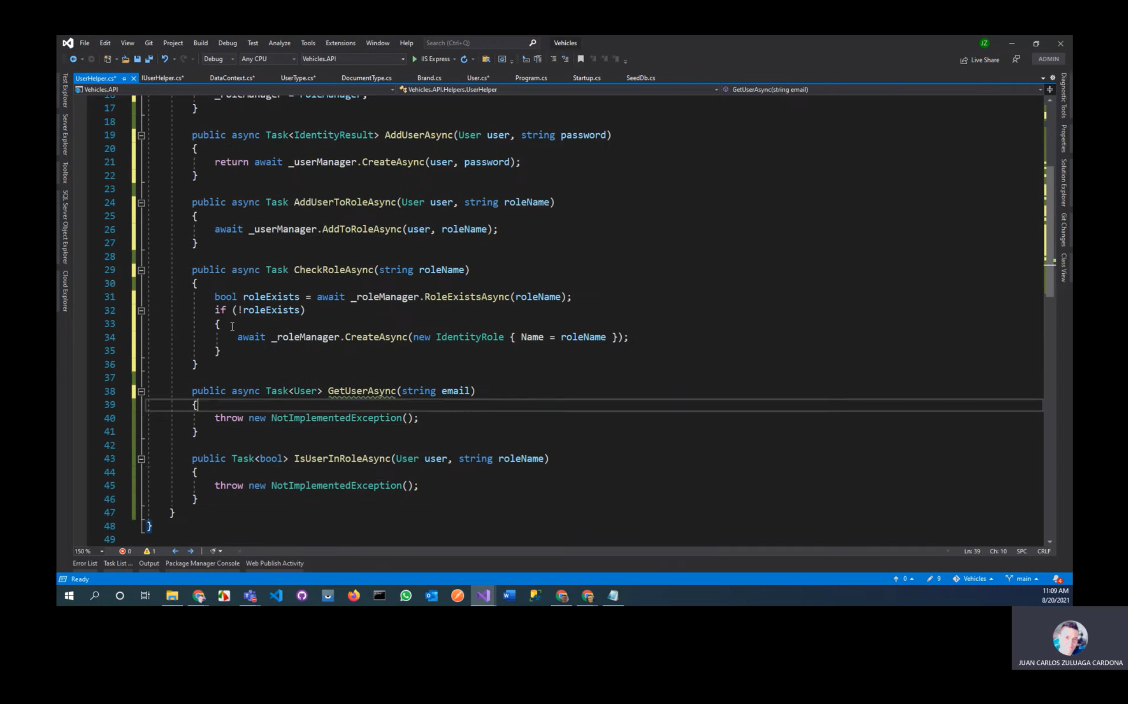

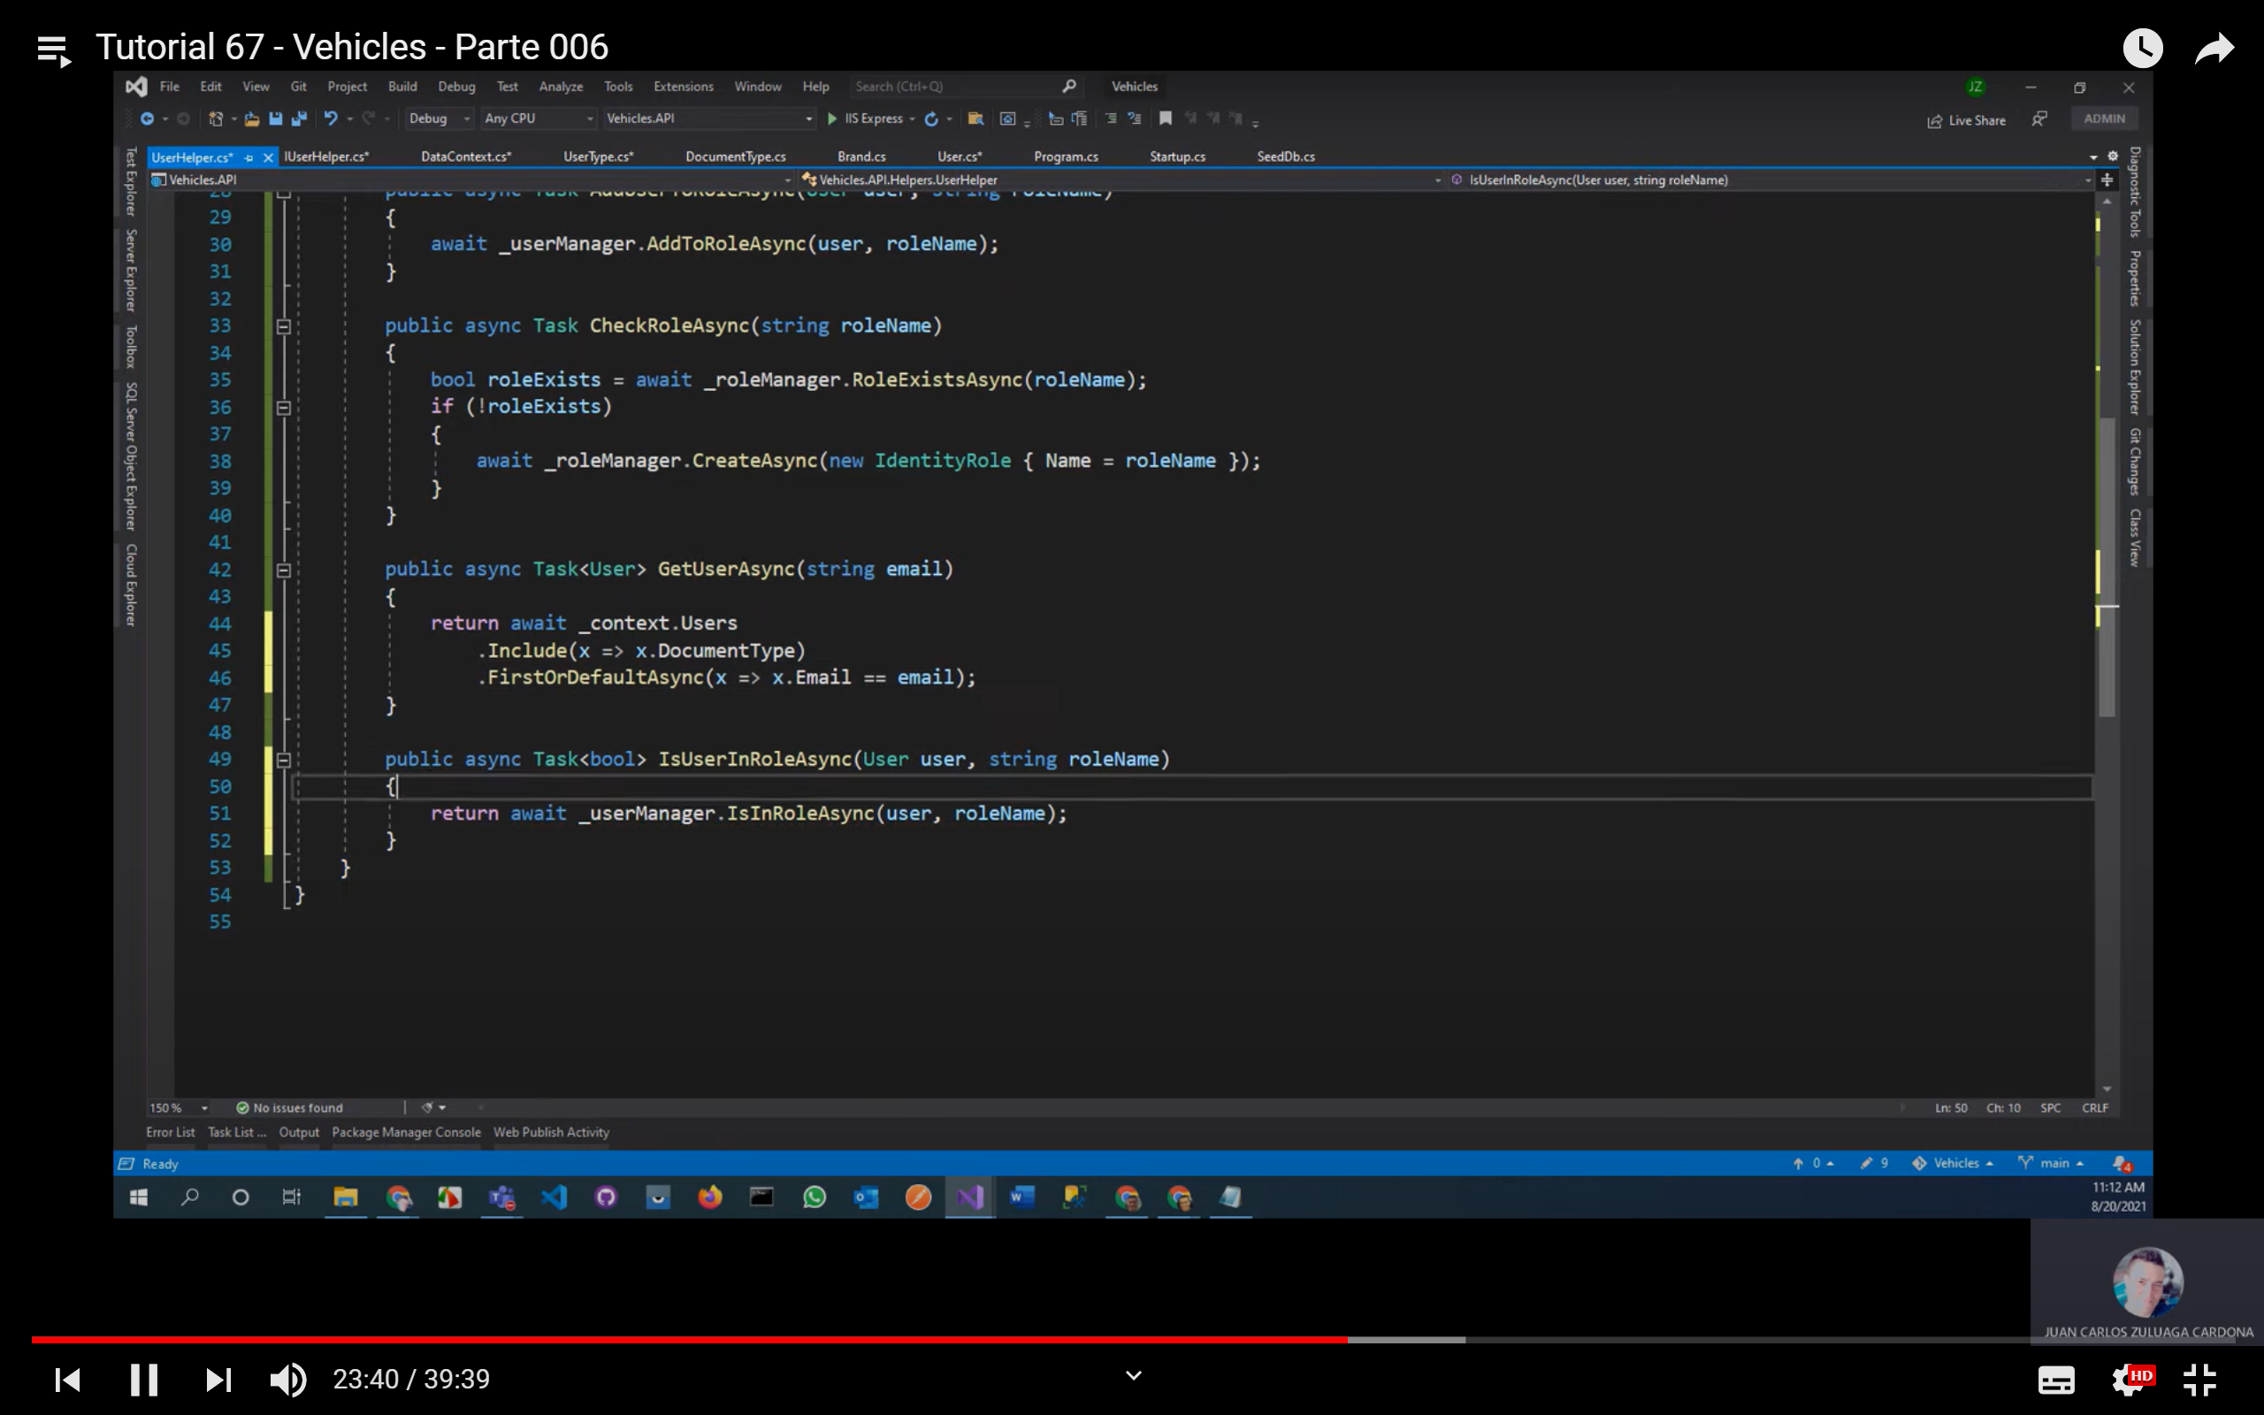

* AddEntityFrameworkStores<DataContext>();-> refiere que los password los vamos a manejar en el DataContext

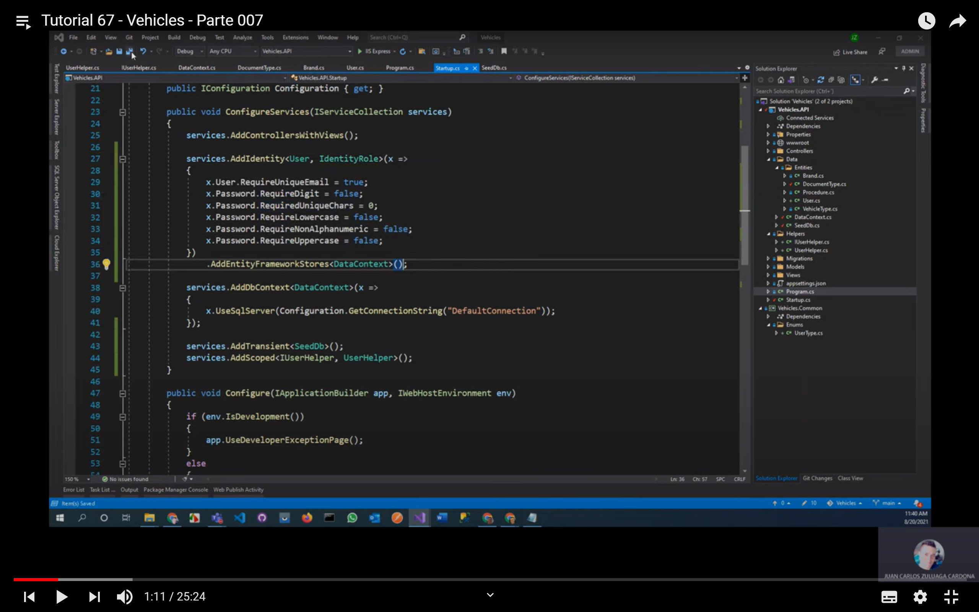

* El AddScope->instancia y elimina

Services.AddScope<IUserHelper, UserHelper>();

* En StartUp en el método public vois Configure()

app.UseAuthentication();->va a utilizar autenticación

* Inyectar en el SeedDB en el contructor el IUserHelper, crear un CheckRoles() en el método SeedAsync(),

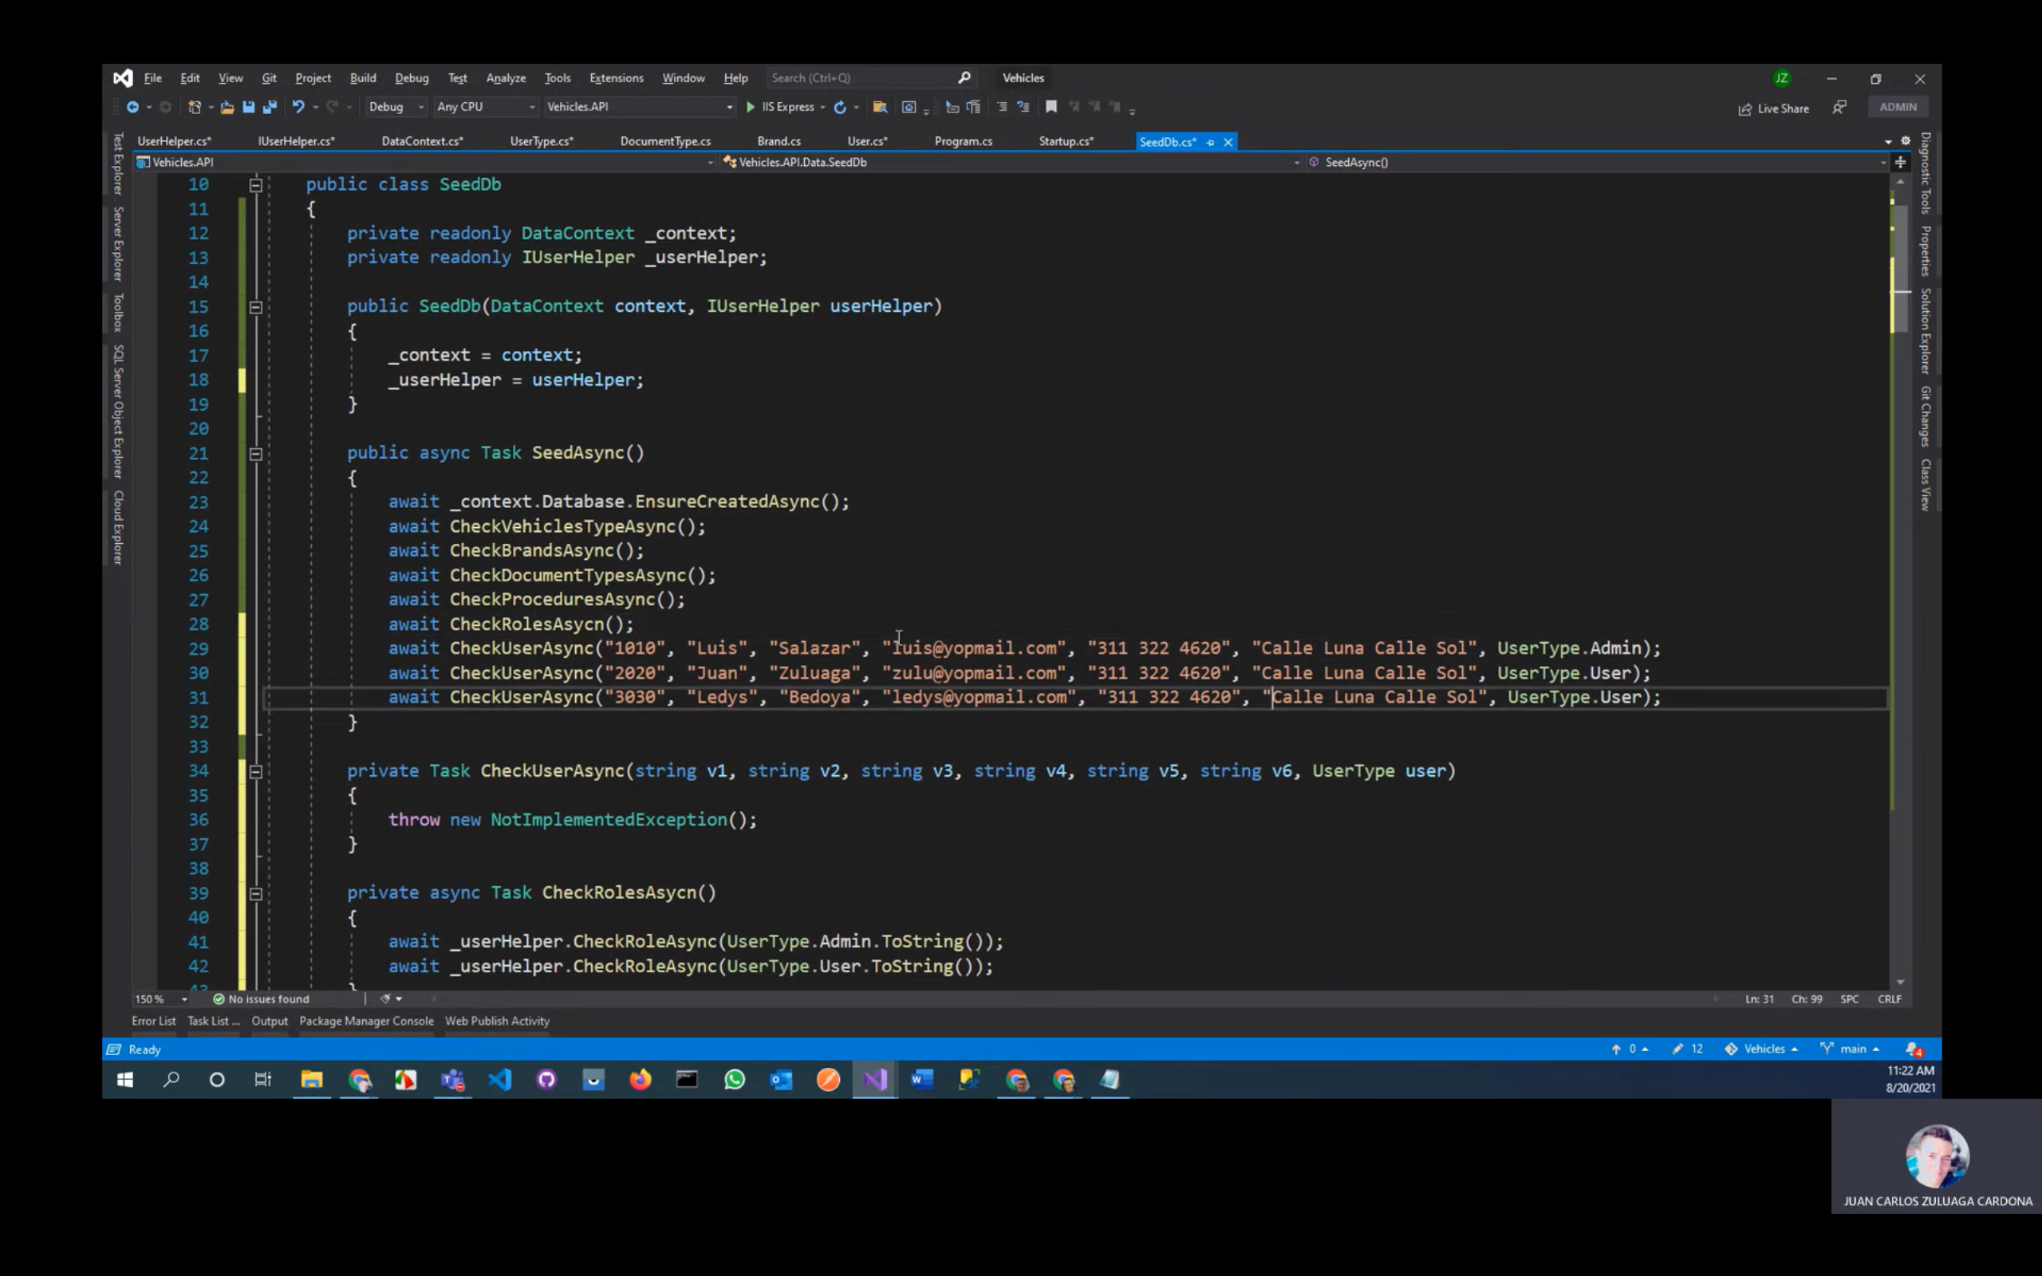

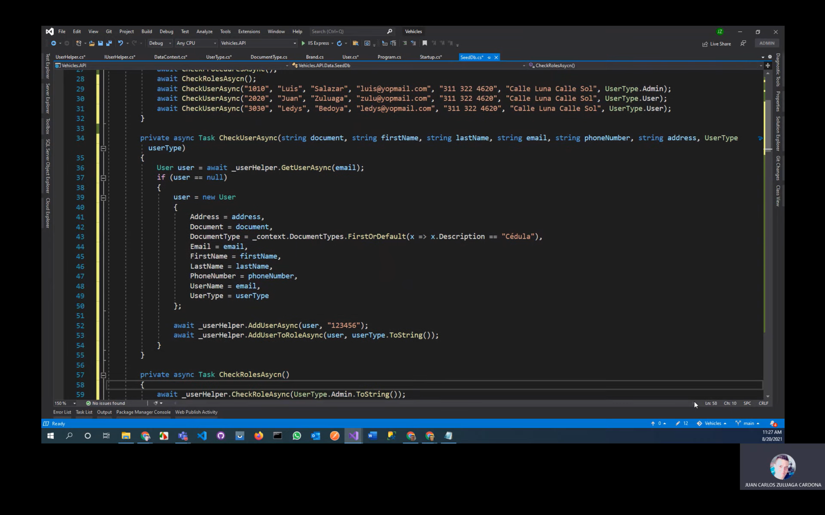

* add-migration AddUserTables
* update-database

# Video 7 Login y Logout

* 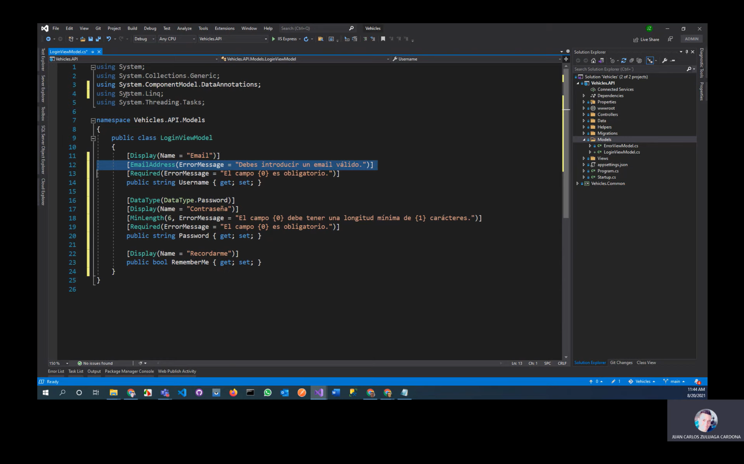
* En IUserHelper agregar dos métodos

Task<SignInResult> LoginAsync(LoginViewModel model);

Task LogoutAsync();

* Implementar en UserHelper y agregar en el contexto SignInManager<User> signManager y agregar dicha variable como campo
* Una vez implementado, modificar métodos

El parámetro RememberMe mantiene la sesión abierta, el parámetro false se refiere a los intentos de logueo

public async Task<SignInResult> LoginAsync(LoginViewModel model)

{

return await _signInManager.PasswordSignInAsync(model.Username, model.Password, model.RememberMe, false);

}

public async Task LogoutAsync()

{

await _signInManager.SignOutAsync();

}

* Crear una clase de nombre AccountController en la carpeta controlador el cual hereda de Controller, inyectar en el constructor el IUserHelper
* Crear un método

public IActionResult Login()

{

if (User.Identity.IsAuthenticated)

{

Nos retorna a una acción Index que esta dentro del ControllerHome

return RedirectToAction(nameof(Index), "Home");

}

return View(new LoginViewModel());

}

* Crear una vista de Login con RazorView

@model Vehicles.API.Models.LoginViewModel

@{

ViewData["Title"] = "Login";

}

<h2>Inicio de Sesión</h2>

<div class="row">

<div class="col-md-6">

<form method="post">

<div asp-validation-summary="ModelOnly"></div>

<div class="form-group">

<label asp-for="Username"></label>

<input asp-for="Username" class="form-control" />

<span asp-validation-for="Username" class="text-warning"></span>

</div>

<script src="~/lib/jquery-validation/dist/jquery.validate.js"></script>

<div class="form-group">

<label asp-for="Password"></label>

<input asp-for="Password" type="password" class="form-control" />

<span asp-validation-for="Password" class="text-warning"></span>

</div>

<div class="form-group">

<div class="form-check">

<input asp-for="RememberMe" type="checkbox" class="form-check-input" />

<label asp-for="RememberMe" class="form-check-label"></label>

</div>

<span asp-validation-for="RememberMe" class="text-warning"></span>

</div>

<div class="form-group">

<input type="submit" value="Iniciar Sesión" class="btn btn-primary" />

<a asp-action="Register" class="btn btn-secondary">Registrar Nuevo Usuario</a>

<hr />

<a asp-action="RecoverPassword" class="btn btn-link">¿Olvidaste tu contraseña?</a>

</div>

</form>

</div>

</div>

@section Scripts {

@{await Html.RenderPartialAsync("_ValidationScriptsPartial");}

}

[HttpPost]

public async Task<IActionResult> Login(LoginViewModel model)

{

if (ModelState.IsValid)

{

Microsoft.AspNetCore.Identity.SignInResult result = await _userHelper.LoginAsync(model);

if (result.Succeeded)

{

if (Request.Query.Keys.Contains("ReturnUrl"))

{

return Redirect(Request.Query["ReturnUrl"].First());

}

return RedirectToAction("Index", "Home");

}

ModelState.AddModelError(string.Empty, "Email o contraseña incorrectos.");

}

return View(model);

}

public async Task<IActionResult> Logout()

{

await _userHelper.LogoutAsync();

return RedirectToAction("Index", "Home");

}

* En la carpeta View de Home en la vista index

@{

ViewData["Title"] = "Home Page";

}

<div class="text-center">

<h1 class="display-4">Vehicles</h1>

<img src="~/images/vehicles_logo.png"/>

</div>

* Agregar [Authorize(Roles = “Admin”)] para los controllers Brand, DocumentType, Procedure, VehiclesType
* En View-> Shared-> _Layout reemplazar

<div class="navbar-collapse collapse d-sm-inline-flex justify-content-between">

<ul class="navbar-nav flex-grow-1">

@if (User.Identity.IsAuthenticated && User.IsInRole("Admin"))

{

<li class="nav-item">

<a class="nav-link text-dark" asp-area="" asp-controller="Brands" asp-action="Index">Marcas</a>

</li>

<li class="nav-item">

<a class="nav-link text-dark" asp-area="" asp-controller="Users" asp-action="Index2">Mecánicos</a>

</li>

<li class="nav-item">

<a class="nav-link text-dark" asp-area="" asp-controller="Procedures" asp-action="Index">Procedimientos</a>

</li>

<li class="nav-item">

<a class="nav-link text-dark" asp-area="" asp-controller="DocumentTypes" asp-action="Index">Tipos de Documento</a>

</li>

<li class="nav-item">

<a class="nav-link text-dark" asp-area="" asp-controller="VehicleTypes" asp-action="Index">Tipos de Vehículo</a>

</li>

<li class="nav-item">

<a class="nav-link text-dark" asp-area="" asp-controller="Users" asp-action="Index">Usuarios</a>

</li>

}

</ul>

<ul class="nav navbar-nav navbar-right">

@if (User.Identity.IsAuthenticated)

{

<li class="nav-item">

<a class="nav-link text-dark" asp-area="" asp-controller="Account" asp-action="ChangeUser">@User.Identity.Name</a>

</li>

<li class="nav-item">

<a class="nav-link text-dark" asp-area="" asp-controller="Account" asp-action="Logout">Cerrar Sesión</a>

</li>

}

else

{

<li><a asp-area="" asp-controller="Account" asp-action="Login">Iniciar Sesión</a></li>

}

</ul>

</div>

* 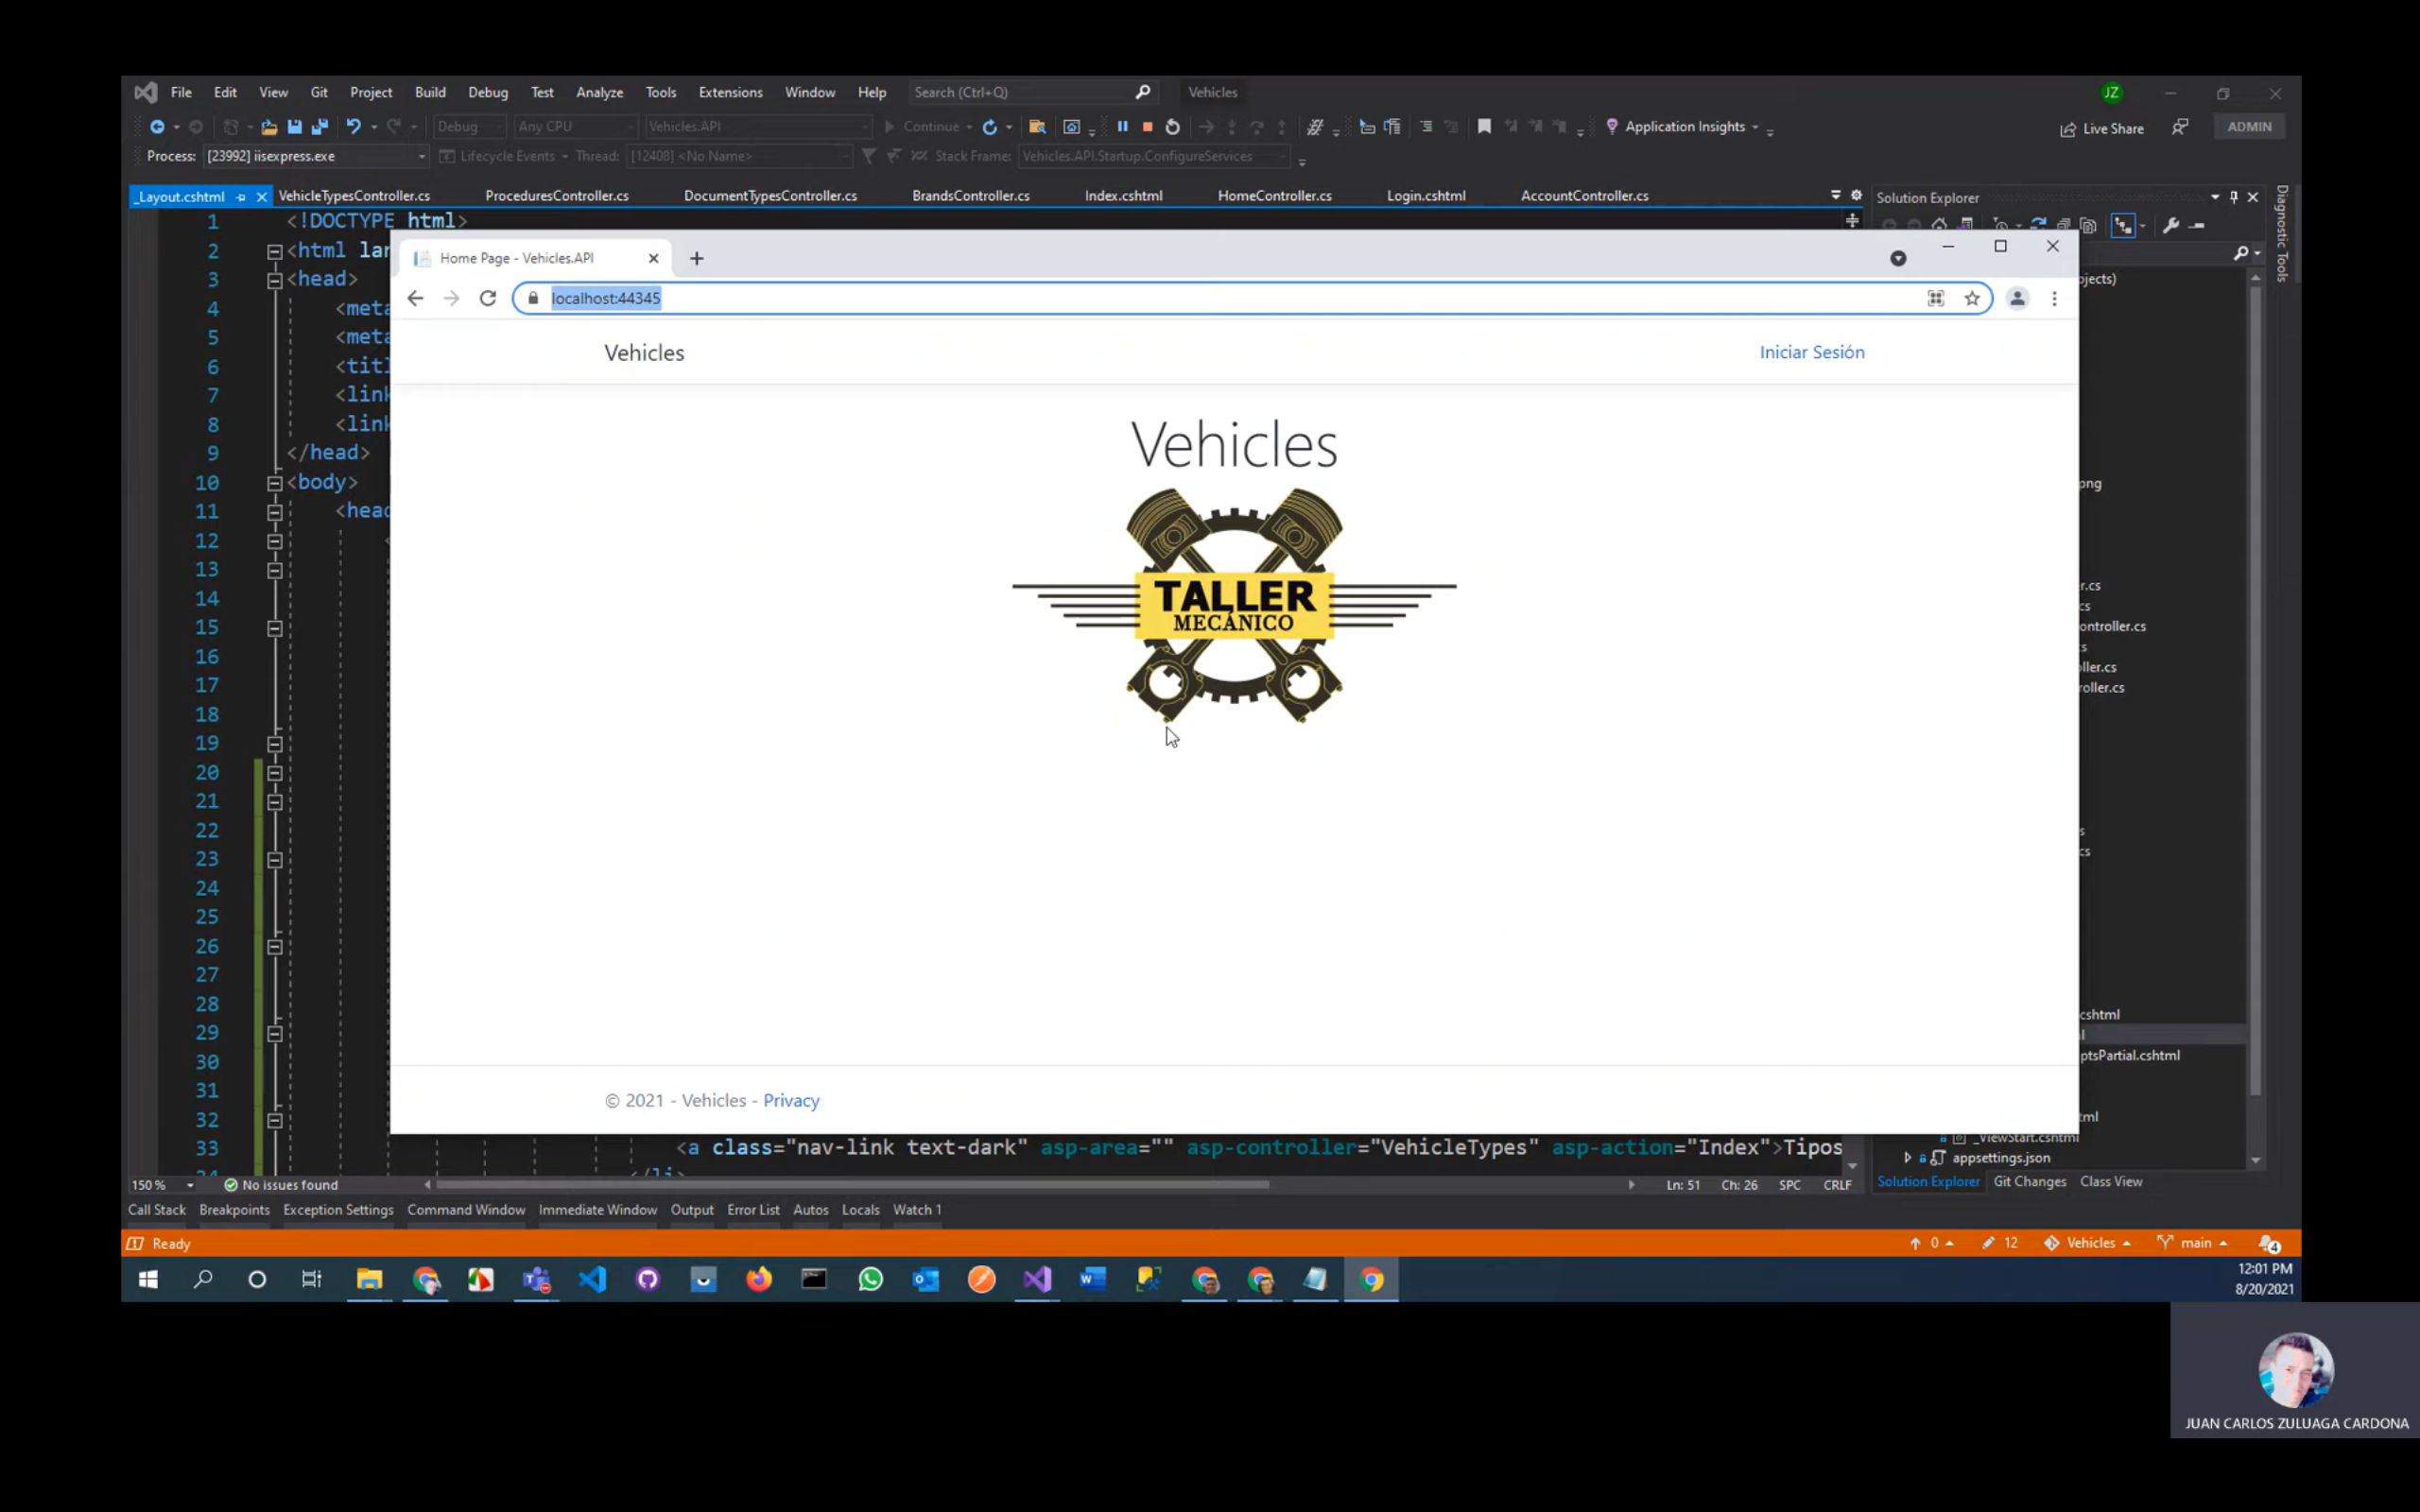

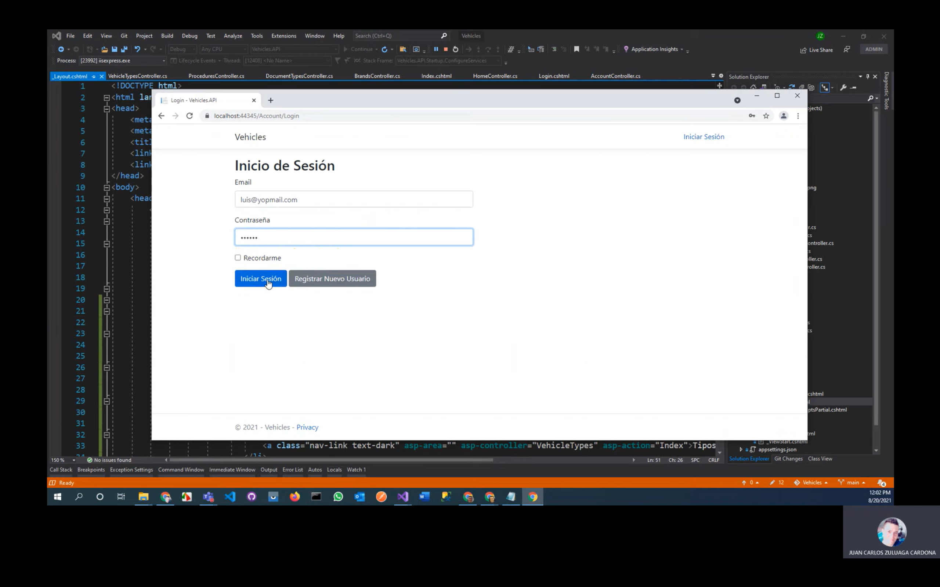

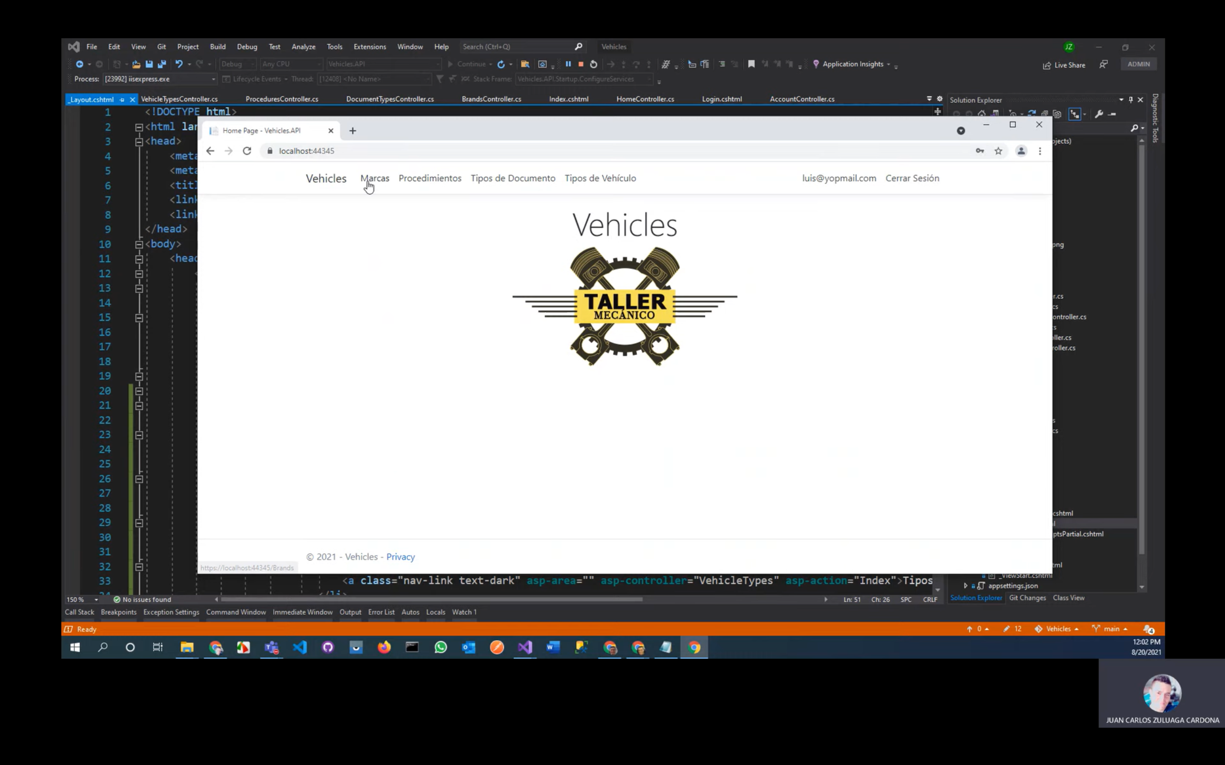

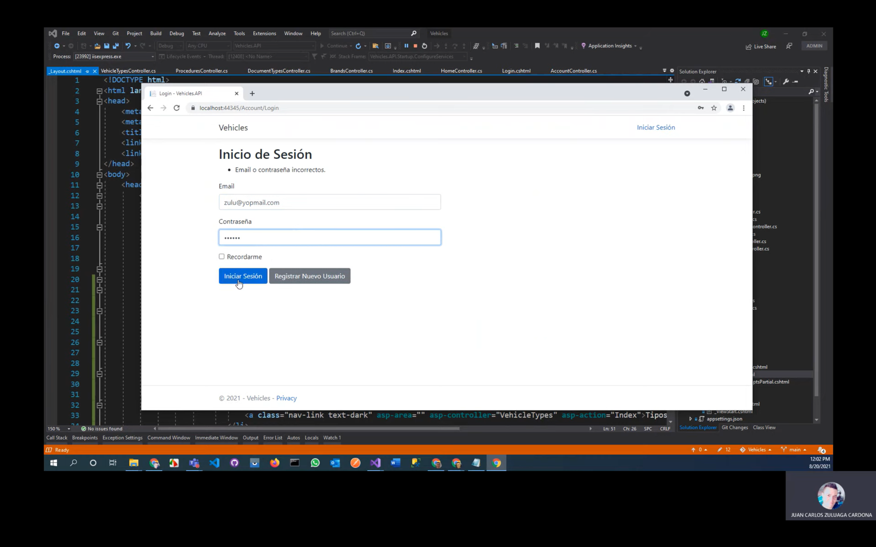

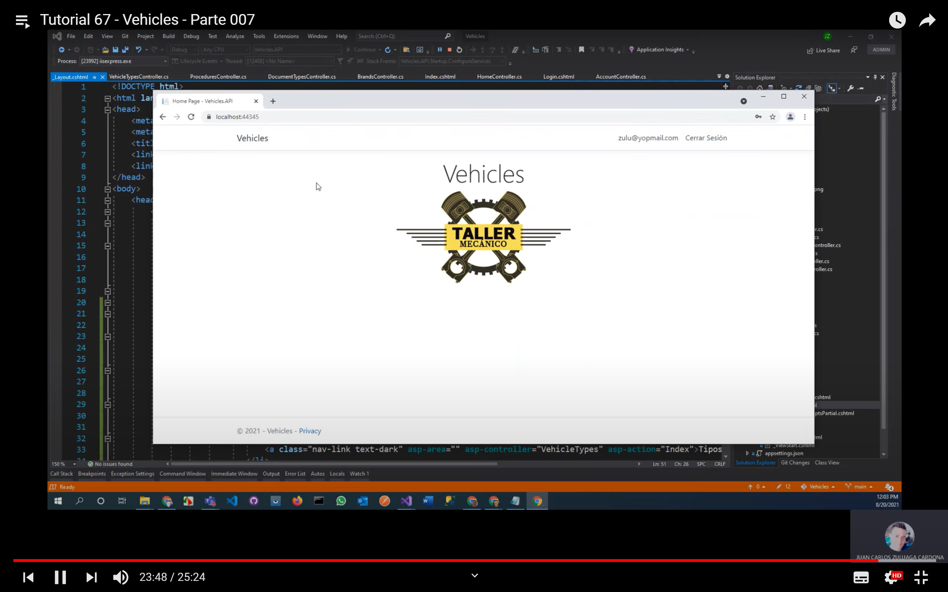

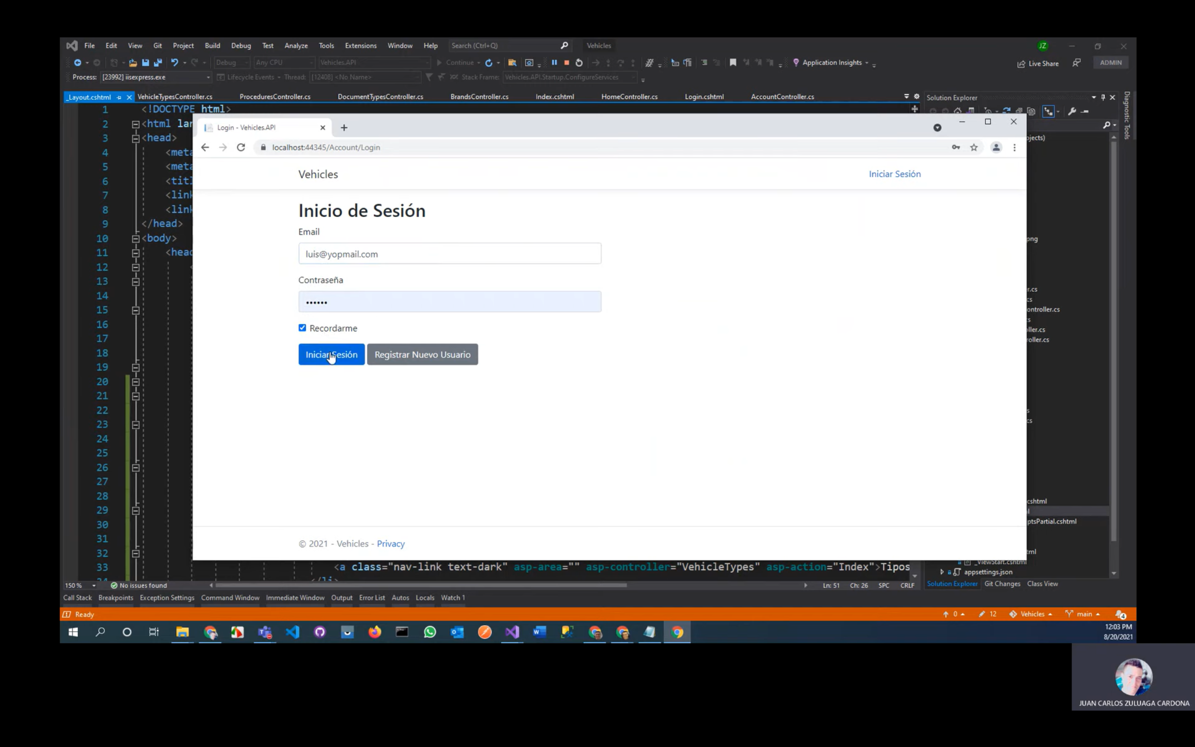

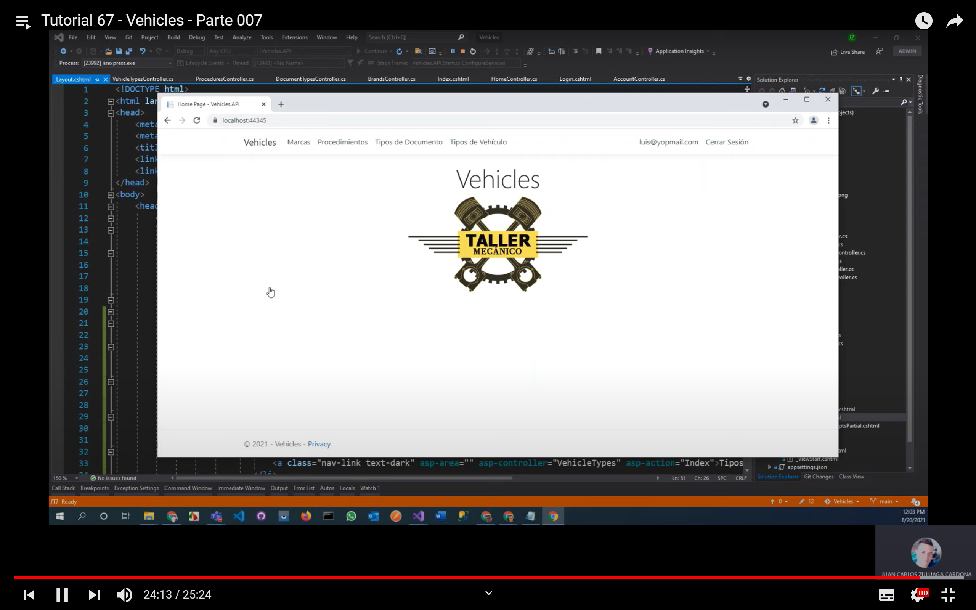

Cerrar aplicación y ejecutar nuevamente para verificar si la opción recordar esta funcionando

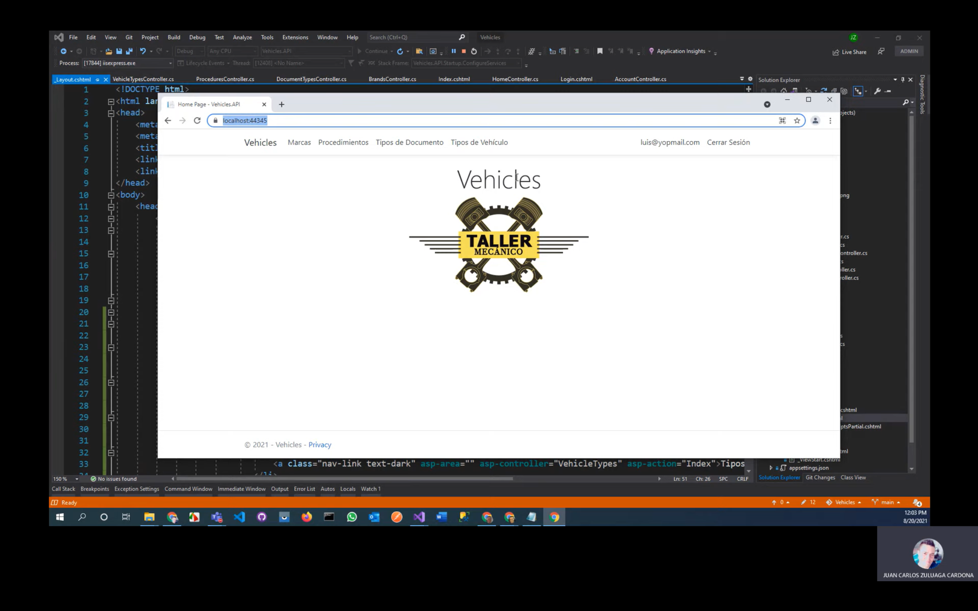

# Video 8 Agregando Entidad Detail, History, VehiclePhoto

* En la entidad VehicleType

Public ICollection<Vehicle> Vehicles get set

* En la entidad Band

Public ICollection<Vehicle> Vehicles get set

* En la entidad User

Public ICollection<Vehicle> Vehicles get set

* Crear una entidad Vehicle

public class Vehicle

{

public int Id { get; set; }

[Display(Name = "Tipo de vehículo")]

[Required(ErrorMessage = "El campo {0} es obligatorio.")]

public VehicleType VehicleType { get; set; }

[Display(Name = "Marca")]

[Required(ErrorMessage = "El campo {0} es obligatorio.")]

public Brand Brand { get; set; }

[Display(Name = "Modelo")]

[Required(ErrorMessage = "El campo {0} es obligatorio.")]

[Range(1900, 3000, ErrorMessage = "Valor de módelo no válido.")]

public int Model { get; set; }

[Display(Name = "Placa")]

[RegularExpression(@"[a-zA-Z]{3}[0-9]{2}[a-zA-Z0-9]", ErrorMessage = "Formato de placa incorrecto.")]

[Required(ErrorMessage = "El campo {0} es obligatorio.")]

[StringLength(6, MinimumLength = 6, ErrorMessage = "El campo {0} debe tener {1} carácteres.")]

public string Plaque { get; set; }

[Display(Name = "Línea")]

[MaxLength(50, ErrorMessage = "El campo {0} no puede tener más de {1} carácteres.")]

[Required(ErrorMessage = "El campo {0} es obligatorio.")]

public string Line { get; set; }

[Display(Name = "Color")]

[MaxLength(50, ErrorMessage = "El campo {0} no puede tener más de {1} carácteres.")]

[Required(ErrorMessage = "El campo {0} es obligatorio.")]

public string Color { get; set; }

[Display(Name = "Propietario")]

[Required(ErrorMessage = "El campo {0} es obligatorio.")]

public User User { get; set; }

[Display(Name = "Observación")]

[DataType(DataType.MultilineText)]

public string Remarks { get; set; }

}

* Agregar la entidad Vehicle al datacontex y agregar un índice por Plaque
* Agregar la entidad VehiclePhoto

public class VehiclePhoto

{

public int Id { get; set; }

[Required(ErrorMessage = "El campo {0} es obligatorio.")]

public Vehicle Vehicle { get; set; }

[Display(Name = "Foto")]

public Guid ImageId { get; set; }

[Display(Name = "Foto")]

public string ImageFullPath => ImageId == Guid.Empty

? $"https://localhost:/images/noimage.png"

: $"https://vehicleszuluprep.blob.core.windows.net/vehicles/{ImageId}";

}

* En la entidad Vehicle

Public ICollection<VehiclePhoto> VehiclePhotos get set

[Display(Name = "# Fotos")]

public int VehiclePhotosCount => VehiclePhotos == null ? 0 : VehiclePhotos.Count;

[Display(Name = "Foto")]

public string ImageFullPath => VehiclePhotos == null || VehiclePhotos.Count == 0

? $"https://localhost:44345/images/noimage.png"

: VehiclePhotos.FirstOrDefault().ImageFullPath;

* Agregar la entidad History

public class History

{

public int Id { get; set; }

[Display(Name = "Vehículo")]

[Required(ErrorMessage = "El campo {0} es obligatorio.")]

public Vehicle Vehicle { get; set; }

[Display(Name = "Mecánico")]

[Required(ErrorMessage = "El campo {0} es obligatorio.")]

public User User { get; set; }

[Display(Name = "Fecha")]

[DisplayFormat(DataFormatString = "{0:yyyy/MM/dd hh:mm tt}")]

public DateTime Date { get; set; }

[Display(Name = "Kilometraje")]

[DisplayFormat(DataFormatString = "{0:N0}")]

public int Mileage { get; set; }

[Display(Name = "Observación")]

[DataType(DataType.MultilineText)]

public string Remarks { get; set; }

}

* En la entidad Vehicle

Public ICollection<History> Histories get set

[Display(Name = "# Historias")]

public int HistoriesCount => Histories == null ? 0 : Histories.Count;

* En la entidad User agregar

Public ICollection<History> Histories get set

* Agregar una entidad Detail

public class Detail

{

public int Id { get; set; }

[Display(Name = "Historia")]

[Required(ErrorMessage = "El campo {0} es obligatorio.")]

public History History { get; set; }

[Display(Name = "Procedimiento")]

[Required(ErrorMessage = "El campo {0} es obligatorio.")]

public Procedure Procedure { get; set; }

[Display(Name = "Precio Mano de Obra")]

[DisplayFormat(DataFormatString = "{0:C2}")]

[Required(ErrorMessage = "El campo {0} es obligatorio.")]

public int LaborPrice { get; set; }

[Display(Name = "Precio Repuestos")]

[DisplayFormat(DataFormatString = "{0:C2}")]

[Required(ErrorMessage = "El campo {0} es obligatorio.")]

public int SparePartsPrice { get; set; }

[Display(Name = "Total")]

[DisplayFormat(DataFormatString = "{0:C2}")]

public int TotalPrice => LaborPrice + SparePartsPrice;

[Display(Name = "Observación")]

[DataType(DataType.MultilineText)]

public string Remarks { get; set; }

}

* En la entidad History agregar los atributos

public ICollection<Detail> Details { get; set; }

[Display(Name = "# Detalles")]

public int DetailsCount => Details == null ? 0 : Details.Count;

[Display(Name = "Total Mano de Obra")]

[DisplayFormat(DataFormatString = "{0:C2}")]

public int TotalLabor => Details == null ? 0 : Details.Sum(x => x.LaborPrice);

[Display(Name = "Total Repuestos")]

[DisplayFormat(DataFormatString = "{0:C2}")]

public int TotalSpareParts => Details == null ? 0 : Details.Sum(x => x.SparePartsPrice);

[Display(Name = "Total")]

[DisplayFormat(DataFormatString = "{0:C2}")]

public int Total => Details == null ? 0 : Details.Sum(x => x.TotalPrice);

* En la entidad Procedure agregar un atributo

Public ICollection<Detail> Details get set

* En datacontex agregar Detail, History, Vehicle, VehiclePhoto
* Add-migration tables

Update-database

* Si sale error

Eliminar el ICollectio<History> de la entidad User y de la entidad History eliminar el campo User User

* Nuevamente add-migration, update-database
* 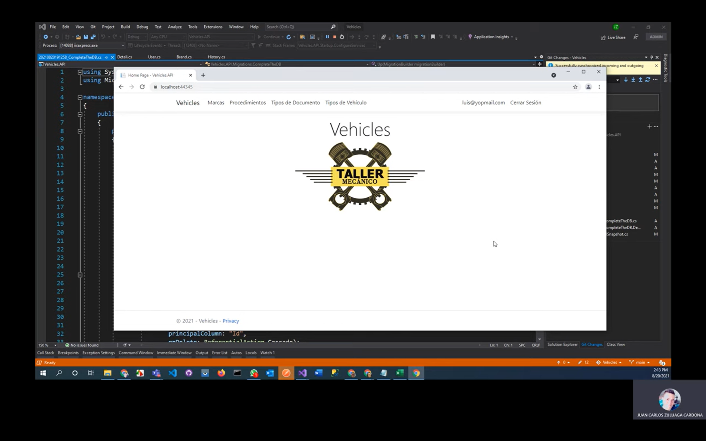

# Video 10 Controller User-> Index

* 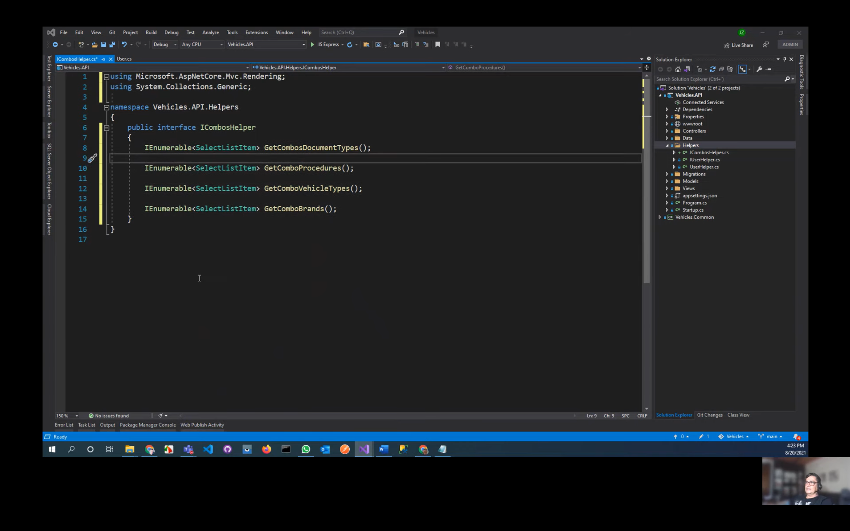
* namespace Vehicles.API.Helpers

{

public class CombosHelper : ICombosHelper

{

private readonly DataContext _context;

public CombosHelper(DataContext context)

{

_context = context;

}

public IEnumerable<SelectListItem> GetComboBrands()

{

List<SelectListItem> list = _context.Brands.Select(x => new SelectListItem

{

Text = x.Description,

Value = $"{x.Id}" //conversión a string

})

.OrderBy(x => x.Text)

.ToList();

list.Insert(0, new SelectListItem

{

Text = "[Seleccione una marca...]",

Value = "0"

});

return list;

}

public IEnumerable<SelectListItem> GetComboProcedures()

{

List<SelectListItem> list = _context.Procedures.Select(x => new SelectListItem

{

Text = x.Description,

Value = $"{x.Id}"

})

.OrderBy(x => x.Text)

.ToList();

list.Insert(0, new SelectListItem

{

Text = "[Seleccione un procedimiento...]",

Value = "0"

});

return list;

}

public IEnumerable<SelectListItem> GetComboDocumentTypes()

{

List<SelectListItem> list = _context.DocumentTypes.Select(x => new SelectListItem

{

Text = x.Description,

Value = $"{x.Id}"

})

.OrderBy(x => x.Text)

.ToList();

list.Insert(0, new SelectListItem

{

Text = "[Seleccione un tipo de documento...]",

Value = "0"

});

return list;

}

public IEnumerable<SelectListItem> GetComboVehicleTypes()

{

List<SelectListItem> list = _context.VehicleTypes.Select(x => new SelectListItem

{

Text = x.Description,

Value = $"{x.Id}"

})

.OrderBy(x => x.Text)

.ToList();

list.Insert(0, new SelectListItem

{

Text = "[Seleccione un tipo de vehículo...]",

Value = "0"

});

return list;

}

}

}

* Inyectar el ICombosHelper
* En la entidad User agregar

Public ICollection<Vehicle> Vehicles get set

[Display(Name = “# Vehículos”)]

Public int VehiclesCount => Vehicles == null ¿ 0 : Vehicles.Count;

* En Shared-> _layout, agregar el menú para usuarios
* namespace Vehicles.API.Controllers

{

[Authorize(Roles = "Admin")]

public class UsersController : Controller

{

private readonly DataContext _context;

public UsersController(DataContext context)

{

_context = context;

}

public async Task<IActionResult> Index()

{

return View(await _context.Users

.Include(x => x.DocumentType)

.Include(x => x.Vehicles)

.Where(x => x.UserType == UserType.User)

.ToListAsync());

}

}

}

@model IEnumerable<Vehicles.API.Data.Entities.User>

@{

ViewData["Title"] = "Index";

}

<link rel="stylesheet" href="https://cdn.datatables.net/1.10.19/css/jquery.dataTables.min.css" />

<p>

<a asp-action="Create" class="btn btn-primary">Nuevo</a>

</p>

<div class="row">

<div class="col-md-12">

<div class="panel panel-default">

<div class="panel-heading">

<h3 class="panel-title">Usuarios</h3>

</div>

<div class="panel-body">

<table class="table table-hover table-responsive table-striped" id="MyTable">

<thead>

<tr>

<th>

@Html.DisplayNameFor(model => model.FullName)

</th>

<th>

@Html.DisplayNameFor(model => model.DocumentType.Description)

</th>

<th>

@Html.DisplayNameFor(model => model.Document)

</th>

<th>

@Html.DisplayNameFor(model => model.Email)

</th>

<th>

@Html.DisplayNameFor(model => model.PhoneNumber)

</th>

<th>

@Html.DisplayNameFor(model => model.VehiclesCount)

</th>

<th>

@Html.DisplayNameFor(model => model.ImageFullPath)

</th>

<th></th>

</tr>

</thead>

<tbody>

@foreach (var item in Model)

{

<tr>

<td>

@Html.DisplayFor(modelItem => item.FullName)

</td>

<td>

@Html.DisplayFor(modelItem => item.DocumentType.Description)

</td>

<td>

@Html.DisplayFor(modelItem => item.Document)

</td>

<td>

@Html.DisplayFor(modelItem => item.Email)

</td>

<td>

@Html.DisplayFor(modelItem => item.PhoneNumber)

</td>

<td>

@Html.DisplayFor(modelItem => item.VehiclesCount)

</td>

<td>

<img src="@item.ImageFullPath" style="width: 100px; height: 100px; border-radius: 150px;" />

</td>

<td>

<a asp-action="Edit" asp-route-id="@item.Id" class="btn btn-warning">Editar</a>

<a asp-action="Details" asp-route-id="@item.Id" class="btn btn-info">Vehiculos</a>

<button data-id="@item.Id" class="btn btn-danger deleteItem" data-toggle="modal" data-target="#deleteDialog">Borrar</button>

</td>

</tr>

}

</tbody>

</table>

</div>

</div>

</div>

</div>

<partial name="_DeleteDialog" />

@section Scripts {

@{await Html.RenderPartialAsync("_ValidationScriptsPartial");}

<script src="//cdn.datatables.net/1.10.19/js/jquery.dataTables.min.js"></script>

<script src="/js/deleteDialog.js"></script>

<script type="text/javascript">

$(document).ready(function () {

$('#MyTable').DataTable({

"language": {

"url": "//cdn.datatables.net/plug-ins/9dcbecd42ad/i18n/Spanish.json"

},

"aLengthMenu": [

[25, 50, 100, 200, -1],

[25, 50, 100, 200, "Todos"]

]

});

// Delete item

sc_deleteDialog.openModal('deleteItem', true, 'btnYesDelete', '/Users/Delete/', false);

});

</script>

}

* 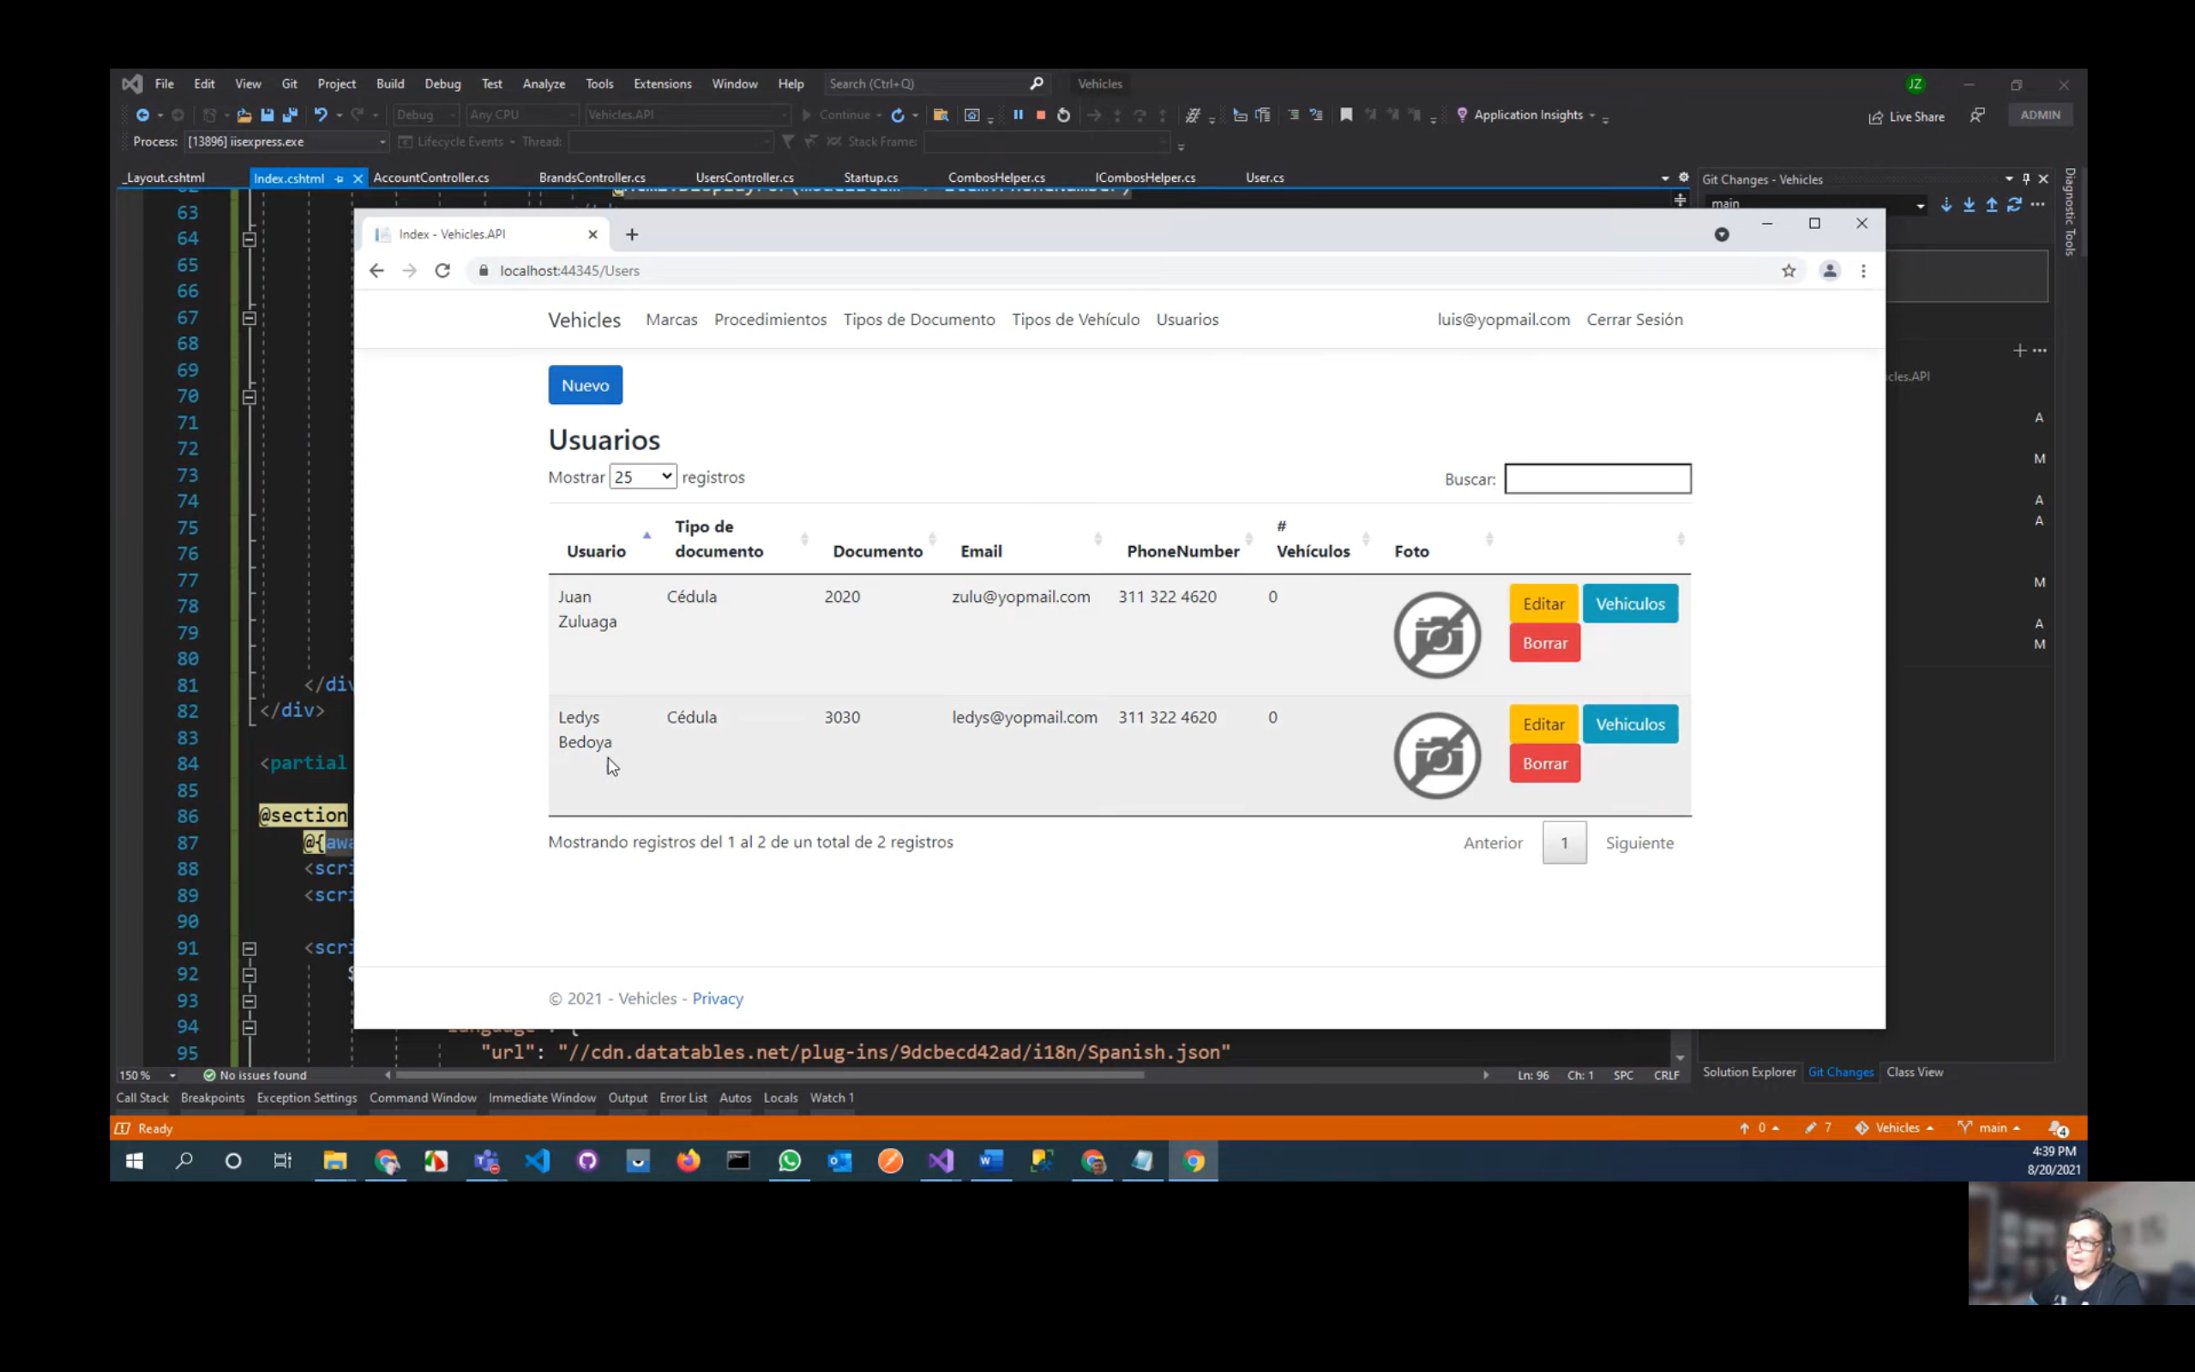

# Video Creación de Usuarios

* En wwwroot-> Images-> crear carpeta Users
* En Helpers crear una interface IImageHelper con los métodos

IFormFile se pasa por la interface de usuario

Task<string> UploadImageAsync(IFormFile imageFile, string folder);

byte[] lo utilizamos para subir las imágenes desde la appmóvil

string UploadImage(byte[] pictureArray, string folder);

Para el blobhelper

Task<Guid> UploadBlobAsync(IFormFile file, string containerName);

Task<Guid> UploadBlobAsync(byte[] file, string containerName);

string image pasa una ruta

Task<Guid> UploadBlobAsync(string image, string containerName);

Guid id permite pasar el id del blob

Task DeleteBlobAsync(Guid id, string containerName);

* EN Helpers crear la clase ImageHelper que herede de IImageHelper e implementarla

public async Task<string> UploadImageAsync(IFormFile imageFile, string folder)

{

string guid = Guid.NewGuid().ToString();

string file = $"{guid}.jpg";

string path = Path.Combine(Directory.GetCurrentDirectory(), $"wwwroot\\images\\{folder}", file);

using (FileStream stream = new FileStream(path, FileMode.Create))

{

await imageFile.CopyToAsync(stream);

}

return $"~/images/{folder}/{file}";

}

* Métodos para el BlobHelper

public class BlobHelper : IBlobHelper

{

private readonly CloudBlobClient _blobClient;

public BlobHelper(IConfiguration configuration)

{

string keys = configuration["Blob:ConnectionString"]; //obtenemos la llave del appsettings.json

CloudStorageAccount storageAccount = CloudStorageAccount.Parse(keys); //obtenemos la llave de la cuenta creada en azure

_blobClient = storageAccount.CreateCloudBlobClient();

}

public async Task<Guid> UploadBlobAsync(byte[] file, string containerName)

{

MemoryStream stream = new MemoryStream(file); //creamos un array

Guid name = Guid.NewGuid(); //nos genera el nombre para el archivo

CloudBlobContainer container = _blobClient.GetContainerReference(containerName); //referenciamos al container

CloudBlockBlob blockBlob = container.GetBlockBlobReference($"{name}"); //vinculamos el blockBlob al ($"{name}")

await blockBlob.UploadFromStreamAsync(stream); //subimos al blob

return name;

}

public async Task<Guid> UploadBlobAsync(IFormFile file, string containerName)

{

Stream stream = file.OpenReadStream(); //creamos un stream

Guid name = Guid.NewGuid(); //nos genera el nombre dl archivo

CloudBlobContainer container = _blobClient.GetContainerReference(containerName);

CloudBlockBlob blockBlob = container.GetBlockBlobReference($"{name}");

await blockBlob.UploadFromStreamAsync(stream);

return name;

}

public async Task<Guid> UploadBlobAsync(string image, string containerName)

{

Stream stream = File.OpenRead(image); //abrimos el archivo

Guid name = Guid.NewGuid();

CloudBlobContainer container = _blobClient.GetContainerReference(containerName);

CloudBlockBlob blockBlob = container.GetBlockBlobReference($"{name}");

await blockBlob.UploadFromStreamAsync(stream);

return name;

}

public async Task DeleteBlobAsync(Guid id, string containerName)

{

CloudBlobContainer container = _blobClient.GetContainerReference(containerName); //obtenemos la referencia del container

CloudBlockBlob blockBlob = container.GetBlockBlobReference($"{id}"); //obtenemos la referencia del blob

await blockBlob.DeleteAsync(); //borramos

}

}

* Inyectamos el IBlobHelper en el starup
* Creamos en Models-> UserViewModel

public class UserViewModel

{

public string Id { get; set; } //IdUser

[Display(Name = "Email")]

[EmailAddress(ErrorMessage = "Debes introducir un email válido.")]

[Required(ErrorMessage = "El campo {0} es obligatorio.")]

public string Email { get; set; }

[Display(Name = "Nombres")]

[MaxLength(50, ErrorMessage = "El campo {0} no puede tener más de {1} carácteres.")]

[Required(ErrorMessage = "El campo {0} es obligatorio.")]

public string FirstName { get; set; }

[Display(Name = "Apellidos")]

[MaxLength(50, ErrorMessage = "El campo {0} no puede tener más de {1} carácteres.")]

[Required(ErrorMessage = "El campo {0} es obligatorio.")]

public string LastName { get; set; }

[Display(Name = "Documento")]

[MaxLength(20, ErrorMessage = "El campo {0} no puede tener más de {1} carácteres.")]

[Required(ErrorMessage = "El campo {0} es obligatorio.")]

public string Document { get; set; }

[Display(Name = "Dirección")]

[MaxLength(100, ErrorMessage = "El campo {0} no puede tener más de {1} carácteres.")]

public string Address { get; set; }

[Display(Name = "Teléfono")]

[MaxLength(20, ErrorMessage = "El campo {0} no puede tener más de {1} carácteres.")]

public string PhoneNumber { get; set; }

[Display(Name = "Foto")]

public Guid ImageId { get; set; }

[Display(Name = "Tipo de usuario")]

public UserType UserType { get; set; }

[Display(Name = "Foto")]

public IFormFile ImageFile { get; set; }

[Display(Name = "Tipo de documento")]

[Range(1, int.MaxValue, ErrorMessage = "Debes seleccionar un tipo de documento.")]

[Required(ErrorMessage = "El campo {0} es obligatorio.")]

public int DocumentTypeId { get; set; }

public IEnumerable<SelectListItem> DocumentTypes { get; set; }

[Display(Name = "Foto")]

public string ImageFullPath => ImageId == Guid.Empty

? $"https://vehiclessalazar.azurewebsites.net/images/noimage.png"

: $"https://vehiclessalazar.blob.core.windows.net/users/{ImageId}";

}

Helpers-> IConverterHelper

Task<Product> ToProductAsync(ProductViewModel model, string path, bool isNew);

ProductViewModel ToProductViewModel(Product entity);

Para el Blob

Task<User> ToUserAsync(UserViewModel model, Guid imageId, bool isNew);

UserViewModel ToUserViewModel(User user);

* Helpers-> ConverterHelper que herede de IConverterHelper e implementarla

private readonly DataContext _context;

private readonly ICombosHelper _combosHelper;

public ConverterHelper(DataContext context, ICombosHelper combosHelper)

{

_context = context;

_combosHelper = combosHelper;

}

El modelo reemplazar por User

public async Task<Product> ToProductAsync(ProductViewModel model, string path, bool isNew)

{

return new Product

{

Id = isNew ? 0 : model.Id,

Description = model.Description,

Name = model.Name,

Price = ToPrice(model.PriceString),

IsActive = model.IsActive,

IsStarred = model.IsStarred,

Category = await _context.Categories.FindAsync(model.CategoryId),

ProductImages = model.ProductImages,

ImageProduct = path,

Store = model.Store

};

}

public ProductViewModel ToProductViewModel(Product entity)

{

return new ProductViewModel

{

Id = entity.Id,

Description = entity.Description,

Name = entity.Name,

PriceString = $"{entity.Price}",

IsActive = entity.IsActive,

IsStarred = entity.IsStarred,

Categories = _combosHelper.GetComboCategories(),

Category = entity.Category,

CategoryId = entity.Category.Id,

ProductImages = entity.ProductImages,

ImageProduct = entity.ImageProduct,

Store = entity.Store

};

}

Para el Blob

public async Task<User> ToUserAsync(UserViewModel model, Guid imageId, bool isNew)

{

return new User

{

Address = model.Address,

Document = model.Document,

DocumentType = await _context.DocumentTypes.FindAsync(model.DocumentTypeId),

Email = model.Email,

FirstName = model.FirstName,

Id = isNew ? Guid.NewGuid().ToString() : model.Id,

ImageId = imageId,

LastName = model.LastName,

PhoneNumber = model.PhoneNumber,

UserName = model.Email,

UserType = model.UserType

};

}

public UserViewModel ToUserViewModel(User user)

{

return new UserViewModel

{

Address = user.Address,

Document = user.Document,

DocumentTypeId = user.DocumentType.Id,

DocumentTypes = _combosHelper.GetComboDocumentTypes(),

Email = user.Email,

FirstName = user.FirstName,

Id = user.Id,

LastName = user.LastName,

PhoneNumber = user.PhoneNumber,

UserType = user.UserType

};

}

* Inyectar el IConverterHelper en el startup
* UsersController

En el constructor inyectar el IUserHelper, ICombosHelper, IConverterHelper, IImageHelper

public IActionResult Create()

{

UserViewModel model = new UserViewModel

{

DocumentTypes = _combosHelper.GetComboDocumentTypes()

};

return View(model);

}

Creamos una vista parcial de nombre _User

@model Vehicles.API.Models.UserViewModel

<div class="row">

<div class="col-md-6">

<div class="form-group">

<label asp-for="FirstName" class="control-label"></label>

<input asp-for="FirstName" class="form-control" />

<span asp-validation-for="FirstName" class="text-danger"></span>

</div>

<div class="form-group">

<label asp-for="LastName" class="control-label"></label>

<input asp-for="LastName" class="form-control">

<span asp-validation-for="LastName" class="text-danger"></span>

</div>

<div class="form-group">

<label asp-for="DocumentTypeId" class="control-label"></label>

<select asp-for="DocumentTypeId" asp-items="Model.DocumentTypes" class="form-control"></select>

<span asp-validation-for="DocumentTypeId" class="text-danger"></span>

</div>

<div class="form-group">

<label asp-for="Document" class="control-label"></label>

<input asp-for="Document" class="form-control" />

<span asp-validation-for="Document" class="text-danger"></span>

</div>

</div>

<div class="col-md-6">

<div class="form-group">

<label asp-for="Address" class="control-label"></label>

<input asp-for="Address" class="form-control" />

<span asp-validation-for="Address" class="text-danger"></span>

</div>

<div class="form-group">

<label asp-for="PhoneNumber" class="control-label"></label>

<input asp-for="PhoneNumber" class="form-control" />

<span asp-validation-for="PhoneNumber" class="text-danger"></span>

</div>

<div class="form-group">

<label asp-for="ImageFile" class="control-label"></label>

<input asp-for="ImageFile" type="file" class="form-control" />

<span asp-validation-for="ImageFile" class="text-danger"></span>

</div>

</div>

</div>

Crear la vista Create

@model Vehicles.API.Models.UserViewModel

@{

ViewData["Title"] = "Create";

}

<h2>Crear</h2>

<h4>Usuario</h4>

<hr />

<div class="row">

<div class="col-md-12">

<form asp-action="Create" enctype="multipart/form-data">

<div asp-validation-summary="ModelOnly" class="text-danger"></div>

<div class="form-group">

<label asp-for="Email" class="control-label"></label>

<input asp-for="Email" class="form-control" />

<span asp-validation-for="Email" class="text-danger"></span>

</div>

<partial name="_User" />

<div class="form-group">

<input type="submit" value="Crear" class="btn btn-primary" />

<a asp-action="Index" class="btn btn-success">Regresar</a>

</div>

</form>

</div>

</div>

@section Scripts {

@{await Html.RenderPartialAsync("_ValidationScriptsPartial");}

}

[HttpPost]

[ValidateAntiForgeryToken]

public async Task<IActionResult> Create(UserViewModel model)

{

if (ModelState.IsValid)

{

Guid imageId = Guid.Empty;

if (model.ImageFile != null)

{

imageId = await _blobHelper.UploadBlobAsync(model.ImageFile, "users");

}

User user = await _converterHelper.ToUserAsync(model, imageId, true);

user.UserType = UserType.User;

await _userHelper.AddUserAsync(user, "123456"); //crea un usuario

await _userHelper.AddUserToRoleAsync(user, user.UserType.ToString()); //creamos el role de tipo usser

return RedirectToAction(nameof(Index));

}

model.DocumentTypes = _combosHelper.GetComboDocumentTypes(); //para que no se pierda los datos del combo

return View(model);

}

Ejecutar y va a salir error que el documenttypes es nulo o vacío por lo que toca realizar los siguiente

Eliminar documenttypes del modelo user y de los métodos del BlobHelper

* 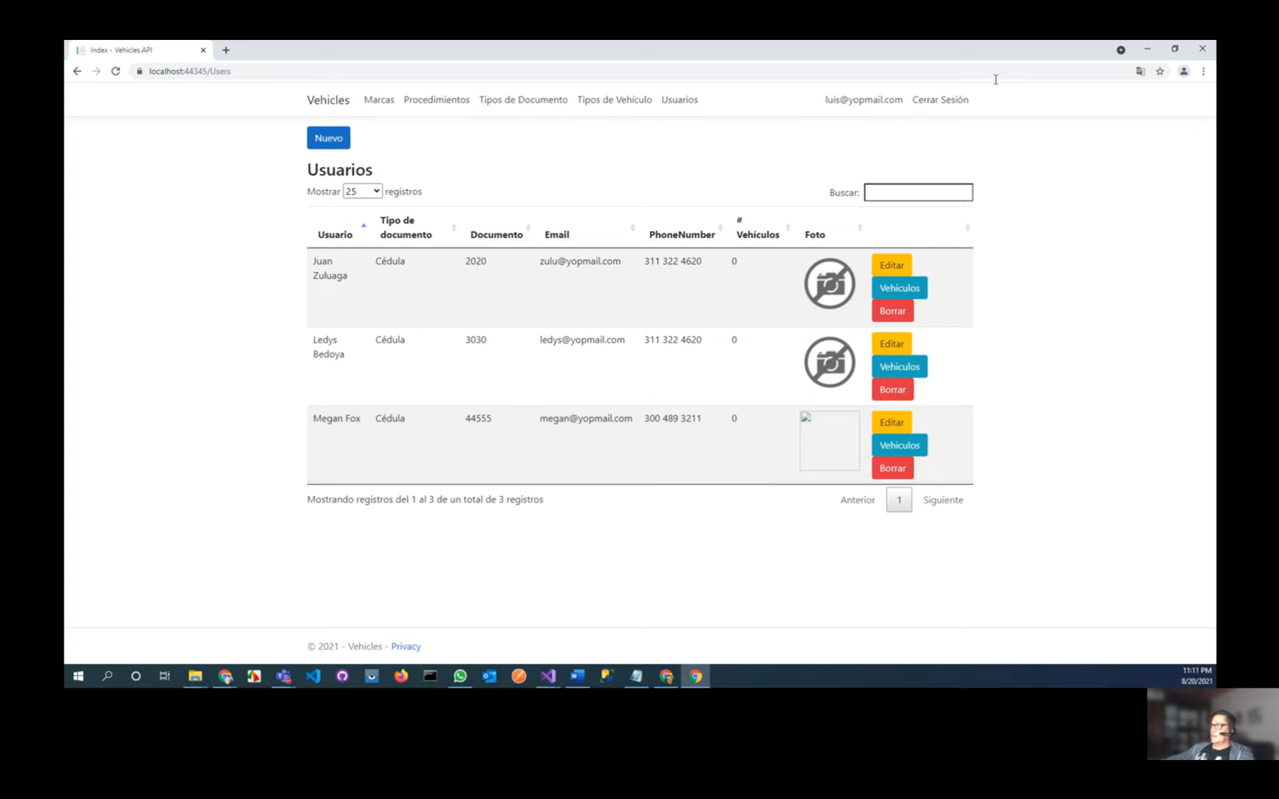

Sale sin foto, agregar los siguiente para los campos de las entidades que manejan imágenes

[Display(Name = "Foto")]

public string ImageFullPath => ImageId == Guid.Empty

? $"https://vehiclessalazar.azurewebsites.net/images/noimage.png"

: $"https://vehiclessalazar.blob.core.windows.net/users/{ImageId}";

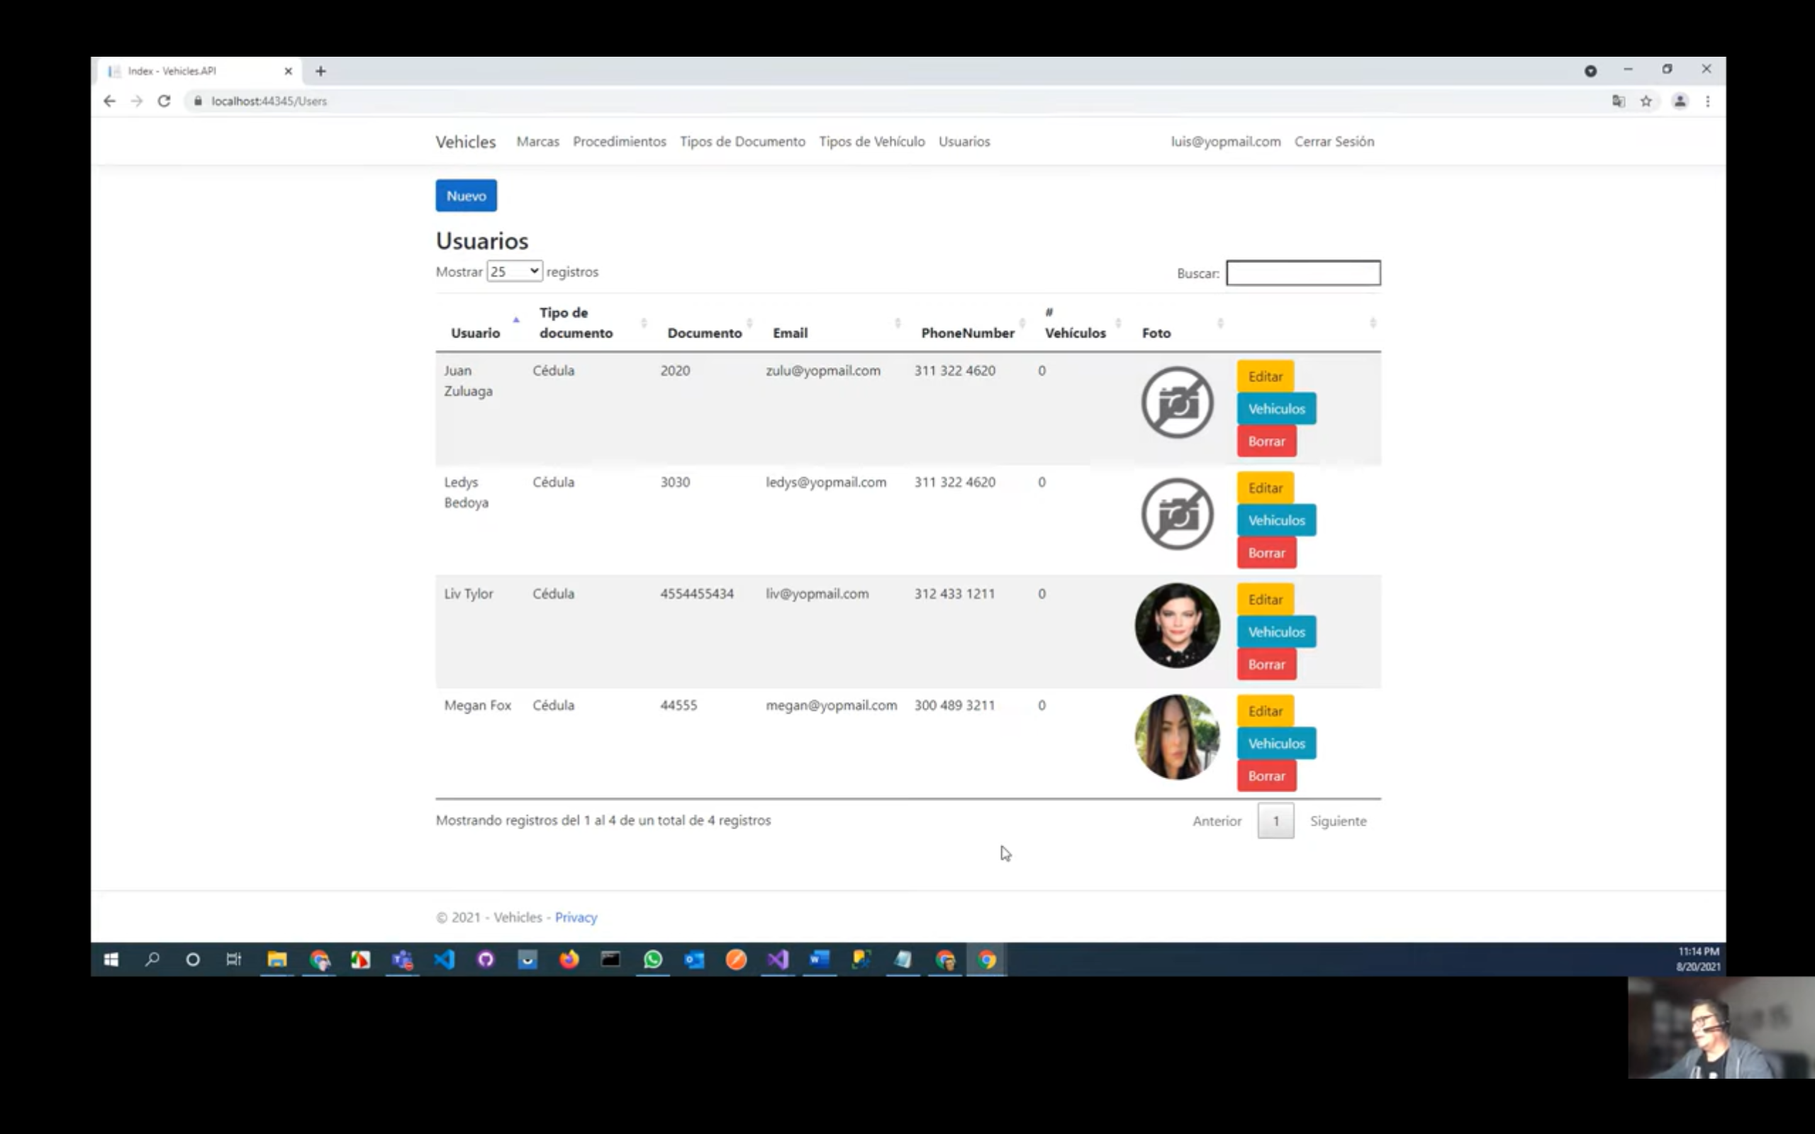

Nos logueamos con los nuevos users creados

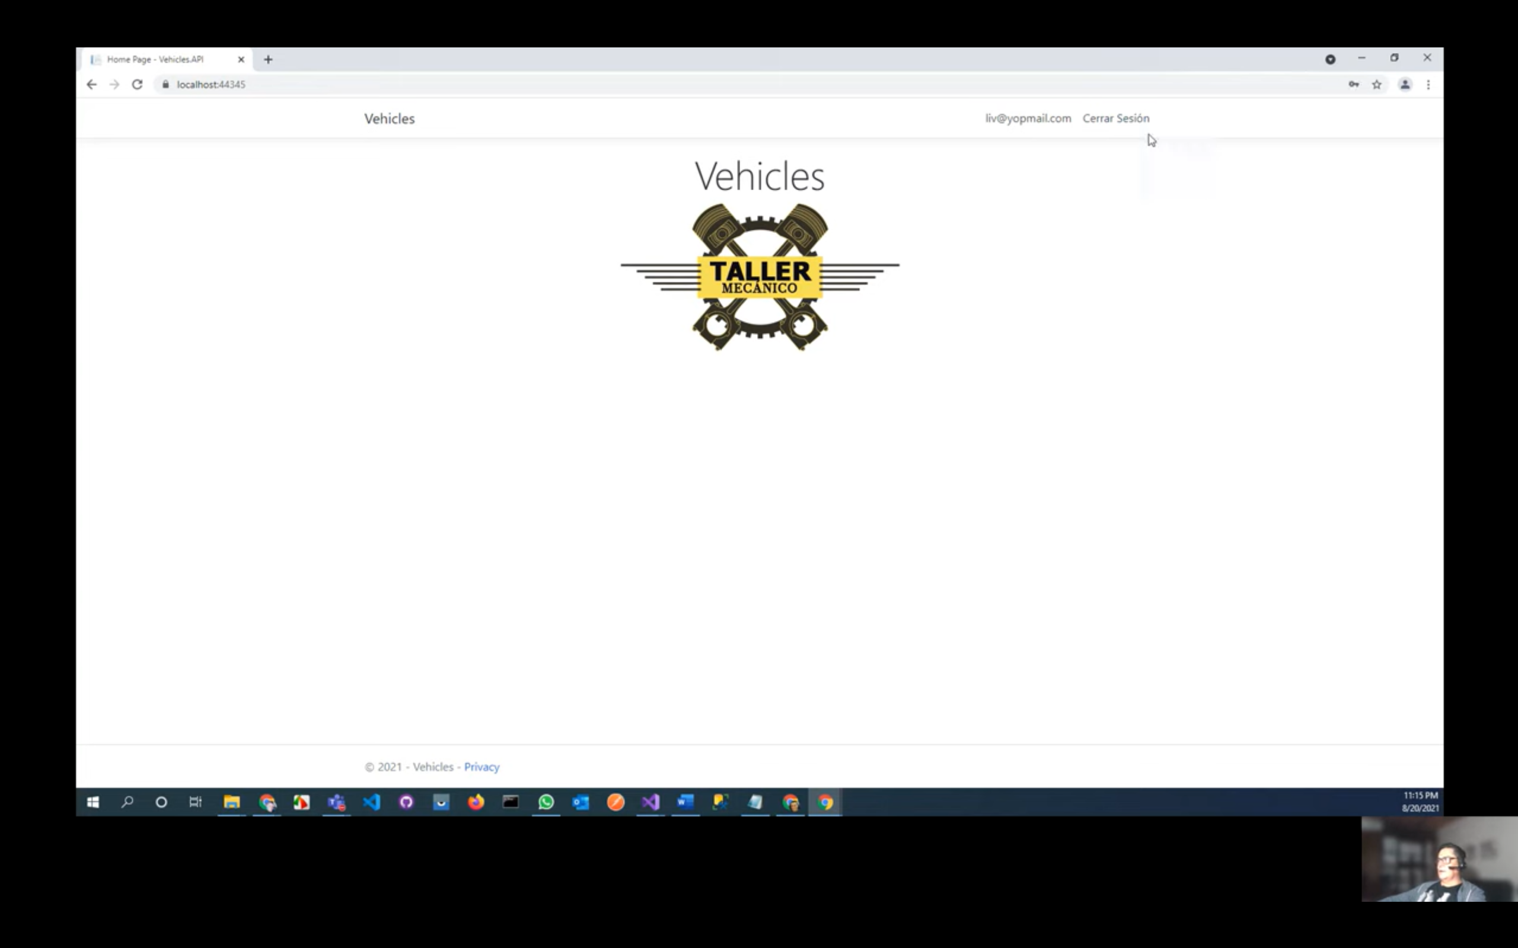

# Video 13

# Errores

* Unable to create an object of type 'DataContext'. For the different patterns supported at design time, see <https://go.microsoft.com/fwlink/?linkid=851728>

Solución:

En el archivo Program.cs copiar:

public class Program

{

public static void Main(string[] args)

{

IWebHost host = CreateWebHostBuilder(args).Build();

RunSeeding(host);

host.Run();

}

private static void RunSeeding(IWebHost host)

{

IServiceScopeFactory scopeFactory = host.Services.GetService<IServiceScopeFactory>();

using (IServiceScope scope = scopeFactory.CreateScope())

{

SeedDB seeder = scope.ServiceProvider.GetService<SeedDB>();

seeder.SeedAsync().Wait();

}

}

public static IWebHostBuilder CreateWebHostBuilder(string[] args)

{

return WebHost.CreateDefaultBuilder(args).UseStartup<Startup>();

}

* Para borrar una Migración, utilizar el comando remove-migration